Notes:
1. Let X = the birth weight of full-term babies. X is known to be normally distributed with mean $μ=\text{3400}$grams and $σ=\text{505}$grams.

a. Show the notation to describe the distribution of X.
b. Draw a normal curve with the parameters labeled (include associated z-scores)
c. What birth weight x represents the 90th percentile?
d. What birth weight x separates the bottom 5% from the top 95%?
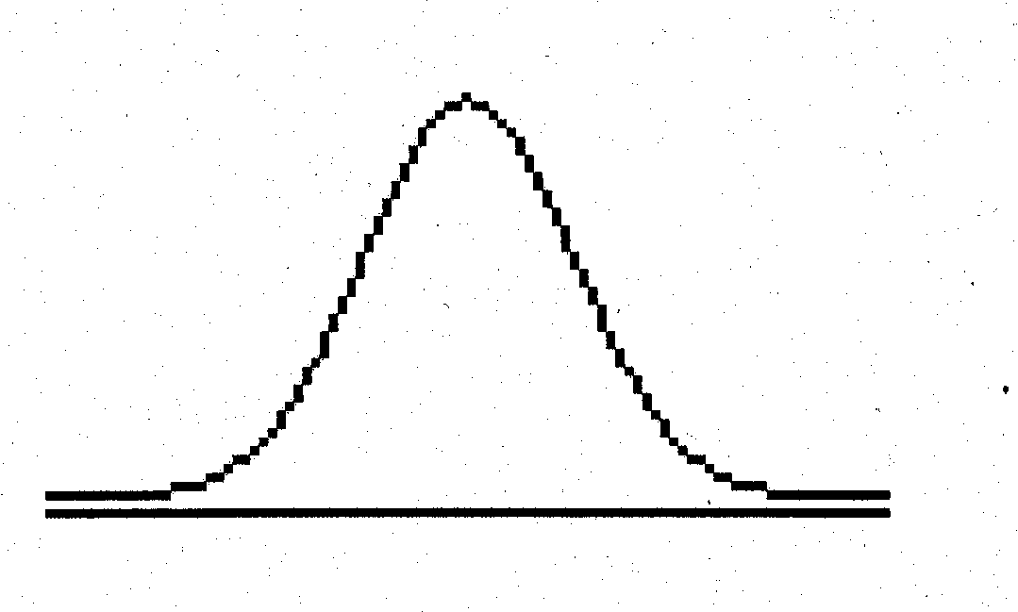

2. Let Y = the height of 10-year old males. Y is known to be normally distributed with $μ=\text{55}\text{.}9$inches and $σ=5\text{.}7$inches.
a. Show the notation to describe the distribution of Y.
b. Draw a normal curve with the parameters labeled (include associated z-scores)
c. What height y represents the 80th percentile?
d. What heights y represent the middle 90%?

3. Let X = the length of human pregnancy. Suppose X is known to be normally distributed with $μ=\text{266}$days and $σ=\text{16}$days.

a. Show the notation to describe the distribution of X.
b. Draw a normal curve with the parameters labeled (include associated z-scores)
c. What length of pregnancy x represents the 10th percentile?
d. What lengths of pregnancies x separates the bottom 25% from the top 75%?
e. What lengths of pregnancies x represent the middle 50%?

4. Let X = the length of healthy human pregnancy. Suppose X is known to be uniformly distributed between 252 and 280 days.

Show the notation to describe the distribution of X.
Draw a uniform curve with the parameters labeled
What length of a healthy pregnancy x represents the 10th percentile?
What lengths of healthy pregnancies x separates the bottom 25% from the top 75%?
What lengths of healthy pregnancies x represent the middle 50%?

