Notes:
UNIT2 Lesson 7: Continuous Random Variable Density Curves – Defined and Properties

A thin 10-inch-long bar is pressed inward until the bar snaps. Let X = the distance from the left end to the break. Here X can assume any value between 0 and 10 inches. In repeated trials, the values of X will vary. Because there are an infinite many locations for the break between 0 and 10, we consider X here to be a continuous random variable.

The probability distribution for a continuous random variable is specified by a mathematical function denoted $f(x)$and is called a density function. The area under a density curve must equal one because the entire area beneath the curve represents all possibilities. Probabilities are found by finding the area under certain parts of the density curve and therefore a density curve cannot dip below the x-axis as probabilities cannot be negative.

When dealing with continuous random variables, we do not consider the probability of any one specific outcome. For example, we do not ask P(X = 4) the probability that the break will be exactly 4 inches from the left end. The reason we do not ask this is because, in theory, this is only one of an infinite many possibilities. We do ask, however, probability statement about a range of potential values such as P(X<4) the probability that the break point is less than 4 inches from the left end. Here the probability is simply the area under the curve to the left of 4 inches.

In the case of a symmetric probability distribution for X, the mean or expected value of the random variable X is median of the possible X values (the center x value)
Here are a couple of possible probability distributions for our continuous random variable X defined as the break point from the left end of the 10 inch bar.

I. Suppose that each location on the 1-ft-bar are equally likely to be broken. The density curve would look as follows: What is the mean of the random variable X?
0
10

Area = 1

II. Suppose that locations near the center of the bar are more likely to be broken than the ends. The density curve may look something like these: What is the mean of the random variable X?
0
10
0
10

Area = 1
Area = 1

III. Suppose that locations near the left end are more likely to be broken than to the right. The density curve may look something like these: What is the mean of the random variable X?
0
10
0
10
Area = 1
Area = 1
UNIT2 Lesson 7: Continuous Random Variable Density Curves – Shading and Interpreting
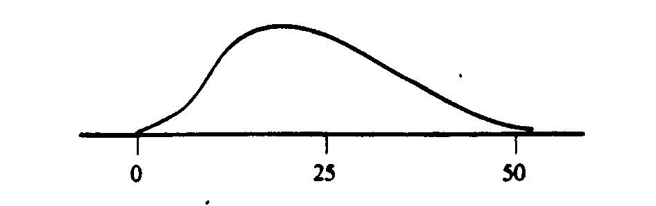
1. Let X denote the lifetime (in thousands of hours) of a certain type of fan used in diesel engines. The density curve of X is as pictured. Shade the area under the curve corresponding to each of the following probabilities. Interpret the area in two separate ways.

a. P($\text{10}<X<\text{25}$) b. P($\text{10}≤X≤\text{25}$) c. P(X is at least 25,000 hours)

2. A particular professor never dismisses class early. Let X denote the amount of time past the hour (minutes) that elapses before the professor dismisses class. Suppose X has a uniform distribution on the interval from 0 to 10 min. The density curve is shown.
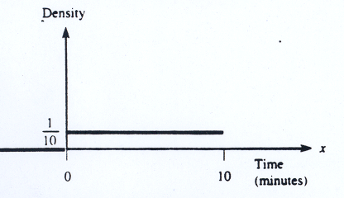

a. Find the probability that at most 6 min elapse before dismissal? Shade and interpret the area in two separate ways. What is the mean value of X?
b. Find the probability that between 3 and 5 min elapse before dismissal? Shade and interpret the area in two separate ways

3. Let X be the weight (in pounds) of a female applying for the reality show “Biggest Loser.” Suppose X has a normal distribution as shown below.

a). Shade: P( X < 203). b). Suppose P(X<203) = 0.0445. Interpret this area in two separate ways. c). Is P( X$\text{203}$) = 0.0445? d) Is it unusual for a female applicant to weigh less than 203 lbs? Why? e). Is it more or less unusual for a sample of female applicant to have an average weight less than 203 lbs? Why ? f) What is the expected weight of a female applicant (the mean)?

UNIT2 Lesson 7: Continuous Random Variable Density Curves – Finding Probabilities
1. Under the surface of the ground is a bioturbation layer. The depth of this layer in a certain region is between 7.5 and 20 cm. Let X = the depth of this layer in cm and suppose that X has a uniform probability distribution on the interval 7.5 to 20.
- Draw the density curve for X.

- What must the height of the density curve be?

- What is the probability that X is at most 12?

- What is the probability that X is between 10 and 15?

- What is expected bioturbation layer depth, i.e., what is the mean bioturbation layer depth?

2. Let X be the amount of time in minutes that a particular San Francisco commuter must wait for a BART train.

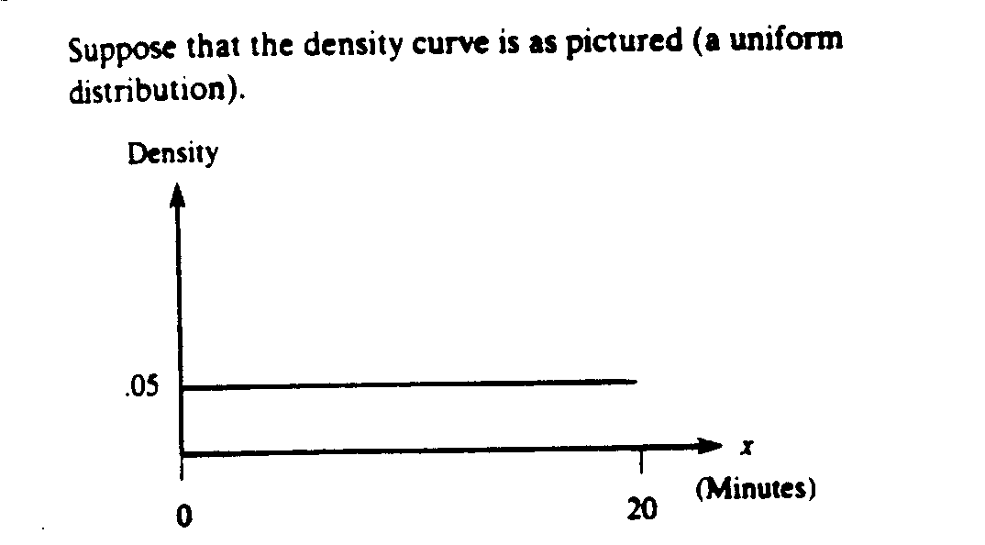

- What is the probability that X is less than 10 min? More than 18 min?

- What is the probability that X is between 7 and 12 min?

- Find a value X_{o} for which P($X<X_{o}$) = 0.9

3. Let the probability distribution of X be as follows:
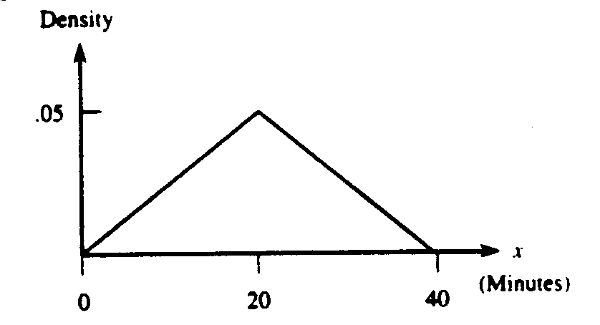

- Verify that the total area under the density curve is equal to one.

- What is the probability that X is less than 20? Less than 10? More than 30?

- What is the probability that X is between 10 and 30?

- What is the mean or expected value of X?

