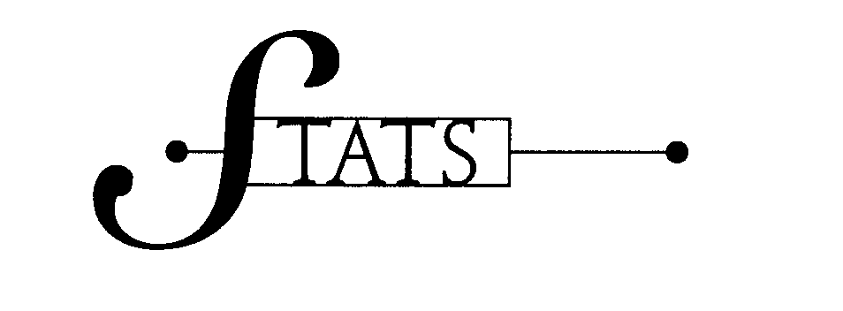
Statistics syllabus
Mr. Bermel 2007-2008
Course Web Site: http://mrbermel.com
Course Text: Statistics; Informed Decisions Using Data, by Michael Sullivan, III

Grades:

Each Quarter: [600 points]
Assignments: [200 points]
2 projects: [200 points]

1 Test: [200 points]

Assignments:  Assignments range from 25 to 125 points. They will be graded rigorously as to aid in your comprehension of the material. Think of an assignment as a take home exam. Expect three to five assignments a quarter. Some class time will be given to work on assignments with the remainder to be complete on your own time.  Assignments must be handed in on lined or graph paper without fringed edges. Your work must be neat and organized. I will not grade what I cannot read. | Projects:  Projects will be 100 points each. They are designed to help you apply the content in your own context. All projects must be professional (typed and all graphs and pictures computer generated). No Glitter! Although the points may not add up, no student is permitted to pass without all projects submitted.  Tests:  Quarter exams are worth 200 points. The exams will consist of approximately four multi-part questions. | Extra Credit:  Students will receive 1.5 extra credit points for each day a sanctioned headband is worn. To earn the extra credit, a student must be present at the sound of the bell.  All students start with a white headband. You must make this headband yourself. It must be long enough to tie around your head and must read, in marker, the name “STATS.” Consider cutting an old sheet for this headband.  To earn a new color band, a student must score 90 or higher on an exam. After white comes yellow, then red, and then black. To get a black belt one must get 90 or better on all four of the course exams. I will provide these color bands in a ceremony.  Tournament:  The top 16 students from each class will participate in the annual statistics tournament. If you qualify, you will be seeded 1 – 16, where #1 represents the top candidate. Seeding is based on first quarter grades prior to the quarter test. Student then advance through a bracket tournament by scoring better on an exam than his or her opponent. In total 32 candidates will participate. After test one, the field is down to 16, then 8 after test two, 4 after test three, and finally the winner will be awarded the “Statistics Cup” after the final test four.
Text Usage:  A text will be assigned to each student to take home. You do not need to bring your text to school, as there are enough texts for a class set to be use during the block. Please note, my notes may vary slightly from the text’s presentation so please take careful notes.  Absenteeism:  When absent, students are responsible for all work missed and assignments assigned.  Over-Due:  With penalty, late assignments are only accepted up to the day we go over it.  Projects lose 5 points for each day (not block) late. | Pink Sheets for Tests:  As a reward, each student present on the day of the exam will be allowed to bring a pre-prepared notes sheet to aid him or her during the exam. I will provide this one sheet of pink paper prior to the exam. You may write on both sides of the “pink sheet” but photocopies or computer generated notes are NOT permitted on “pink sheets”. Any student absent on the day of the exam will NOT be permitted to use his or her pink sheet. NO exceptions!!! Even doctor’s notes, funerals, and or school-sanctioned field trips are not exemptions.

This course will extensively utilize the web-site mrbermel.com. Here you will find notes, worksheets, data sets, assignments, projects, and other pertinent information. Statistics class is a college level course. You are expected to be academically mature and responsible for your own actions. I will treat you as an adult. My hope is for us to “work hard and play hard”. This class can be a lot of fun, but it requires that students work hard and stay on task. Lets make it a great year.

Quarter 1: Types of Variables, Descriptive Statistics, Nature and Source of Variability, Organizing Data with Graphs
[September – October]

Quarter 2: Probability, Probability Density Functions including the Normal Probability Density Function and other well-known density functions [November – December]

Quarter 3: Inferential Statistics; One Sample z and t Tests, Two Sample t Test, Matched Pairs t, and ANOVA
[January – February]

Quarter 4: Regression, Experimental Designs
[March – April]

Final Project: ANOVA and GLM (General Linear Model)
[May – June]

Stats Song: “Stats is my favorite subject, stats is so coool, if it wasn’t for staa-tistics, I would be a fool” © Mr. Bermel 2002

