BC: Q403 CHAPTER 10 – LESSON 1 (10.1)

DEF: A plane curve is a set C of ordered pairs$\left(x(t),y(t)\right)$, where$x(t)$ and $y(t)$are continuous functions on an interval I.

DEF: Let C be the curve consisting of all ordered pairs$\left(x(t),y(t)\right)$, where$x(t)$ and $y(t)$are continuous on an interval I. The equations$x=x(t)$and $y=y(t)$, for t in I, are parametric equations for C with parameter t.

NOTES $\frac{\text{dy}}{\text{dx}}$:

NOTES $\frac{d^{2}y}{{\text{dx}}^{2}}$:

THM: The length of a smooth curve $y=f(x)$from x = a and x = b is given by

THM: If a smooth curve C is given parametrically by $x=x(t)$, $y=y(t)$; $a≤t≤b$, and if C does not intersect itself, except possibly for t = a and t = b, then the length L of C is

THM: Let a smooth curve C be given by $x=x(t)$, $y=y(t)$; $a≤t≤b$, and suppose C does not intersect itself, except possibly for t = a and t = b. If $y(t)≥0$throughout [a, b], then the area S of the surface of revolution obtained by revolving C about the x-axis is

$S=\int{2π\text{yds}=}\int{2π\left(y(t)\right)\sqrt{{\left(\frac{\text{dx}}{\text{dt}}\right)}^{2}+{\left(\frac{\text{dy}}{\text{dt}}\right)}^{2}}}\text{dt}$

THM: Let a smooth curve C be given by $x=x(t)$, $y=y(t)$; $a≤t≤b$, and suppose C does not intersect itself, except possibly for t = a and t = b. If $x(t)≥0$throughout [a, b], then the area S of the surface of revolution obtained by revolving C about the y-axis is
$S=\int{2π\text{xds}=}\int{2π\left(x(t)\right)\sqrt{{\left(\frac{\text{dx}}{\text{dt}}\right)}^{2}+{\left(\frac{\text{dy}}{\text{dt}}\right)}^{2}}}\text{dt}$

Example 1: Let C be the curve that has parametrization

$x=2t$, $y=t^{2}−1$, $−1≤t≤2$.

a. Sketch the graph of C by hand by plotting several points and joining them with a smooth curve. Indicate the orientation
b. Find the slopes of the tangent line and normal line to C at any point P(x,y).
c. Obtain an equation for the curve in the form $y=f(x)$for some function f.
d. Use a graphing utility to plot a graph of C. Set the viewing window so that it contains the entire graph.
e. Find the length of C .
f. Find $\frac{d^{2}y}{{\text{dx}}^{2}}$and discuss its implications.

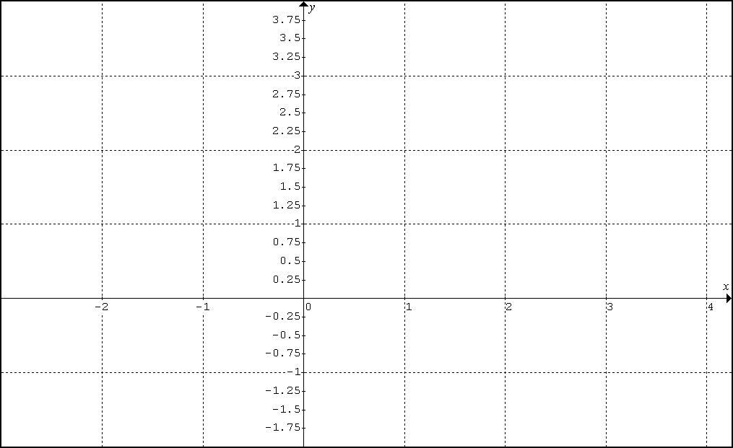

Example 2: A point moves in a plane such that its position P(x,y) at time t is given by
$x=a\text{cos}t$, $y=a\text{sin}t$; $t≥0$, where a is a constant greater than 0.
a. Describe the motion of the point.
b. Find $\frac{\text{dy}}{\text{dx}}$ and $\frac{d^{2}y}{{\text{dx}}^{2}}$for varying values of t.
c. Find the length of C from $t=0$to $t=2π$.

Example 3: Sketch the graph of the curve C that has the parametrization:

$x=−2+t^{2}$, $y=1+2t^{2}$; $t∈ℜ$. What geometric shape does C make?
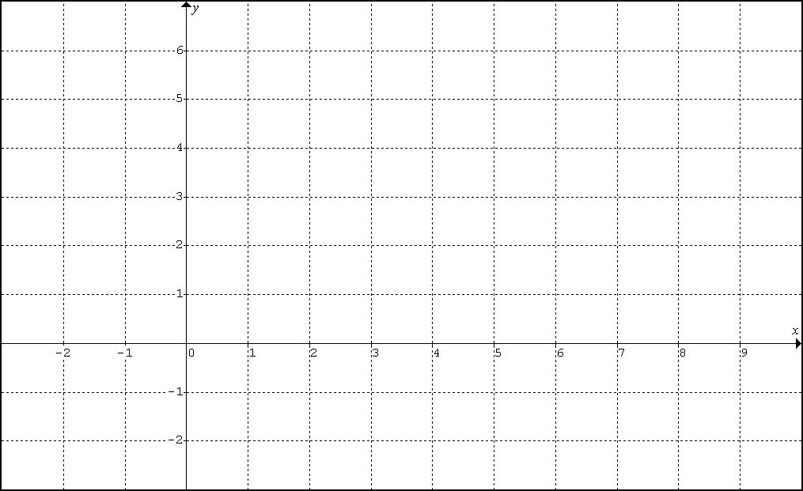

Example 4: Let C be the curve with parametrization $x=e^{−t}$, $y=e^{2t}$; $t∈ℜ$
a. Find $\text{dy}/\text{dx}$and the equation of the tangent line to C at the point when $t=\text{ln}(2)$.
b. $d^{2}y/{\text{dx}}^{2}$ and discuss the concavity of the curve C.
c. Use a calculator to find the length of C from $t=1$to $t=\text{10}$.

Example 5: Suppose the curve C defined as and for is rotated about the x-axis. Without a calculator, find the area of the resulting figure and describe the shape.
Q402: Lesson 1 Homework

I. Textbook: Chapter 10.1: #9, 11, 16, 17, 26, 27, 30, 43

II. Supplemental

A. Find an equation in x and y whose graph contains the points on the curve C. Sketch the graph of C and indicate the orientation.

1. $x=t−2$ $y=2t+3$ $0≤t≤5$
2. $x=4t^{2}−5$ $y=2t+3$ $t∈ℜ$
3. $x=2\text{sin}t$ $y=3\text{cos}t$ $0≤t≤2π$
4. $x=\text{sec}t$ $y=\text{tan}t$ ${−π}/2<t<π/2$

B. Find the slopes of the tangent line and the normal line at the point on the curve that corresponds to$t=1$.

5. $x=t^{2}+1$ $y=t^{2}−1$ $−2≤t≤2$
6. $x=e^{t}$ $y=e^{−2t}$ $t∈ℜ$

C. Let C be the curve with the given parametrization, for t in $ℜ$ . Find the points on C at which the slope of the tangent line is m.

7. $x=−t^{3}$ $y=−6t^{2}−\text{18}t$ $m=2$

D. (1) Find the points on the curve C at which the tangent line is either horizontal or vertical. (2) Find $d^{2}y/{{\text{dx}}^{2}}$.

8. $x=4t^{2}$ $y=t^{3}−\text{12}t$ $t∈ℜ$

E. Find the length of the curve.

9. $x=5t^{2}$ $y=2t^{3}$ $0≤t≤1$
10. $x=e^{t}\text{cos}t$ $y=e^{t}\text{sin}t$ $0≤t≤π/2$

F. Find the area of the surface generated by revolving the curve about the x-axis.

11. $x=t^{2}$ $y=2t$ $0≤t≤4$

G. Find the area of the surface generated by revolving the curve about the y-axis.
(Review Integration by Parts)
12. $x=e^{t}\text{sin}t$ $y=e^{t}\text{cos}t$ $0≤t≤π/2$
BC: Q403 CHAPTER 10 – LESSON 2 (10.2)

Consider a curve C in $ℜ^{2}$

Parametric Equation for C:

Vector Equation for C:

Position Function:

Velocity Function:

Acceleration Function:

Speed:

Differential Equations Method of finding a position function:

Solve for the constant of integration

FTC2 Method of finding a position function:

EXAMPLE 1: (No Calculator)
A particle moves in the xy-plane so that any time t its coordinates are $x=t^{2}$and $y=4−t^{3}$.
A. Find the speed of the particle at $t=1$.
B. Find the acceleration vector at $t=1$.

EXAMPLE 2: (No Calculator)
A particle moves in the xy-plane so that its velocity vector at time t is $v(t)=\left\langle t^{2}\text{,sin}(π t)\right\rangle$and the particle’s position vector at time t = 0 is $\left(1,0\right)$.
A. Find the speed of the particle at time $t=3$
B. Find the position vector of the particle when $t=3$.

EXAMPLE 3: (Calculator Required)
A particle moves in the xy-plane so that it velocity at time t is $v(t)=\left\langle e^{\sqrt{t}}−t\text{,sin}(\sqrt{t+1})\right\rangle$ and the particle’s position vector at time t = 1 is $\left(2,−3\right)$.
A. Find the position vector of the particle when $t=4$.
B. Find the distance traveled by the particle on $1≤t≤4$.

EXAMPLE 4: (Calculator Required)
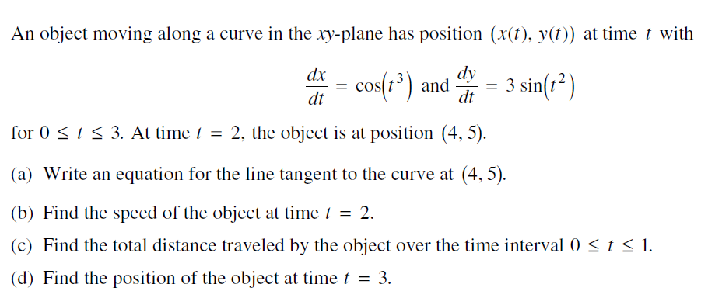

EXAMPLE 5: (No Calculator)

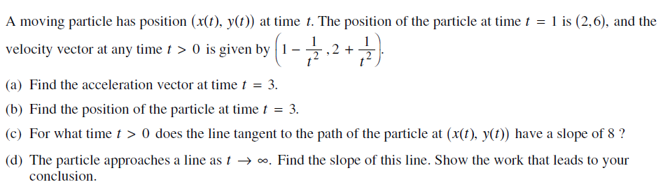

CH10 LESSON 2 HOMEWORK
1 (No Calculator). The position of a moving particle in the xy-plane is given by parametric equations $x(t)=9\text{cos}t$ and $y(t)=4\text{sin}t$for $t≥0$.
A. Find the speed of the particle at $t=π/3$
B. Find the acceleration vector at $t=3$.

2 (No Calculator). A particle moves in the xy-plane so that any time t, t > 0, its coordinates are $x=e^{t}\text{sin}t$ and $y=e^{t}\text{cos}t$. Find the velocity vector at $t=π$.

3 (No Calculator). The velocity vector of a particle moving in the xy-plane is given by $\vec{v}=\left\langle 2\text{sin}t,3\text{cos}t\right\rangle$for $t≥0$. At t = 0, the particle is at the point (1, 1). What is the position vector at t = 2?

4 (Calculator Required). The velocity vector of a particle moving in the xy-plane is given by $\vec{v}=\left\langle \sqrt{1+t^{2}}\text{,sin}\left(e^{t}−4\right)\right\rangle$for $t≥0$. At t = 0, the particle is at the point (-3, 1). What is the position vector at t = 2?
HW #5 (Calculator Required)
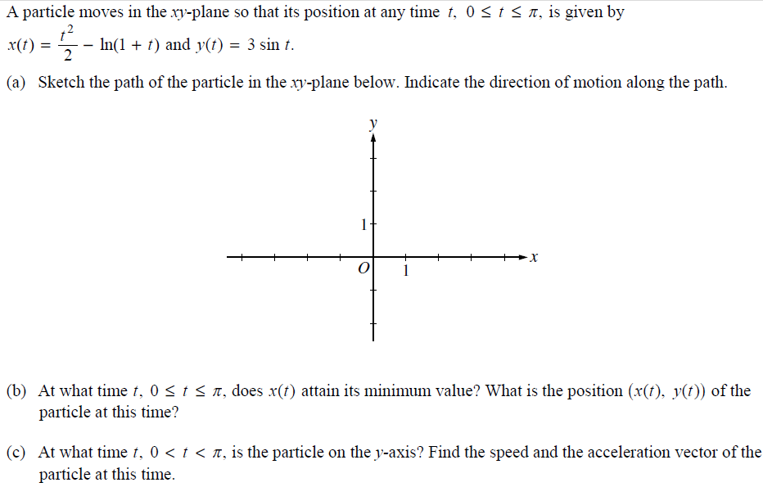

HW #6 (No Calculator)
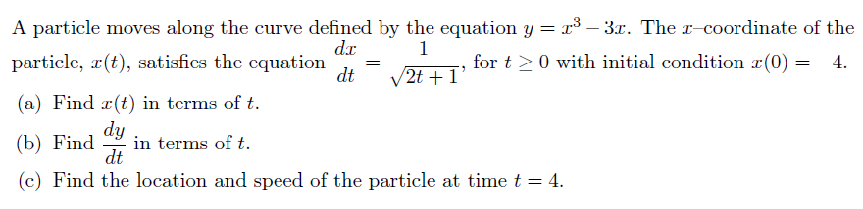

HW #7 (Calculator Required)
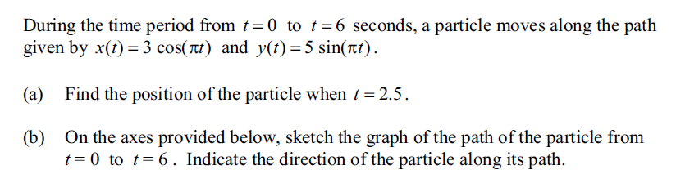
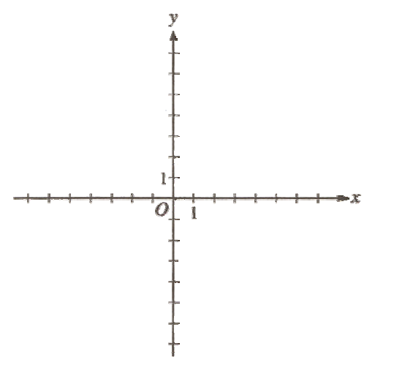

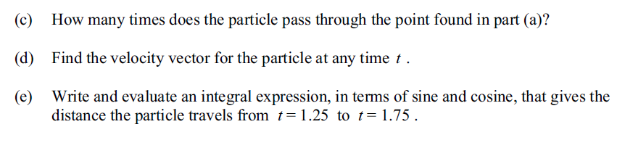

BC: Q403 CHAPTER 10 – LESSON 3 (10.3)
Notes Outline for Polar Calculus

Polar Function: $r=f(θ)$
For $r≥0$and $θ≥0$:
r at point P is the distance from the origin to the point P.
$θ$ at point P is the counterclockwise angle between the x-axis and the line segment connecting the origin and a point

1. Graph the following given in polar form: ($2,π/3$); ($−3,π$ ); $r=2$; $θ=π/4$; $r=2+2\text{cos}θ$

2. Covert each polar point to a Cartesian point: $(\sqrt{2},π/4$); (1,0); $\left(−3,5π/6\right)$
Notes: $x=r\text{cos}θ$ and $y=r\text{sin}θ$, but why?

3. Convert each polar equation to a Cartesian equation:
Notes: $x^{2}+y^{2}=r^{2}$, but why?
a. $r\text{sin}θ=0$ 10.5 #19
b. $r=4\text{csc}θ$ 10.5 #21
c. $r\text{cos}θ+r\text{sin}θ=1$ 10.5 #23
What is the domain of f($θ$) to complete exactly one revolution of the curve? Is it $0≤θ≤π$ or is it $0≤θ≤2π$? Each curve is different. Use polar MODE to graph. Use WINDOW to check from $α=0$ to $β=π$ or $2π$.
See page 557: 11-20
d. 10.5 #25
e. 10.5 #27
f. $r=a\text{sin}θ$ BERMEL
g. $r=\text{cot}θ\text{csc}θ$ 10.5 #28

4. (a) Sketch $r=2+2\text{cos}θ$
Derive formula for $\text{dy}/\text{dx}$: (b) Find $\text{dy}/\text{dx}$for $r=2+2\text{cos}θ$
Derive formula for area enclosed: (c) Find the area enclosed by $r=2+2\text{cos}θ$
(d) Find the area inside $r=2+2\text{cos}θ$ but outside $r=3$.
(e) Find the area outside $r=2+2\text{cos}θ$ but inside $r=3$.
(f) Find the area inside both $r=2+2\text{cos}θ$ and $r=3$.
*Derive formula for polar length: (g) *Find the length of $r=2+2\text{cos}θ$ on $0≤θ≤2π$.

5. Convert from Cartesian to Polar
(-1 , 1); ($1,−\sqrt{3}$); (0, 3)
HOMEWORK in TEXTBOOK
Section 10.3: 41, 46, 47, 53, 56, 57, 58, 59
Section 10.3: 1 – 9 odd; 21 -29 odd, 16, 17
$y=x$
$x=7$
$$x^{2}+y^{2}=4$$
$$\frac{x^{2}}{9}+\frac{y^{2}}{4}=1$$
$$x^{2}+(y−2)^{2}=4$$

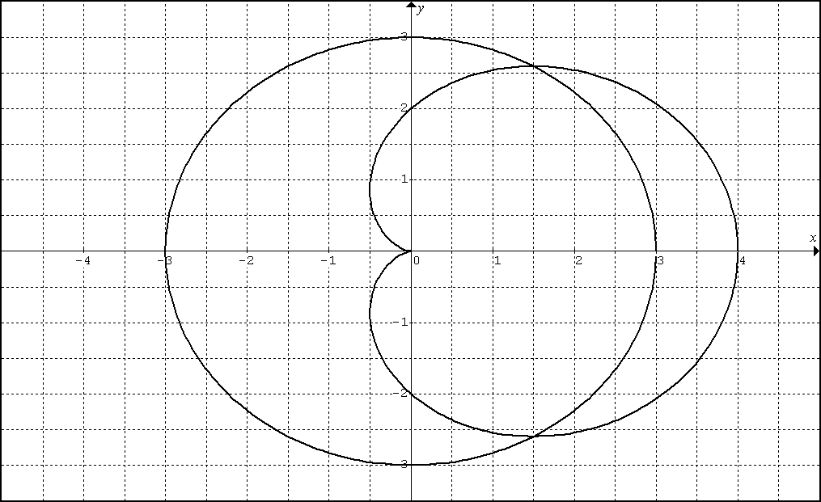

BC: Q403 CHAPTER 10 – LESSON 4 (REVIEW)
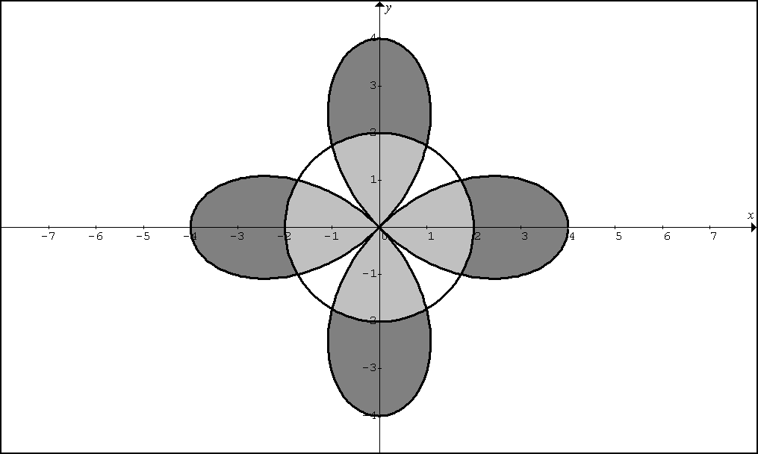

1. The diagram above shows the graphs of $r=4\text{cos}(2θ)$and $r=2$. Set up, but do not evaluate, an expression involving one or more integrals, used to find the area of the light shaded region.

2. Revisit HW #47 Find the area within one loop of $r^{2}=4\text{cos}(2θ)$

3. Text Problem #48. Find the area inside the curve $r^{2}=2\text{sin}(3θ)$.

4. Consider $r=3\text{cos}(θ)+2$. Set up, but do not evaluate, an expression involving one or more integrals used to find the area inside the large loop but outside the small loop.
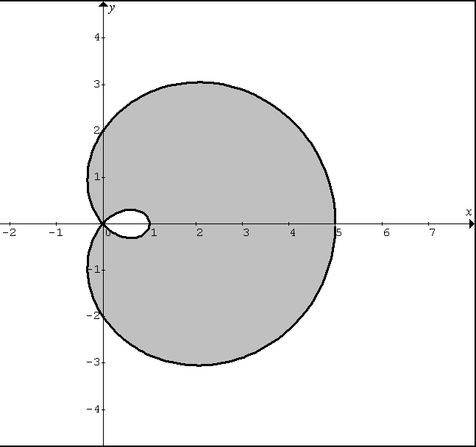

CHAPTER 10 [THE BASICS] REVIEW

1(NC). A curve is parametrized by $x=t^{2}+5$and $y=e^{2t}$.
A. Find $\frac{\text{dy}}{\text{dx}}$ B. Find $\frac{d^{2}y}{{\text{dx}}^{2}}$
2(NC). Find the length of the curve parametrized by $x=\frac{1}{6}{\left(4t+1\right)}^{3/2}$and $y=t^{2}$on $1≤t≤5$.
3(Calc). A curve is generated by $x=\text{12}t$and $y=\frac{t^{2}}{2}+4$on $5≤t≤9$. Find the area of the surface generated by revolving the curve about the y-axis.

7. The position vector of a particle in the plane is given by $\vec{r}(t)=\left[\text{ln}\left(t+2\right)\right]i+\left[t^{2}−2\right]j$ on $−2<t≤2$
A(Calc). Draw the graph of the particle.
B(NC). Find the velocity and acceleration vectors.

8(NC). Solve the initial value problem for r as a vector function of t. $\frac{\text{dr}}{\text{dt}}=\left\langle 3e^{3t},2t\right\rangle , \vec{r}(0)=\left\langle 1,−4\right\rangle$.

9(Calc). At time t = 1, a particle starts has the position (1,2) and continues to moves along a curve C. The velocity of a particle moving along the curve C is given by: $\vec{v}(t)=\left\langle \text{ln}\sqrt{t},−\text{cos}(e^{t})\right\rangle$. Find the position of the particle at time t = 3.1.

12(Calc). Graph the polar curve given by $r=1+2\text{cos}(2θ)$.

13(NC). Suppose a polar graph is symmetric about the x-axis and contains the point $\left(4,\frac{π}{6}\right)$. Which of the following identifies another point that must be on the graph?
I. $\left(4,−\frac{π}{6}\right)$ II. $\left(4,\frac{5π}{6}\right)$ III. $\left(−4,\frac{5π}{6}\right)$
(A)I only (B)II only (C)III only (D) I and II (E) I and III

14(NC). Replace the polar equation $r={\text{sec}}^{2}(θ)$by an equivalent Cartesian equation.

15(NC). Find the slope of the polar curve $r=−2\text{cos}(3θ)$at $θ=\frac{π}{6}$

16(Calc). Find the area of the region enclosed by the oval limacon $r=5−2\text{cos}θ$.

17(NC … check with Calc). Find the length of the polar curve given by $r=5{\text{sin}}^{2}\frac{θ}{2}$ for

