BC: Q402.CH9B – Power Series: Writing Power Series (LESSON 1)

Power Series:

An expression of the form
$\sum_{n=0}^{∞}{c_{n}x^{n}=}c_{0}+c_{1}x+c_{2}x^{2}+⋅+c_{n}x^{n}+⋅$is a power series centered at $x=0$.

An expression of the form
$\sum_{n=0}^{∞}{c_{n}(x−a)^{n}=}c_{0}+c_{1}(x−a)+c_{2}(x−a)^{2}+⋅+c_{n}(x−a)^{n}+⋅$is a power series centered at $x=a$.

I. Write a Power Series:

- GEOMETRIC SUM: Using properties of a Geometric Series Sum
- RAW CONSTRUCTION: Using Raw (Maclaurin) Construction – compile a set of memorized Maclaurin Series
- MANIPULATE KNOWN: Using Manipulation (integral or derivative) of a known power series
- SUBSTITUTE KNOWN: Using Substitution into a known power series.

II. Write an nth order polynomial:

- GEOMETRIC SUM: Using properties of a Geometric Series Sum
- RAW CONSTRUCTION: Using Raw (Maclaurin) Construction – compile a set of memorized Maclaurin Series
- MANIPULATE KNOWN: Using Manipulation (integral or derivative) of a known power series
- SUBSTITUTE KNOWN: Using Substitution into a known power series.
Power Series:

An expression of the form
$\sum_{n=0}^{∞}{c_{n}x^{n}=}c_{0}+c_{1}x+c_{2}x^{2}+⋅+c_{n}x^{n}+⋅$is a power series centered at $x=0$.

An expression of the form
$\sum_{n=0}^{∞}{c_{n}(x−a)^{n}=}c_{0}+c_{1}(x−a)+c_{2}(x−a)^{2}+⋅+c_{n}(x−a)^{n}+⋅$is a power series centered at $x=a$.

Definition: Taylor Series Generated by f at $x=a$

Let f be a function with derivatives of all orders throughout some open interval containing a. Then the Taylor series generated by f at $x=a$ is

$$f(a)+f^{}(a)(x−a)+\frac{f^{\text{//}}(a)}{2!}(x−a)^{2}+\text{.}\text{.}\text{.}+\frac{f^{(n)}(a)}{n!}(x−a)^{n}+\text{.}\text{.}\text{.}=\sum_{k=0}^{∞}{\frac{f^{(k)}(a)}{k!}(x−a)^{k}\text{.}}$$

The partial sum $P_{n}(x)=\sum_{k=0}^{n}{\frac{f^{(k)}(a)}{k!}(x−a)^{k}}$is the Taylor polynomial of order n for f at $x=a\text{.}$

Definition: Taylor Series Generated by f at $x=0$ (Maclaurin Series)

Let f be a function with derivatives of all orders throughout some open interval containing 0. Then the Taylor series generated by f at $x=0$ is

$$f(0)+f^{}(0)x+\frac{f^{\text{//}}(0)}{2!}x^{2}+\text{.}\text{.}\text{.}+\frac{f^{(n)}(0)}{n!}x^{n}+\text{.}\text{.}\text{.}=\sum_{k=0}^{∞}{\frac{f^{(k)}(0)}{k!}x^{k}\text{.}}$$

This series is also called the Maclaurin Series generated by f at $x=0\text{.}$

The partial sum $P_{n}(x)=\sum_{k=0}^{n}{\frac{f^{(k)}(0)}{k!}x^{k}}$is the Taylor polynomial of order n for f at $x=0\text{.}$

I. Write a Power Series:
A.GEOMETRIC SUM: Using properties of a Geometric Series Sum
Give a power series representation of …

I. Write a Power Series:
B. RAW CONSTRUCTION: Using Raw (Maclaurin) Construction
$$f(x)=f(0)+f^{}(0)x+\frac{f^{\text{//}}(0)x^{2}}{2!}+\frac{f^{\text{///}}(0)x^{3}}{3!}+⋅+\frac{f^{n}(0)x^{n}}{n!}+⋅$$
Give a power series representation of …

I. Write a Power Series:
C. MANIPULATE KNOWN: Using Manipulation (integral or derivative) of a known
Give a power series representation of …

I. Write a Power Series:
D. SUBSTITUTE KNOWN: Using Substitution into a known power series.
Give a power series representation of …

II. Write an nth order polynomial:
Give a 7th order Taylor Polynomial for $\text{sin}x$

Give a 6th order Taylor Polynomial for $\text{cos}x$

HW:
PG. 483: #55, 57, 59, 72, 63, 64
PG. 492: #3, 5, 7, 10, 12, 22, 24, 27

BC: Q402 – CH9B: Lesson 1 continued - A Closer Look
1. Find a power series for $f(x)=\text{ln}(1+x)$centered at $x=0\text{.}$

2. Suppose $g^{}(x)=\frac{1}{1+x}$ with $g(0)=5$and domain $−1<x<1$. Find a power series for the function $g(x)$centered at $x=0\text{.}$

Connection: In #1 the particular function was given already: $f(x)=\text{ln}(1+x)$ with $f(0)=0$.
In #2 the particular function was not given, so we needed a condition to find it.
BC: Q402 – CH9B LESSON2
Memorize | Substitute into Memorized Maclaurin | Raw Construction

Taylor Series:

1. $f(x)=\text{cos}(x)$ Natural Center:

A. Write a fourth order Taylor polynomial for $f(x)=\text{cos}(x)$centered at $x=0$

B. Write a third order Taylor polynomial for $f(x)=\text{cos}(x)$centered at $x=\frac{π}{4}$

2. $f(x)=\text{cos}\left(x−\frac{π}{4}\right)$ Natural Center:

A. Write a second order Taylor polynomial for $f(x)=\text{cos}\left(x−\frac{π}{4}\right)$centered at $x=0$

B. Write a fourth order Taylor polynomial for $f(x)=\text{cos}\left(x−\frac{π}{4}\right)$centered at $x=\frac{π}{4}$
3. $f(x)=e^{5x}$ Natural Center:

A. Write a third order Taylor polynomial for $f(x)=e^{5x}$centered at $x=0$

B. Write a third order Taylor polynomial for $f(x)=e^{5x}$centered at $x=1$

4. $f(x)=e^{\left(x−2\right)}$ Natural Center:

A. Write a third order Taylor polynomial for $f(x)=e^{\left(x−2\right)}$centered at $x=0$

B. Write a third order Taylor polynomial for $f(x)=e^{\left(x−2\right)}$centered at $x=2$

HW

1. Let $P(x)=7−3(x−4)+5(x−4)^{2}−2(x−4)^{3}+6(x−4)^{4}$be the fourth-degree Taylor polynomial for the function f about 4. Assume f has derivatives of all orders for all real numbers.

- Find $f(4)$and $f^{\text{///}}(4)$.
- Write the second-degree Taylor polynomial for $f^{}$about 4 and use it to approximate $f^{}(4\text{.}3)$
- Write the fourth-degree Taylor polynomial for $g(x)=\int_{4}^{x}{f(t)}\text{dt}$about 4.

2. Let f be a function that has derivatives of all orders for all real numbers. Assume $f(0)=5,f^{}(0)=−3,f^{\text{//}}(0)=1,f^{\text{///}}(0)=4\text{.}$

- Write the third-degree Taylor polynomial for f about $x=0$ and use it to approximate f(0.2).
- Write the fourth-degree Taylor polynomial for g, where $g(x)=f(x^{2})$, about $x=0\text{.}$
- Write the third-degree polynomial for h, where $h(x)=\int_{0}^{x}{f(t)\text{dt}}$, about $x=0$.
- Suppose $r^{}(x)=f(x)$with $r(0)=\text{10}$. Write a third-degree polynomial for r about $x=0$.

3. The Maclaurin series $f(x)$ is given by $1+\frac{x}{2!}+\frac{x^{2}}{3!}+\frac{x^{3}}{4!}+⋅+\frac{x^{n}}{(n+1)!}+⋅$

- Find $f^{}(0)$ and $f^{(\text{17})}(0)\text{.}$
- Let $g(x)=\text{xf}(x)\text{.}$ Write the Maclaurin series for g(x) , showing the first three nonzero terms and the general term.
- Write g(x) in terms of a familiar function without using series. Then, write f(x) in terms of the same familiar function.
- For what values of x does the given series for f(x) converge? Show your reasoning.

Textbook: Pg. 492 # 4, 14, 19, 21, 23, 33, and 34
BC: Q402.CH9B – Taylor Series: Error Analysis (LESSON 3)

THM E1: Alternating Series Bound

If a series for is strictly alternating and decreasing in absolute value to zero, the error in using to approximate is less than or equal to the first omitted non-zero term:

with

THM E2: Taylor’s Formula with Remainder
The error in using to approximate is equal to for some value c where c is between the center a and the value of (inclusive).

with for

Consequently: for

ERROR ANALYSIS (E1: Alternating Series Bound)
1.
A. Use a 5th order Taylor polynomial centered at to estimate .
B. Show that the estimate in part A differs from by no more than .

2. Approximate $\int_{0}^{1}{\text{sin}(x^{2})\text{dx}}$to four decimal places. Estimate the error.

3. Let f be the function defined by $f(x)=\frac{1}{x−1}$.
  - Write the first four terms and the general term of the Taylor series expansion of f(x) about $x=2$.
  - Use the result from part (a) to find the first four terms and the general term of the series expansion about $x=2$for $\text{ln}|x−1|$.
  - Use the series in part (b) to compute a number that differs from $\text{ln}\frac{3}{2}$by less than 0.05. Justify your answer.

4. The Taylor series about $x=5$ for a certain function f converges to f(x) for all x in the interval of convergence. The nth derivative of f at x = 5 is given by $f^{(n)}(5)=\frac{(−1)^{n}n!}{2^{n}(n+2)}$, and $f(5)=\frac{1}{2}$.

- Write the third-degree Taylor polynomial for f about x = 5.
- Find the radius of convergence of the Taylor series for f about x = 5.
- Show that the sixth-degree Taylor polynomial for f about x = 5 approximates f(6) with error less than $\frac{1}{\text{1000}}\text{.}$
5. The function f is defined by the power series $f(x)=\sum_{n=0}^{∞}{\frac{{\left(−1\right)}^{n}x^{2n}}{\left(2n+1\right)!}}$ for all real numbers.

(a). Find $f^{}(0)$ and $f^{\text{//}}(0)$. Determine whether f has a local maximum, a local minimum, or neither at $x=0$. Give a reason for your answer.
(b). Show that $1−\frac{1}{3!}$ approximates $f(1)$with error less than $\frac{1}{\text{100}}$.
(c) Show that $y=f(x)$is a solution to the differential equation ${\text{xy}}^{}+y=\text{cos}x$.
ERROR ANALYSIS (E2: Lagrange Error Bound)
6.
A. Use a 5th order Taylor polynomial centered at to estimate .
B. Show that the estimate in part A differs from by no more than .

7.
A. Use a 2nd order Taylor polynomial centered at to estimate .
B. Show that .

8.
A. Use a 1st order Taylor polynomial centered at to estimate .
B. Show that

9.
A. Use a 3rd order Taylor polynomial centered at to estimate .
B. Show that.

CALCULATOR ACTIVE
10. Let h be a function having derivatives of all orders for $x>0$. Select values of h and its first four derivatives are indicated in the table above. The function h and these four derivatives are increasing on the interval $1≤x≤3$.
A. Write the first-degree Taylor polynomial for h about $x=2$and use it to approximate $h(1\text{.}9)$. Is this approximation greater than or less than $h(1\text{.}9)$? Explain your reasoning.
B. Write the third-degree Taylor polynomial for h about $x=2$ and use it to approximate $h(1\text{.}9)$.
C. Use the Lagrange error bound to show that the third-degree Taylor polynomial for h about $x=2$ approximates $h(1\text{.}9)$ with error less than $3×{\text{10}}^{−4}$.
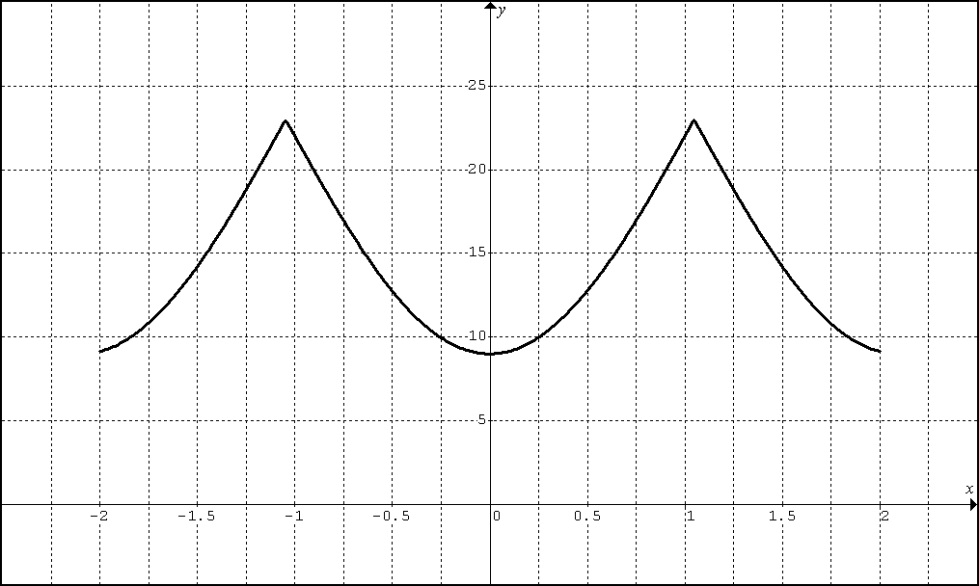
11. Consider a function $f(x)$ which has non-zero real derivatives of all orders. A graph of $\left|f^{\text{///}}(x)\right|$on (-2,2) is show above. Show that $\left|f(0\text{.}5)−P_{2}(0\text{.}5)\right|<\frac{3}{8}$ where P₂(x) is a Taylor polynomial of second degree centered at zero.

12. Use the first two nonzero terms of the Maclaurin series to approximate sin(x).
Estimate the maximum error if |x|<1.

