BC.Q302. LESSON 1 - Section 7.2 (AREA BETWEEN CURVES)

THM: If f and g are continuous and $f(x)≥g(x)$for every x in [a, b], then the area A of the region bounded by the graphs of f, g, x =a, and x = b is $A=\int_{a}^{b}{[f(x)−g(x)]\text{dx}}\text{.}$

NON CALCULATOR SECTION

Example 1: Set up, but do not evaluate, the expression used to find the area of region bounded by the graphs of $y=x^{2}$ and $y=\sqrt{x}\text{.}$

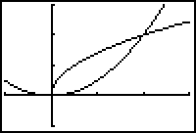

Example 2: Set up, but do not evaluate, the expression used to find the area of region bounded by the graphs of $y+x^{2}=6$ and $y+2x−3=0$.

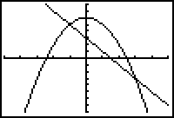

Example 3: Set up, but do not evaluate, the expression used to find the area of region bounded by the graphs of $y=x+6$ and $y=x^{3}$and $y=−\frac{x}{2}$.

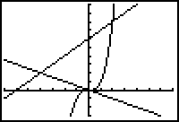

Example 4: Set up, but do not evaluate, the expression used to find the area of region bounded by the graphs of$x=2y^{3}−y^{4}$ and $y^{2}−2y=x$.

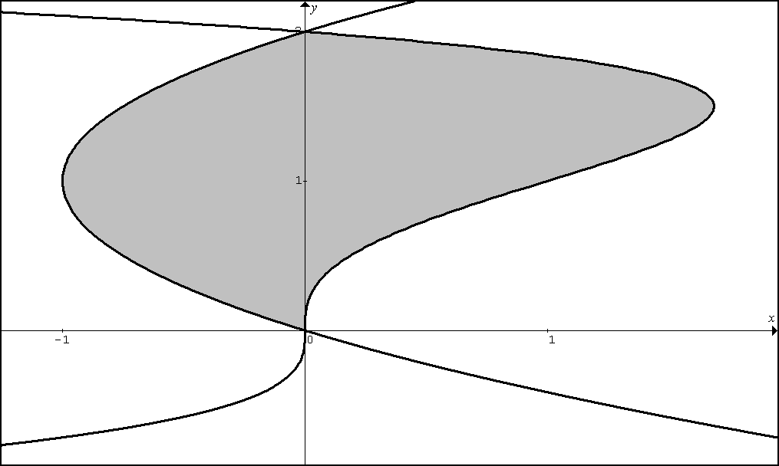

CALCULATOR ACTIVE SECTION

Example 5: Find the area for the region of the plane bounded by the curves
$f(x)=\text{cos}(0\text{.}3x^{2})$ and $g(x)=x^{2}+0\text{.}6x−2$.

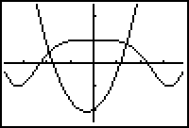

Example 6: Find the area bounded by $f(x)=\text{cos}(x)$, $g(x)=0\text{.}4+\text{sin}\left(πx−5\right)$, $x=0$ and $x=1\text{.}\text{48858}$

1. NO CALCULATOR. Let R be the shaded region enclosed by the graphs of , , and the y-axis as shown in the figure below. Find the area of region R.
BC:Q302 LESSON 1 HOMEWORK
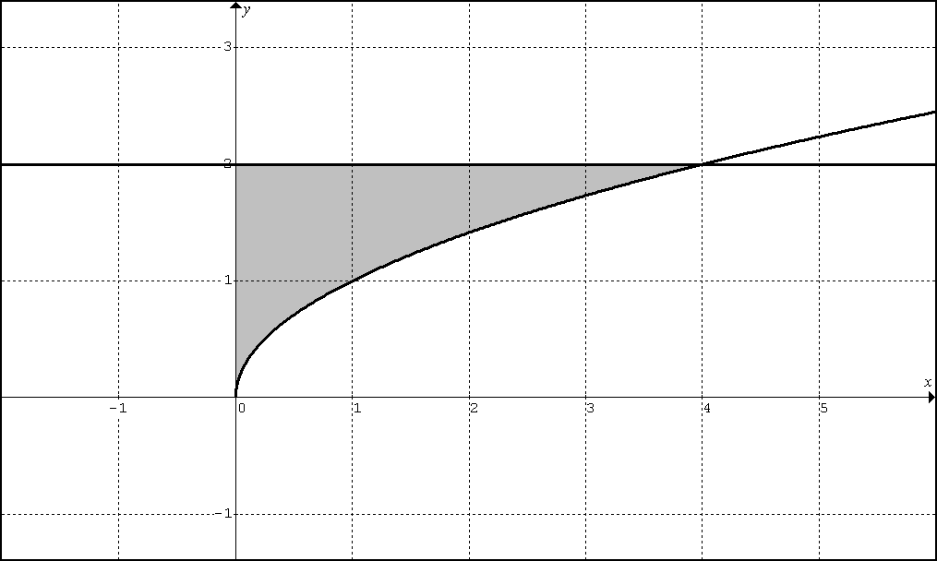

2. NO CALCULATOR. Let R be the shaded region enclosed by the graphs of , , and the x-axis as shown in the figure below. Find the area of region R.

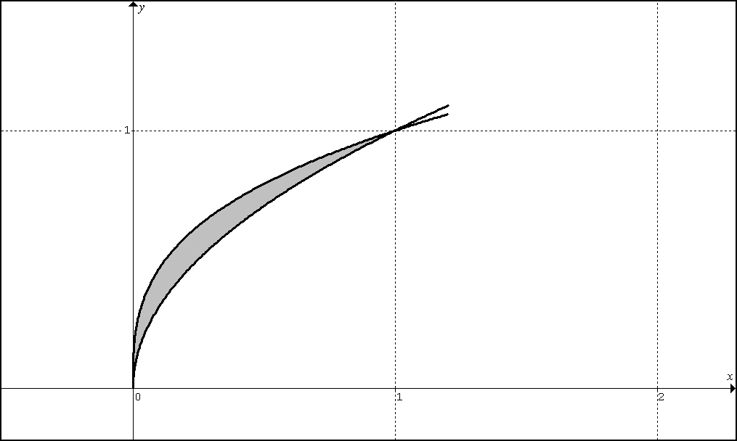

3. NO CALCULATOR. Let R be the shaded region enclosed by the graphs of , , and the x-axis as shown in the figure below. Find the area of region R.

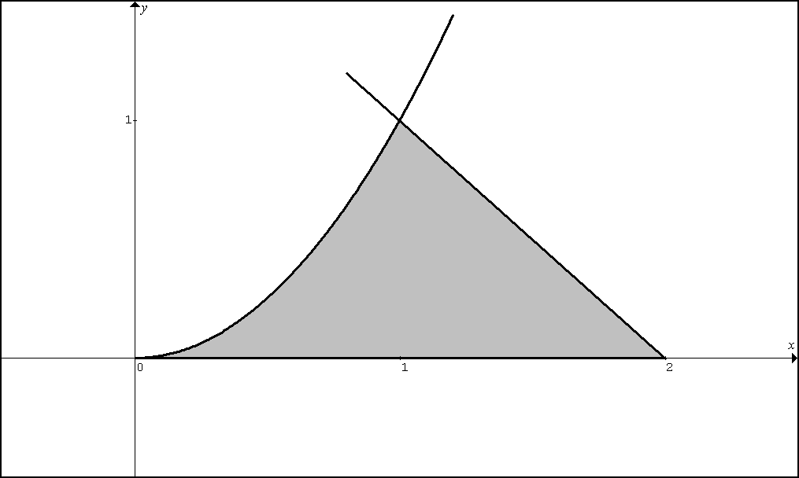

4. NO CALCULATOR. Let R be the shaded region enclosed by the graphs of the odd functions and as shown in the figure below. Find the area of region R.
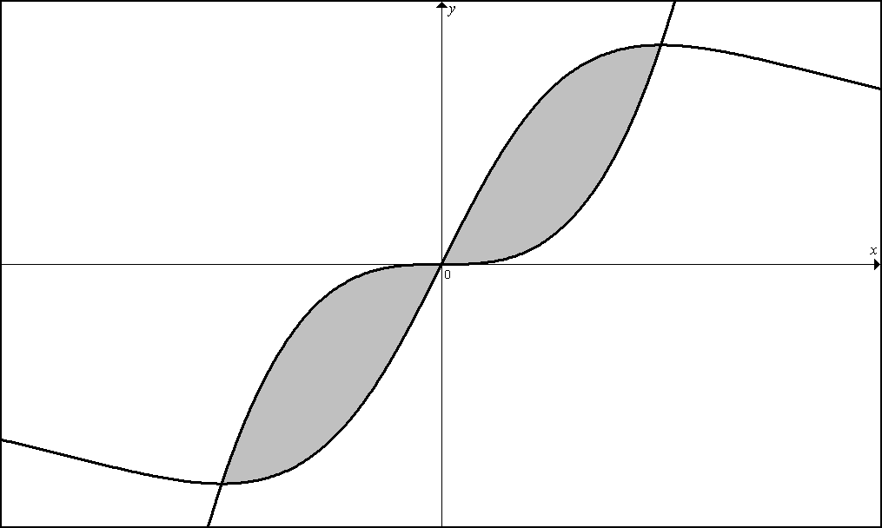
Note: the graphs intersect at (1,1)

5. CALCULATOR PERMITTED. Let R be the shaded region enclosed by the graphs of andas shown in the figure below. Find the area of region R.
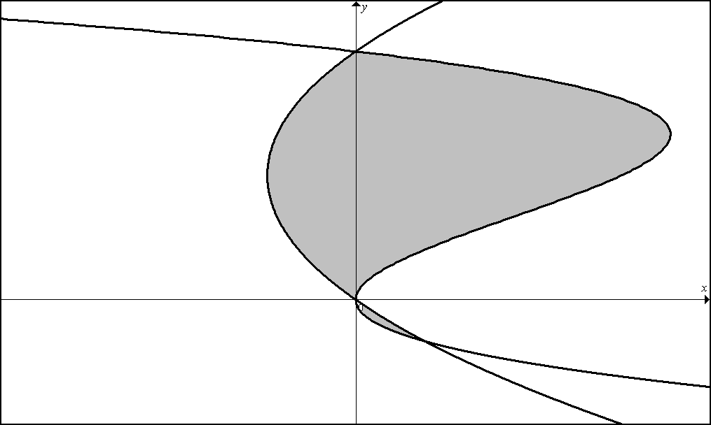
(If you are up for an extreme arithmetic challenge, try to find the answer to #5 without a calculator)

6. CALCULATOR REQUIRED Let R be the shaded region in the first quadrant enclosed by the graphs of $x=\sqrt{−\text{ln}(y/8)}$ and $f(x)=2+\text{cos}(3x−π/2)$as shown in the figure below. Find the area of region R. Hint: You must perform preliminary work before using your calculator.

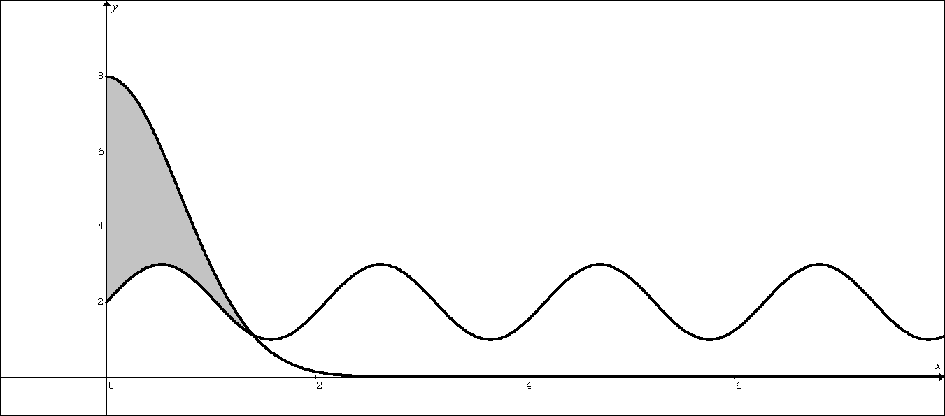

BC.Q302. LESSON 2 - Section 7.3 (Solids of Revolutions)

CIRCULAR DISC

Volume of a Circular disc: V=

Example 1: The region bounded by the x-axis, the graph of , and the lines and is revolved about the x-axis. Find the volume of the resulting solid.
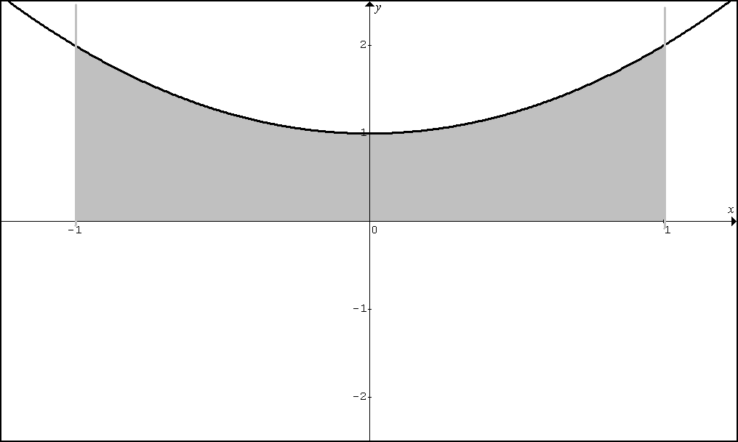

Example 2: The region bounded by the y-axis and the graphs of andis revolved around the y-axis. Find the volume of the resulting solid.

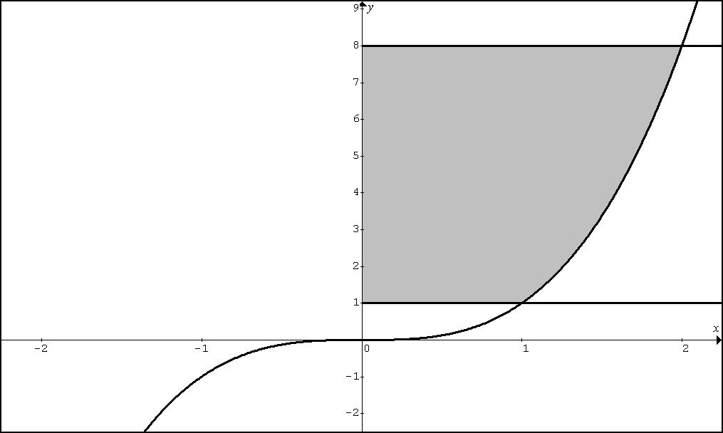
WASHER

Volume of a Washer: V =
Consider the region R bounded by the graphs of the equations and and the vertical lines and for examples 3 – 5.

Set up, but do not evaluate, an integral expression used to find the volume of the solid.

Example 3: The region R is revolved around the x-axis.
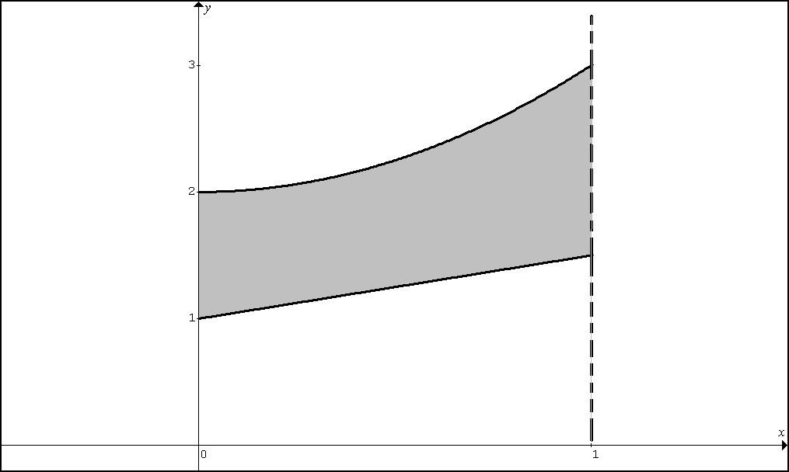

Example 4: The region R is revolved about

Example 5: The region R is revolved about .

Consider the region R in the first quadrant bounded by the graphs of and for examples 6 – 10.
Set up, but do not evaluate, an integral expression used to find the volume of the solid.

Example 6: Region R is revolved about the x-axis.
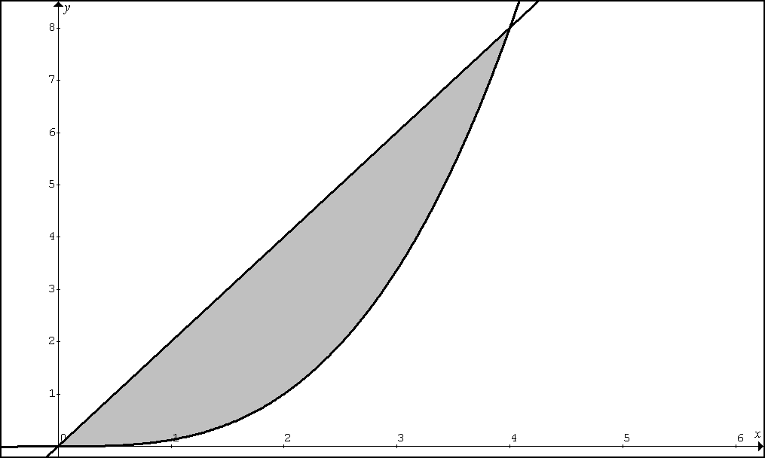

Example 7: Region R is revolved about the line .

Example 8: The region in example 6 is revolved about the line .

Example 9: The region in example 6 is revolved about the y-axis.

Example 10: The region in example 6 is revolved about the line .
CALCULATOR ACTIVE
(AB) Example 11: The region bounded by the graphs of and is revolved about the line$y=\text{18}$. Set up and evaluate the integral to find the volume of the resulting solid.

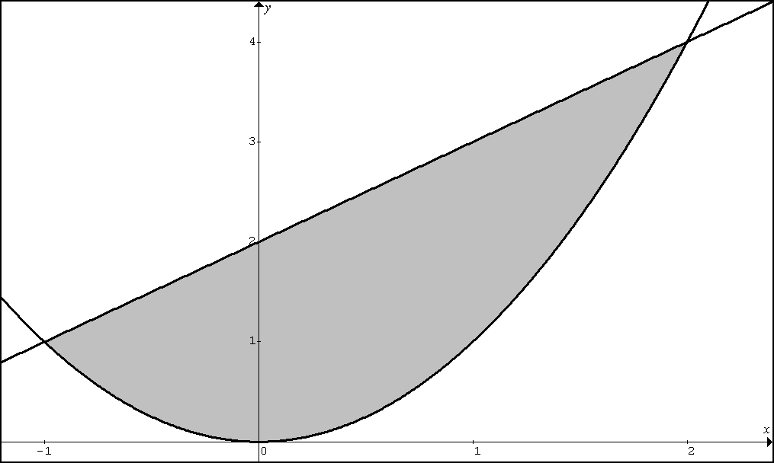

CALCULATOR ACTIVE
(AB) Example 12: The region in the first quadrant bounded by the graph of the equation $x=2y^{3}−y^{4}$and the y-axis is revolved about the line$x=2$. Set up and evaluate the integral to find the volume of the resulting solid.
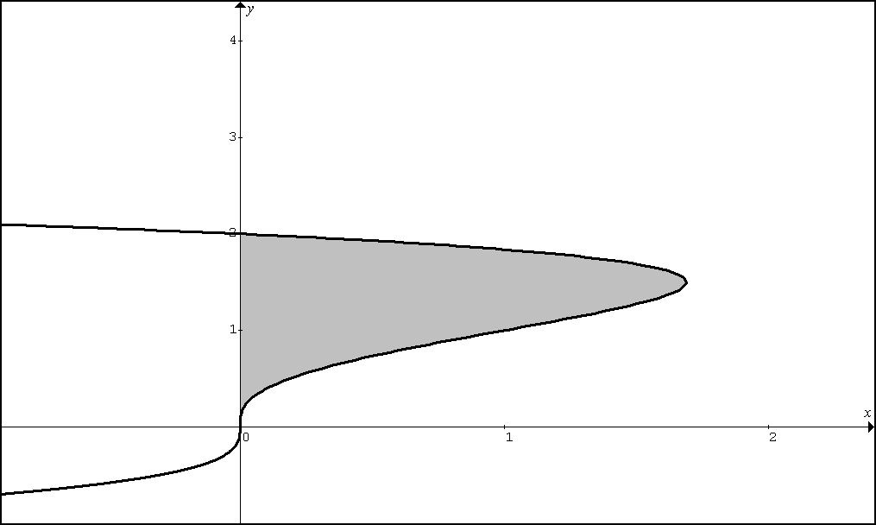
CYLINDRICAL SHELLS

Washers versus Cylindrical Shells

More Visualization and Determining Shape: “With the grain” or “Against the grain”.
Volumes by Cylindrical Shells:

Volume of a Cylindrical Shell: V =

Let f be continuous and suppose on the interval [a, b], where Let R be the region under the graph of f from a to b. Find the volume V of the solid of revolution generated by revolving R about the (a) the y-axis is (b) the line x = k >b and (c) the line x = v < a

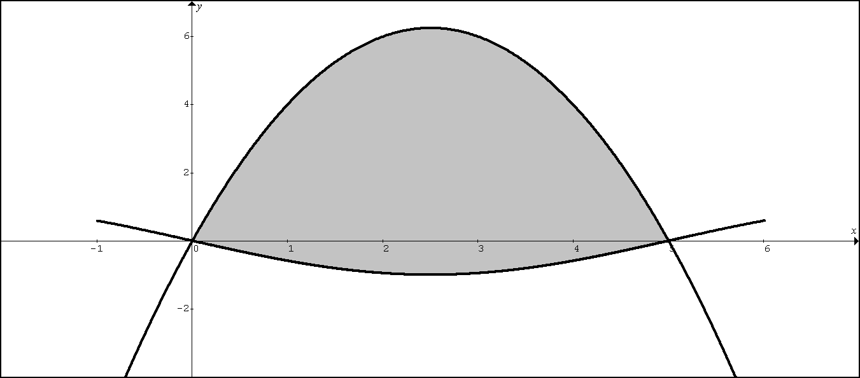
Example 11: Consider the region R bounded by the graphs of $y=5x−x^{2}$and $y=−\text{sin}\left(\frac{πx}{5}\right)$as shown by the shaded region above.

A. Set up, but do not evaluate, an expression involving one or more integrals used to find the volume of the solid generated when the region R is revolved about the line $y=9$.

B. Set up, but do not evaluate, an expression involving one or more integrals used to find the volume of the solid generated when the region R is revolved about the $y$axis.

C. Set up, but do not evaluate, an expression involving one or more integrals used to find the volume of the solid generated when the region R is revolved about the line $x=6$.

D. Set up, but do not evaluate, an expression involving one or more integrals used to find the volume of the solid generated when the region R is revolved about the line $x=−1$.

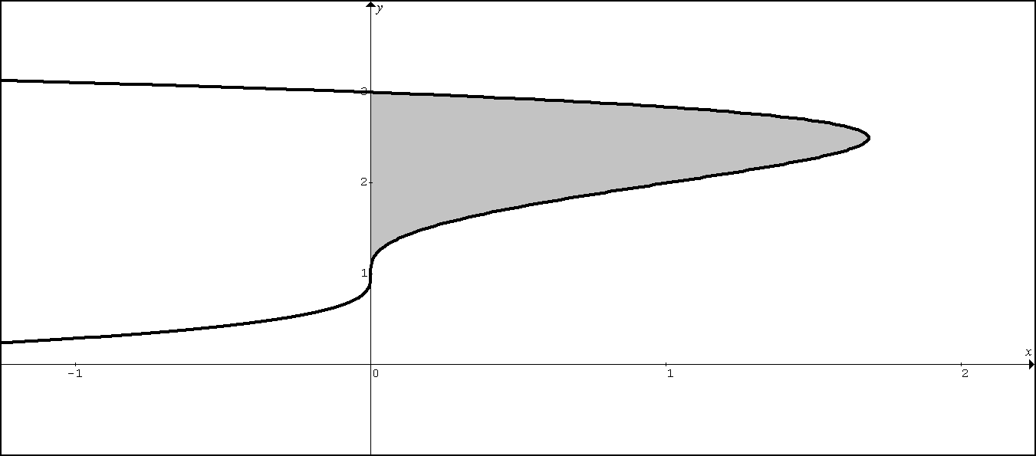
Example 12: Consider the region R bounded by the graphs of $x=2(y−1)^{3}−(y−1)^{4}$and the
y – axis as shown by the shaded region above.

A. Set up, but do not evaluate, an expression involving one or more integrals used to find the volume of the solid generated when the region R is revolved about the line $x=−1$.

B. Set up, but do not evaluate, an expression involving one or more integrals used to find the volume of the solid generated when the region R is revolved about the $x$axis.

C. Set up, but do not evaluate, an expression involving one or more integrals used to find the volume of the solid generated when the region R is revolved about the line $y=4$.

D. Set up, but do not evaluate, an expression involving one or more integrals used to find the volume of the solid generated when the region R is revolved about the line $y=−1$.

1. Let R be the shaded region enclosed by the graphs of , , and the y-axis as shown in the figure above.
BC.Q302.CH7.LESSON 2 HOMEWORK

a. Find the area of region R. LESSON 1

b. Set up, but do not solve and expression involving one or more integrals, use to find the volume of the solid if R is revolved around the x-axis.

c. Set up, but do not solve and expression involving one or more integrals, use to find the volume of the solid if R is revolved around the line y = 3.

d. Set up, but do not solve and expression involving one or more integrals, use to find the volume of the solid if R is revolved around the line y = -1.

e. Set up, but do not solve and expression involving one or more integrals, use to find the volume of the solid if R is revolved around the y – axis.

f. Set up, but do not solve and expression involving one or more integrals, use to find the volume of the solid if R is revolved around the line x = 5.

g. Set up, but do not solve and expression involving one or more integrals, use to find the volume of the solid if R is revolved around the line x = -2.

2. Let R be the shaded region enclosed by the graphs of , , and the x-axis as shown in the figure above.

a. Find the area of region R. . LESSON 1

b. Set up, but do not solve and expression involving one or more integrals, use to find the volume of the solid if R is revolved around the x-axis.

c. Set up, but do not solve and expression involving one or more integrals, use to find the volume of the solid if R is revolved around the line y = 8.

d. Set up, but do not solve and expression involving one or more integrals, use to find the volume of the solid if R is revolved around the line y = -2.

e. Set up, but do not solve and expression involving one or more integrals, use to find the volume of the solid if R is revolved around the y – axis.

f. Set up, but do not solve and expression involving one or more integrals, use to find the volume of the solid if R is revolved around the line x = 4.

g. Set up, but do not solve and expression involving one or more integrals, use to find the volume of the solid if R is revolved around the line x = -3.

3. Let R be the shaded region enclosed by the graphs of , , and the x-axis as shown in the figure above.

a. Find the area of region R. . LESSON 1

b. Set up, but do not solve and expression involving one or more integrals, use to find the volume of the solid if R is revolved around the x-axis.

c. Set up, but do not solve and expression involving one or more integrals, use to find the volume of the solid if R is revolved around the line y = 2.

d. Set up, but do not solve and expression involving one or more integrals, use to find the volume of the solid if R is revolved around the line y = -7.

e. Set up, but do not solve and expression involving one or more integrals, use to find the volume of the solid if R is revolved around the y – axis.

f. Set up, but do not solve and expression involving one or more integrals, use to find the volume of the solid if R is revolved around the line x = 5.

g. Set up, but do not solve and expression involving one or more integrals, use to find the volume of the solid if R is revolved around the line x = -10.

CALCULTOR PERMITTED
4. Let R be the shaded region enclosed by the graphs of andas shown in the figure above. Find the volume of the solid if R is revolved around the line x = -2.

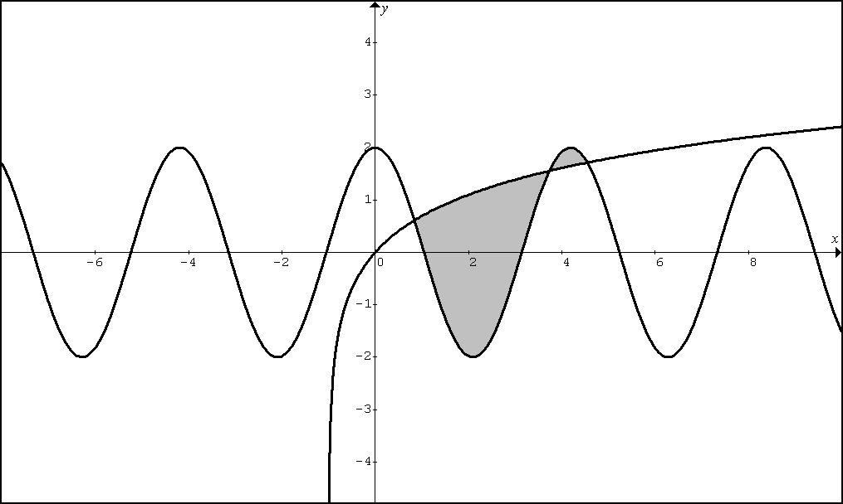
CALCULTOR REQUIRED
5. Let R be the shaded region enclosed by the graphs of and as shown in the figure above.

A. Find the area of region R.

B. Find the volume of the solid if R is revolved around the line y = π.

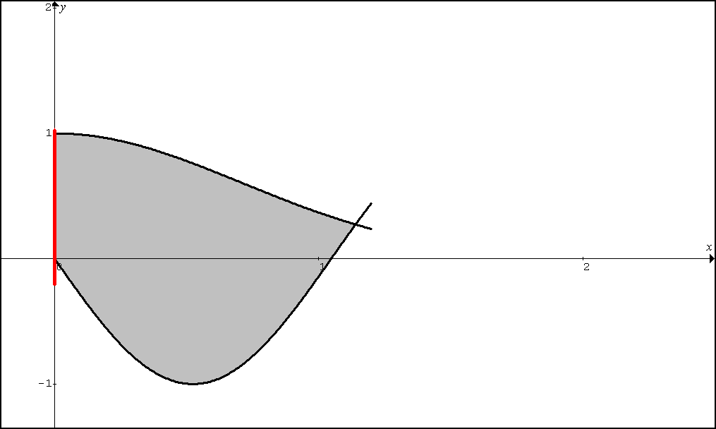
6. Let R be the shaded region enclosed by the graphs of $y=e^{−x^{2}}$, $y=−\text{sin}(3x)$, and the y-axis as shown in the figure above.

a. Find the area of region R.

b. Find the volume of the solid if R is revolved around the line y = 2.

c. Find the volume of the solid if R is revolved around the line x = 4.

d. Find the volume of the solid if R is revolved around the line x = -5.

BC.Q302. LESSON 3 - Section 7.4 (Solids with Cross Sections and Arc Length)

This question is to be completed using a calculator.

Let R be the region enclosed by the graphs of$y=\text{ln}(x^{2}+1)$ and $y=\text{cos}(x)$.

(a) Find the area of R.

(b) The base of a solid is the region R. Each cross section of the solid perpendicular to the x-axis is square. Write an expression involving one or more integrals that gives the volume of the solid. Do not evaluate.

(c) The base of a solid is the region R. Each cross section of the solid perpendicular to the x-axis is rectangle with height 5 units. Write an expression involving one or more integrals that gives the volume of the solid. Do not evaluate.

(d) The base of a solid is the region R. Each cross section of the solid perpendicular to the x-axis is a rectangle with height twice the length of its base. Write an expression involving one or more integrals that gives the volume of the solid. Do not evaluate.

(e) The base of a solid is the region R. Each cross section of the solid perpendicular to the x-axis is an equilateral triangle. Write an expression involving one or more integrals that gives the volume of the solid. Do not evaluate.

(f) The base of a solid is the region R. Each cross section of the solid perpendicular to the x-axis is semi-circle whose diameter is the base. Write an expression involving one or more integrals that gives the volume of the solid. Do not evaluate.
Derive a Formula for the Arc Length of a curve:
Let R be the region enclosed by the graphs of$y=\text{ln}(x^{2}+1)$ and $y=\text{cos}(x)$.

1. Write an expression involving one or more integrals that gives the length of the boundary of the region R. Do not evaluate.

2. Find the length of $y=\text{tan}x$ on ${−π}/3≤x≤0$.

3. Find the length of $y=\int_{0}^{x}{\sqrt{{\text{sec}}^{2}t−1}}\text{dt}$ on ${−π}/3≤x≤π/4$. (BY HAND CHALLENGE)

4. Find the length of $y=\left(1/3\right){\left(x^{2}+2\right)}^{3/2}$ from x = 0 to x = 3. (DO BY HAND)

BC: Q302 Lesson 3 Homework

No Calculator is allowed for this problem

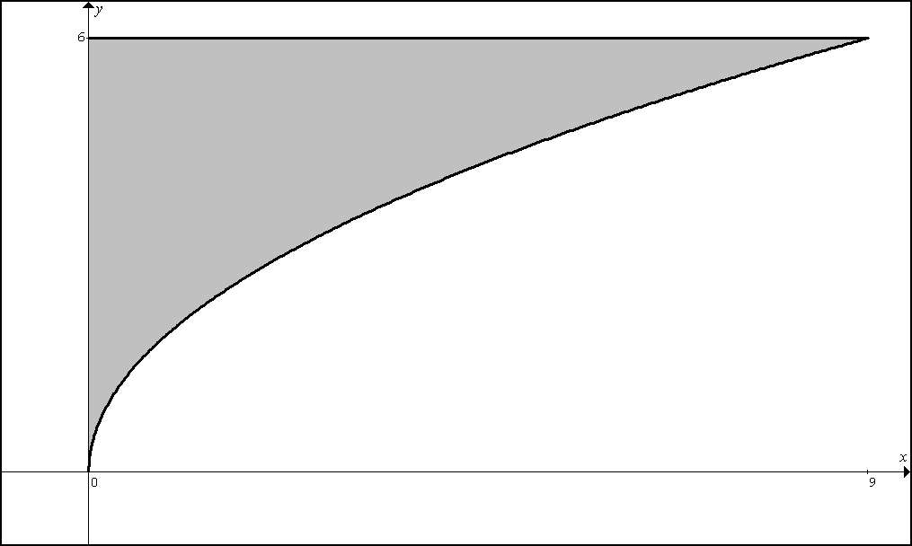

1. Let R be the region in the first quadrant bounded by the graph of $y=2\sqrt{x}$, the horizontal $y=6$, and the y = axis, as shown in the figure above.

(a) Find the area of R.
(b) Write, but do not evaluate, an integral expression that gives the volume of the solid generated when R is rotated about the horizontal line $y=7$.
(c) Region R is the base of a solid. For each y, where $0≤y≤6$, the cross section of the solid taken perpendicular to the y-axis is a rectangle whose height is 3 times the length of its base in region R. Write, but do not evaluate, an integral expression that gives the volume of the solid.
(d) Write, but do not evaluate, an expression involving one or more integrals that gives the perimeter of region R.

No Calculator is allowed for this problem

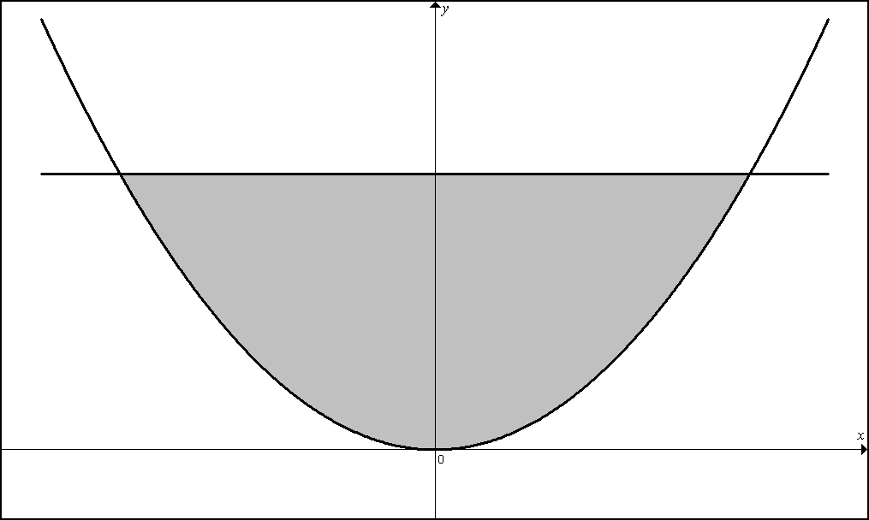

2. The shaded region, R, is bounded by the graphs of $y=x^{2}$and the line $y=4$, as shown in the figure above.

(a) Find the area of R.
(b) Find the volume of solid generated by revolving R about the x-axis.
(c) There exists a number k, $k>4$, such that when R is revolved about the line$y=k$, the resulting solid has the same volume as the solid in part (b). Write, but do not solve, an equation involving an integral expression that can be used to find the value of k.
(d) The region R is the base a solid. For this solid, every cross section perpendicular to the x-axis is a semi-circle. Write, but do not evaluate, an integral expression used to find the volume of the solid.
(e) Write, but do not evaluate, an expression involving one or more integrals that gives the perimeter of region R.

A graphing calculator is required for some parts of the problem

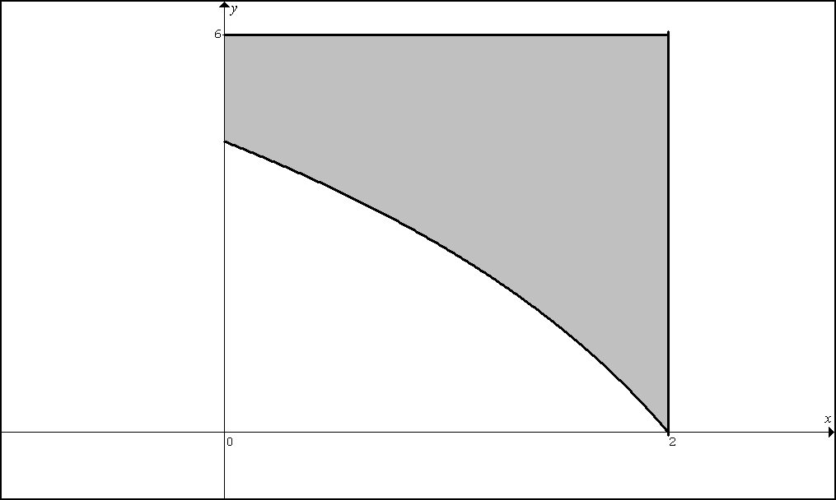

3. In the figure above, R is the shaded region in the first quadrant bounded by the graph of $y=4\text{ln}(3−x)$, the horizontal line $y=6$, and the vertical line $x=2$.

(a) Find the area of R.
(b) Find the volume of the solid generated when R is revolved about the horizontal line $y=8$.
(c) The region R is the base of a solid. For this solid, each cross section perpendicular to the x-axis is a square. Find the volume.
(d) Find the perimeter of the region R.

No Calculator is allowed for this problem

4. (3 continued...) In the figure above, R is the shaded region in the first quadrant bounded by the graph of $y=4\text{ln}(3−x)$, the horizontal line $y=6$, and the vertical line $x=2$.

(e) The region R is the base of a solid. For this solid, each cross section perpendicular to the
y-axis is a square. Set up, but do not evaluate, an expression involving one or more integrals used to find the volume of this solid.

(f) Suppose a horizontal line cuts through the shaded region R at the point where $y=4\text{ln}(3−x)$intersects the y-axis. This horizontal line creates two regions. Suppose the bottom region is revolved about the line $x=−4$. Set up, but do not evaluate, an expression involving one or more integrals used to find the volume of the solid.

5. Find the length of $y=x^{2}$ on $−1≤x≤2$.

6. Find the length of $y^{2}+2y=2x+1$ from the point (-1, -1) to the point (7, 3).

7. Find the length of $y=\int_{0}^{x}{\text{tan}t }\text{dt}$ on $0≤x≤π/6$.

8. Find the length of $x=\int_{0}^{y}{\sqrt{{\text{sec}}^{4}t−1}}\text{dt}$ on ${−π}/4≤y≤π/4$.

9. Find the length of $y=\int_{0}^{x}{\sqrt{\text{cos}2t} }\text{dt}$ on $0≤x≤π/4$.

