Parent Graphs
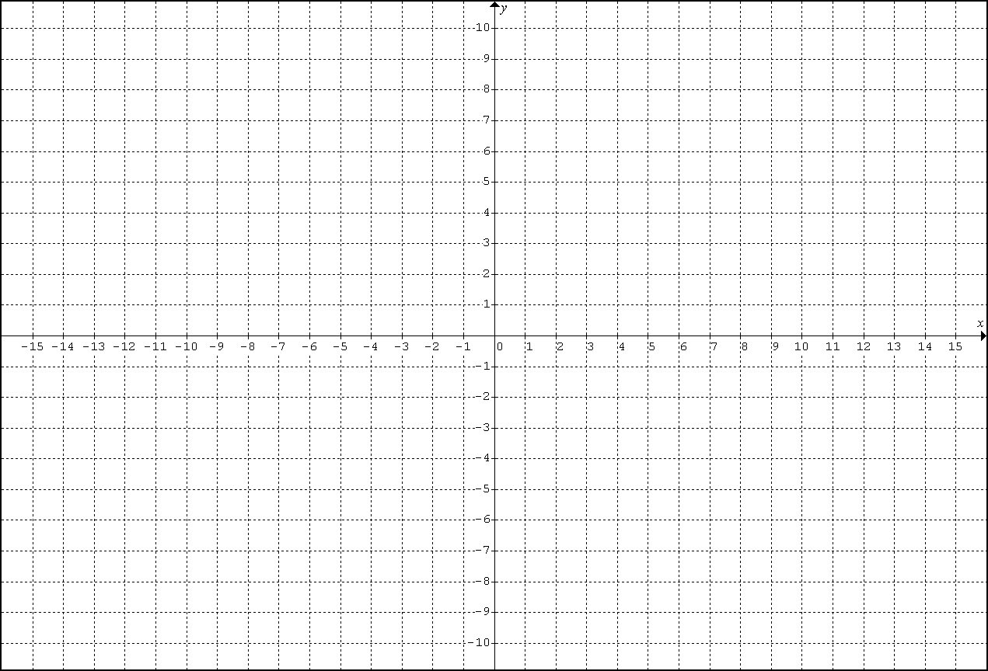
x
-9
-4
-1
0
1
4
9

x
-27
-8
-1
0
1
8
27

x | $$f_{3}\left(x\right)$$
-6
-3
-1
0
1
3
6

