For each study: (1) Plot the scatter-plot (2) Discuss the form, strength, and direction of the relationship (3) Draw a line that “best” fits the data points (4) Write the equation of the line (5) State the domain and range of the relationship (6) Interpret the slope and y-intercept in the context of the study.

1. Safety Report
Let x = the number of hours spent in safety training by workers in an industrial plant
Let y = the number of hours lost due to accidents by workers in an industrial plant

A safety inspector visits 7 districts and records the following data:
District | Number of hours spent in safety training | Number of hours lost due to accidents
1 | 50.0 | 35
2 | 65.0 | 10
3 | 19.5 | 65
4 | 45.0 | 55
5 | 80.0 | 12
6 | 10.0 | 80
7 | 30.0 | 68

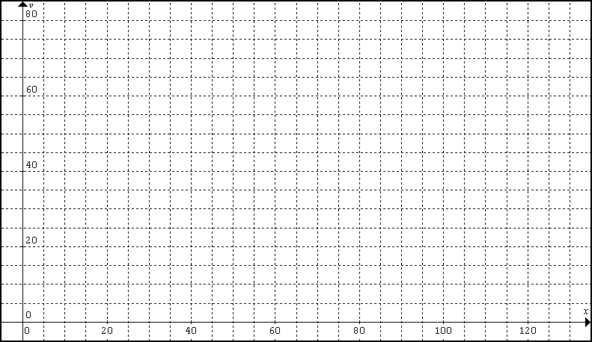
2. Muggings
Let x = number of police officers on duty in the park
Let y = the number of reported muggings on that day

x | 10 | 15 | 16 | 1 | 4 | 6 | 18 | 12 | 14 | 7
y | 5 | 2 | 1 | 9 | 7 | 8 | 1 | 5 | 3 | 6

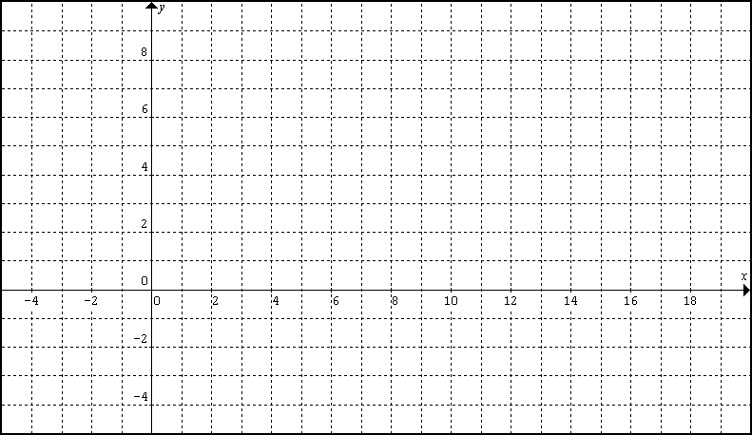
4. Birds
Let x = the wing-beat rate “flapping rate” (in beats per second)
Let y = the wing length (in millimeters)

Bird | Flamingo | Shellduck | Velvet Scoter | Fulmar | Great Egret
Wing-beat rate | 2.4 | 3.0 | 4.3 | 3.6 | 2.1
Wing Length | 400 | 375 | 281 | 321 | 437

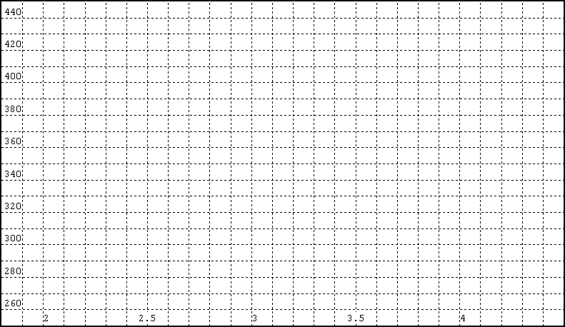
3. Ponies
Let x = the age of a pony (in months)
Let y = the weight of a pony (in kilograms)
x | 3 | 6 | 12 | 18 | 24
y | 60 | 95 | 140 | 170 | 185

