Most of the “real world” relationships we have discussed so far have been linear. In many examples you were told that the relationship was linear and then were asked to construct the equation for the line, and hence the linear relationship, based on two points. We also discussed situations where the relationship was linear, but not perfect. Here we found the linear equation for the line that fits the points by choosing two points on the line. Many computer software programs and, of course, the TI84 enable you to calculate the equation for the best-fit line from a set of points. You may recognize the data for the example, as it was question 10 from test number 3.

Example: Mr. Smith teaches a summer algebra class at the local community college in Morris County, New Jersey. He feels there is a relationship between the temperature and the number of students absent. Let x = the temperature of the day in degrees Fahrenheit. Let y = the number of students absent. A graph of the selected points is shown below.
X | 78 | 89 | 96 | 95 | 92 | 103 | 80 | 101 | 85
Y | 11 | 19 | 18 | 20 | 16 | 25 | 13 | 23 | 12

Here is the scatterplot:
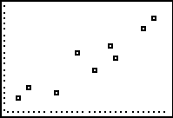

Here is the scatterplot with the line of best-fit overlapping the points:
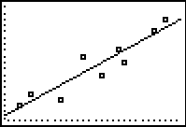

Here is the equation for the line of best-fit provided by the TI84 calculator:
$$y=0\text{.}\text{519}x−\text{29}\text{.}\text{828}$$

TASK: Follow the directions on the next two pages to obtain (I) the scatterplot, (II) the equation for the line of best fit, and (III) the graph of the line overlapping the scatterplot for the example presented here.

(I) SCATTERPLOT: (A) To obtain a scatterplot on the TI84, you must first enter the data into your calculator. You will put the data for the x variable into a list (L1) and the corresponding y variable data into an adjacent list (L2). (B) Next you will enable your calculator to graph a scatterplot. (C) Finally you will display the scatterplot.

(A) Entering Data Directions:
- Press the STAT key
- Press 1 or ENTER to edit data
- Under the column heading “L1”, type in the values of the x variable
(What if there are already data in this list? Use the up arrow to highlight L1. DO NOT press DELETE. With L1 highlighted, press CLEAR, then arrow down and the existing data will disappear.)
- Under the column heading “L2”, type in the values of the y variable
Be sure that each y value corresponds to the appropriate x value. For example, on the day when the temperature was 103 degrees, the number of students absent was 25. Here we must make sure that the 103 and 25 match-up in their respective lists. See the diagram below.
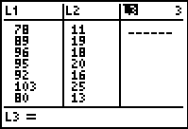
To exit this list mode simply press 2nd MODE

(B) Directions for enabling your calculator to plot graphs
- Press 2nd followed by the Y= key (This is the STAT PLOT mode)
- Press 1 or ENTER
- Highlight “On” and press ENTER
- Use the arrow key to highlight what looks like a scatterplot (the first one) and press ENTER
- For the Xlist, choose L1 by pressing 2nd followed by 1
- For the Ylist, choose L2 by pressing 2nd followed by 2
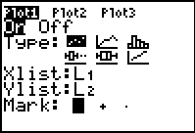
To exit this list mode simply press 2nd MODE

(C) Directions for displaying the scatterplot
Press the ZOOM key followed by 9
(II) EQUATION: Direction for obtaining the equation for the line of bets fit using the TI84.

- Press STAT
- Scroll right and highlight CALC
- Press option 4: (Your calculator will display LinReg(ax+b))
- After LinReg(ax+b) press 2nd 1 for L1, type a comma, and then press 2nd 2 for list 2 (See below)
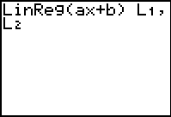
- Press ENTER
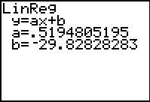
We often know a line as $y=\text{mx}+b$. Here it is presented as $y=\text{ax}+b$. Substitute the values of a and b to get the desired equation. Here: $y=0\text{.}\text{519}x−\text{29}\text{.}\text{828}$

(III) DISPLAY: Directions for graphing the line of best fit over the scatterplot.
Go to the regular Y= menu and type in the equation
Press GRAPH

