**AB: Q502.LESSON1**

Washers versus Cylindrical Shells

More Visualization and Determining Shape: “With the grain” or “Against the grain”.

Volume of a Cylindrical Shell: V =

Let f be continuous and suppose on the interval [a, b], where Let *R* be the region under the graph of *f* from a to b. Find the volume *V* of the solid of revolution generated by revolving *R* about the (a) the *y*-axis is (b) the line *x = k >b* and (c) the line *x = v < a*



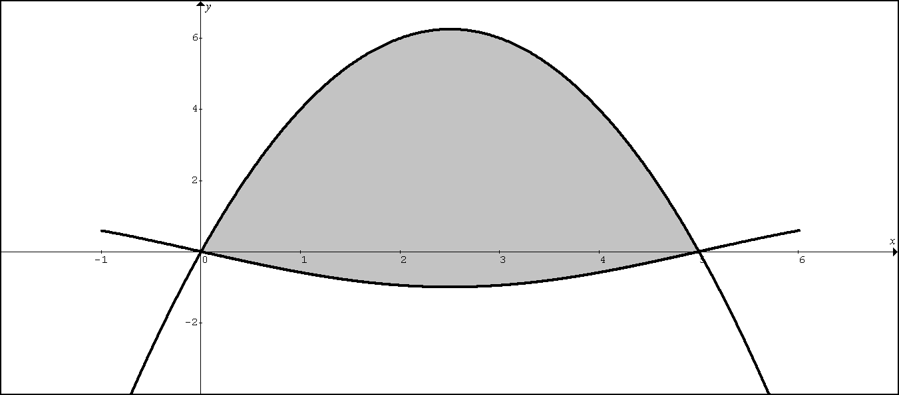

Example 11: Consider the region R bounded by the graphs of and as shown by the shaded region above.

A. Set up, but do not evaluate, an expression involving one or more integrals used to find the volume of the solid generated when the region R is revolved about the line .

B. Set up, but do not evaluate, an expression involving one or more integrals used to find the volume of the solid generated when the region R is revolved about the axis.

C. Set up, but do not evaluate, an expression involving one or more integrals used to find the volume of the solid generated when the region R is revolved about the line .

D. Set up, but do not evaluate, an expression involving one or more integrals used to find the volume of the solid generated when the region R is revolved about the line .

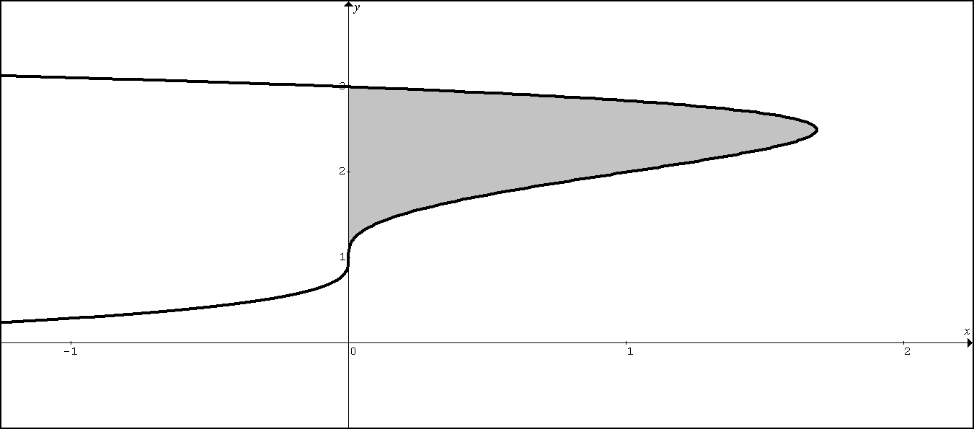

Example 12: Consider the region R bounded by the graphs of and the

*y* – axis as shown by the shaded region above.

A. Set up, but do not evaluate, an expression involving one or more integrals used to find the volume of the solid generated when the region R is revolved about the line .

B. Set up, but do not evaluate, an expression involving one or more integrals used to find the volume of the solid generated when the region R is revolved about the axis.

C. Set up, but do not evaluate, an expression involving one or more integrals used to find the volume of the solid generated when the region R is revolved about the line .

D. Set up, but do not evaluate, an expression involving one or more integrals used to find the volume of the solid generated when the region R is revolved about the line .

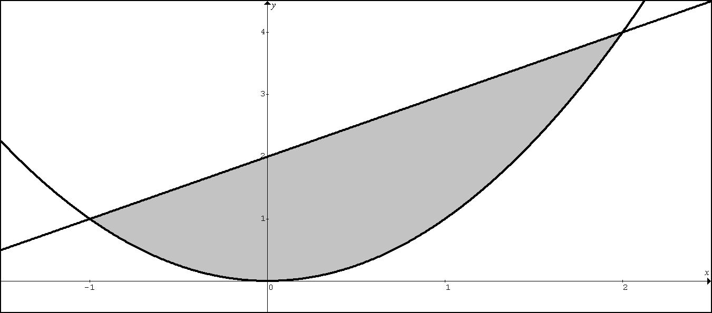

PRACTICE 1: Consider the region R bounded by the graphs of and  as shown by the shaded region above.

A. Set up, but do not evaluate, an expression involving one or more integrals used to find the volume of the solid generated when the region R is revolved about the line .

B. Set up, but do not evaluate, an expression involving one or more integrals used to find the volume of the solid generated when the region R is revolved about the axis.

C. Set up, but do not evaluate, an expression involving one or more integrals used to find the volume of the solid generated when the region R is revolved about the line .

D. Set up, but do not evaluate, an expression involving one or more integrals used to find the volume of the solid generated when the region R is revolved about the line .

E. Set up, but do not evaluate, an expression involving one or more integrals used to find the volume of the solid generated when the region R is revolved about the line .

F. Set up, but do not evaluate, an expression involving one or more integrals used to find the volume of the solid generated when the region R is revolved about the line .

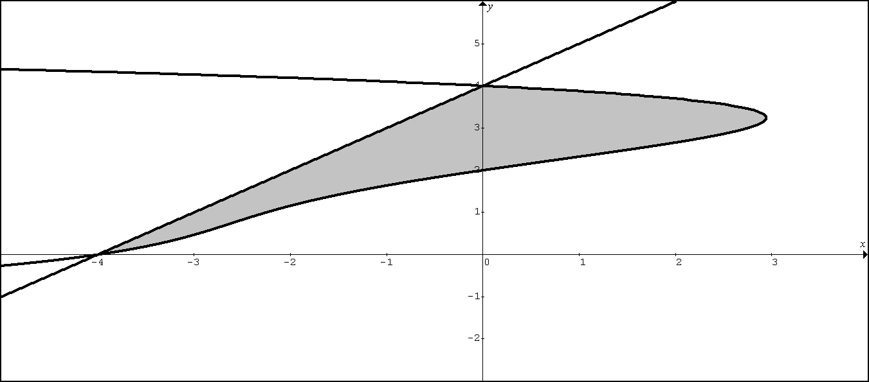

PRACTICE 2: Consider the region R bounded by the graphs of and  as shown by the shaded region above.

Both graphs pass through the points and 

A. Set up, but do not evaluate, an expression involving one or more integrals used to find the volume of the solid generated when the region R is revolved about the line .

B. Set up, but do not evaluate, an expression involving one or more integrals used to find the volume of the solid generated when the region R is revolved about the axis.

C. Set up, but do not evaluate, an expression involving one or more integrals used to find the volume of the solid generated when the region R is revolved about the line .

D. Set up, but do not evaluate, an expression involving one or more integrals used to find the volume of the solid generated when the region R is revolved about the line .

E. Set up, but do not evaluate, an expression involving one or more integrals used to find the volume of the solid generated when the region R is revolved about the line .

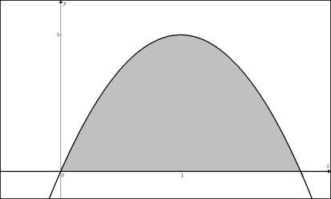

NO CALCULATOR

PRACTICE 3: Consider the region R bounded by the graph of and the *x*-axis as shown by the shaded region above.



A. **Find** the volume of the solid generated when the region R is revolved about the axis.

B. **Find** the volume of the solid generated when the region R is revolved about the *x* axis.

**AB: Q502.LESSON2: LOGISTIC GROWTH**

**Logistic Growth**

The solution to the differential equation  is 

where *L* is the carrying capacity and where *k* is the constant of proportionality.

Let 

1. Draw a slope field for :

2. If  i.e. 

A. Draw :

B. Find 

C. Find 

3. What is the value of *y* when *y* is growing fastest?Example 1: If and , find the function .

Example 2: If  and , find the function .

Example 3: If  and , find the function .Example 4: Because of the limited food space, a squirrel population and cannot exceed 1000. grows at a rate proportional both to the existing population and to the attainable additional population. If there were 100 squirrels 2 years ago, and 1 year ago the population was 400, about how many are there now? What is the squirrel population when it is growing the fastest?

PROOF: Use separation of variables to prove that the general solution to  is .

LESSON 2 PRACTICE

1. Let with initial condition *P* = 8 people when *t* = 0 years.

A. Write the function *P*(t).

B. What is the size of the population when it is growing its fastest?

C. What is the rate at which the population is growing when it is growing the fastest?

D. Find 

2. Let  with initial condition *P* = 4 eggs when *t* = 0 months.

A. Write the function *P*(t).

B. What is the size of the population when it is growing its fastest?

C. What is the rate at which the population is growing when it is growing the fastest?

D. Find 

3. A certain rumor spreads through a community at the rate , where *y* is the proportion of the population that has heard the rumor at time *t* hours.

(a) What proportion of the population has heard the rumor when it is spreading the fastest?

(b) If ten percent of the people have heard the rumor at time *t* = 0, find *y* as a function of *t*.

(c) At what time *t* is the rumor spreading the fastest?

**AB: Q502 LESSON 3**

**LINEAR APPROXIMATION and EULERS METHOD OF APPROXIMATION**

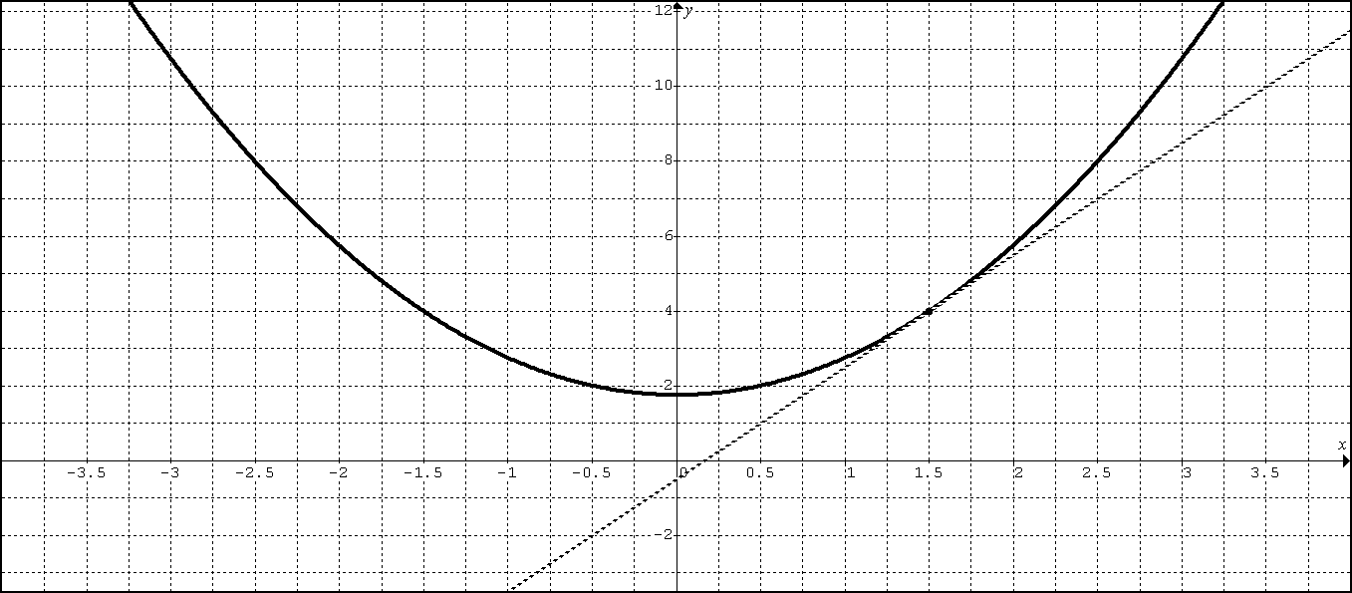

1. Suppose where is the solution to the differential equation that passes through the point .



A. Write an equation of the line tangent to the curve at and use it to approximate .



B. Starting at the point (1.5, 4), use Euler’s Method with step size to approximate .



C. Find the exact value of .



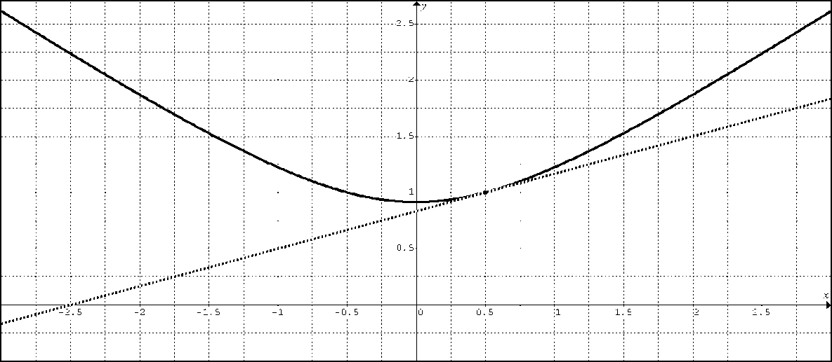

2. Suppose where is the solution to the differential equation that passes through the point .



A. Write an equation of the line tangent to the curve at and use it to approximate .



B. Starting at the point (0.5, 1), use Euler’s Method with step size to approximate .



C. Find the exact value of .



**PRACTICE**

1: Let be a function with such that for all points (*x*, *y*) on the graph of the slope is given by.



A. Find the slope of the graph of at the point where *x* = 1.



B. Write an equation for the line tangent to the graph of at *x* = 1 and use it to approximate *f*(1.2)



C. Starting at the point (1, 4), use Euler’s Method with step size to approximate



2: Consider the differential equation given by.



A. Let be a particular solution to the given differential equation with initial condition. Use Euler’s method starting at *x* = 0, with step size 0.1, to approximate. Show the work that leads to your answer.



B. Starting at the point (0, 3), use Euler’s Method with step size to approximate .



C. Find the particular solution to the given differential equation with initial condition



3. Consider the differential equation  with .

A. Use a linearization centered at to approximate.

B. Use Euler’s method starting at  with step size  to approximate.