**AB: Q304 UNIT WARM UP**

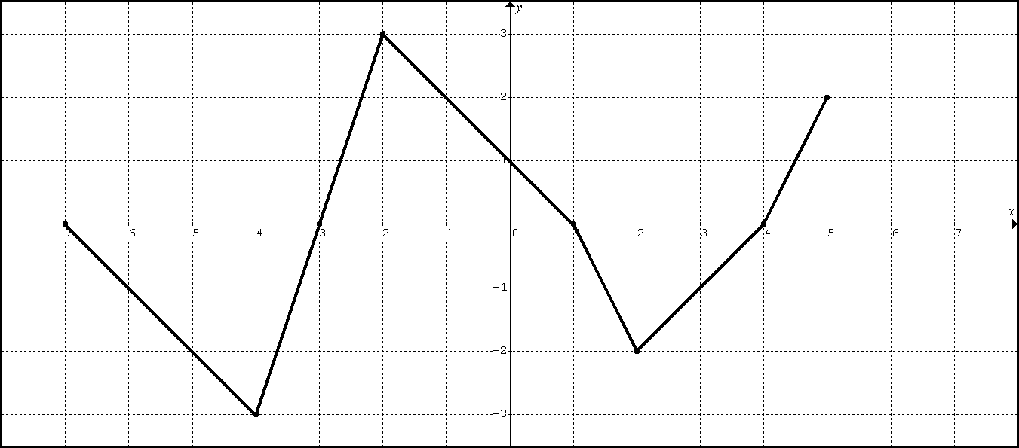

The graph above represents  (the derivative of the function) on .

Suppose .

1. Evaluate 

2. Find and 

3. What is the average rate of change in on the interval ?



The graph above represents  (the derivative of the function) on 

Suppose .

4. Find , , , and 

5. For what value(s) of *x* will the function  have a local minimum? Justify.

6. For what value(s) of *x* will the function  be concave downward? Justify.

**AB Q304 LESSON 1A**

GUIDED PRACTICE 1: 2007FB #4

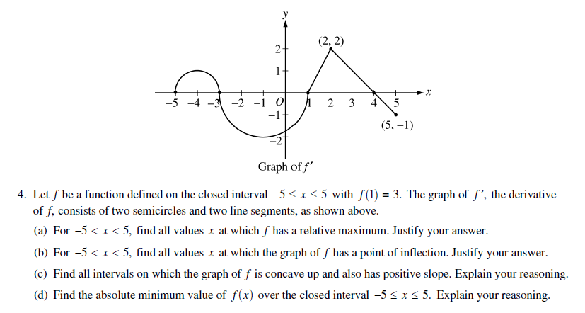GUIDED PRACTICE 2: 2008FB#5

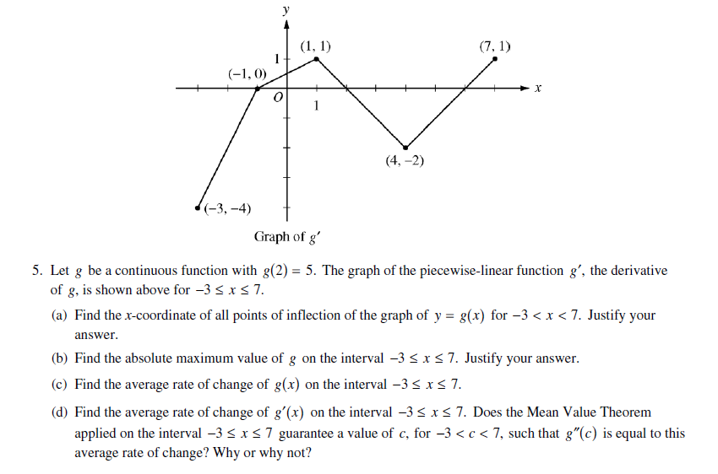

GUIDED PRACTICE 3: 2015 #5

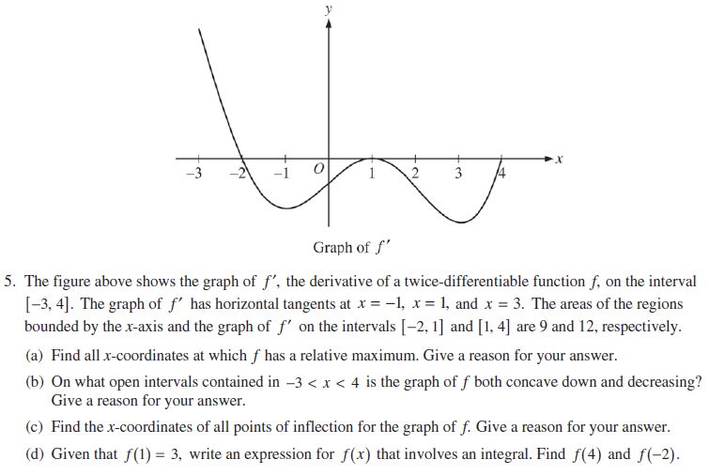

GUIDED PRACTICE 4: 2003 #4

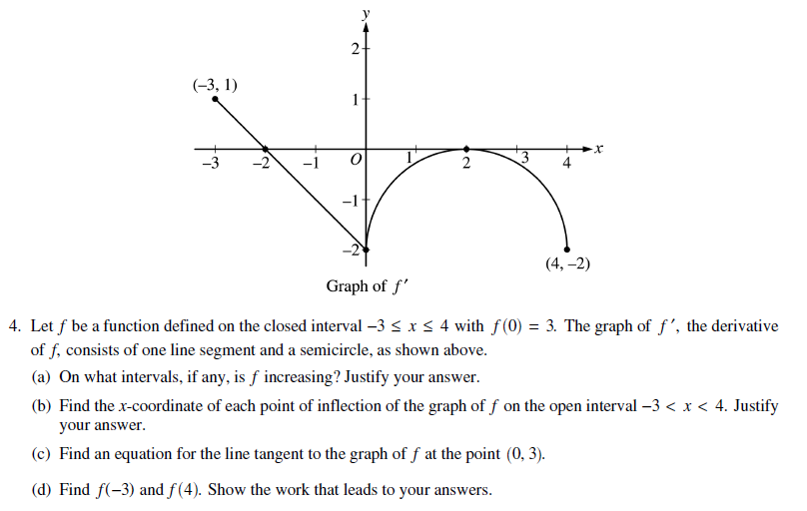

**AB Q304 LESSON 1B**

**FUNDAMENTAL THEOREM OF CALCULUS PART 1**

THE FUNDAMENTAL THEOREM OF CALCULUS PART 1 (Defines the Relationship)

Defining the relationship: 

Defining the relationship:  (*a* is a constant)

GUIDED PRACTICE 1: 1999 #5 (adaptation)

(1, 4)

(4, -1)

(2, 1)

-2

2

2

-2

EX1: The graph of the function *f*, consisting of three line segments, is given above. Let 

A. Compute *g*(4) and *g*(-2)

B. Find the instantaneous rate of change of *g*, with respect to *x*, at *x* = 1.

C. Find the absolute maximum and minimum values of *g* on the closed interval [-2, 4]. Justify your answer.

D. The second derivative of *g* is not defined at *x* = 1 and *x* = 2. How many of these values are *x*-coordinates of points of inflection of the graph of *g*? Justify your answer.

GUIDED PRACTICE 2: 2012 #3

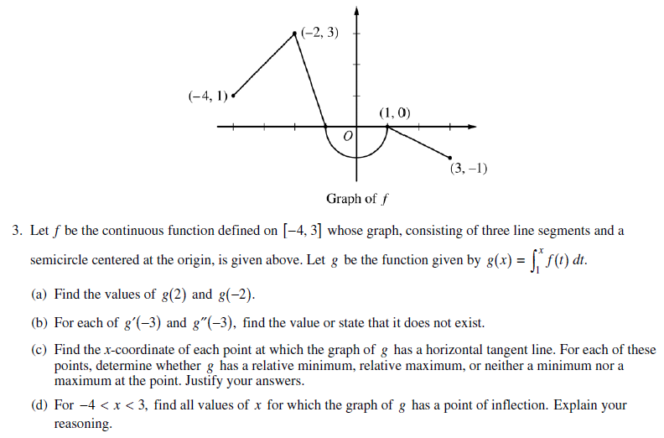

GUIDED PRACTICE 3: 2014 #3 (AP SCORE THIS)

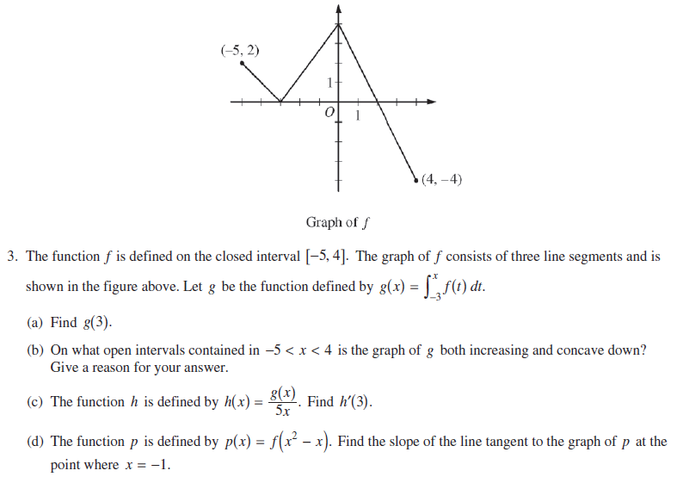

GUIDED PRACTICE 4: 2011 #4

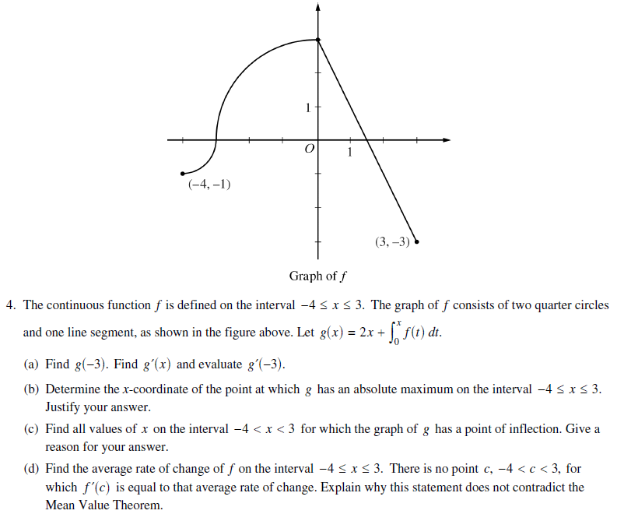

OTHER PRACTICE 1: 2004 #5

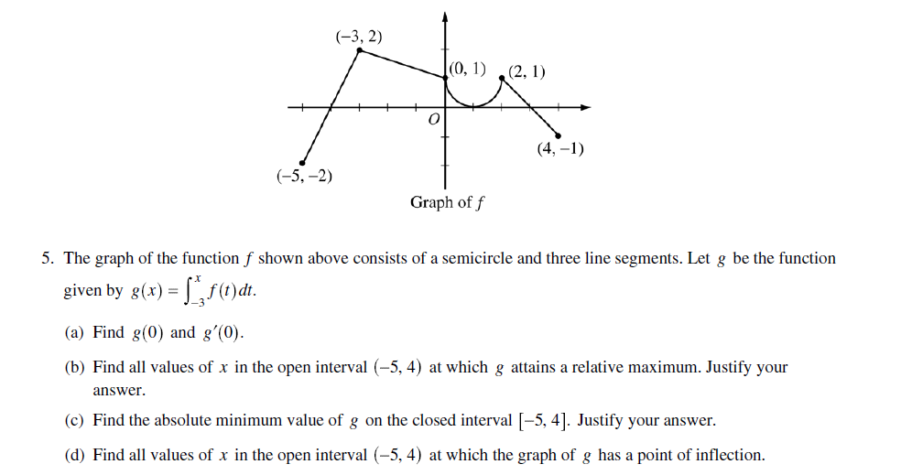

OTHER PRACTICE 2: *VERY CHALLENGING* 2005FB #5

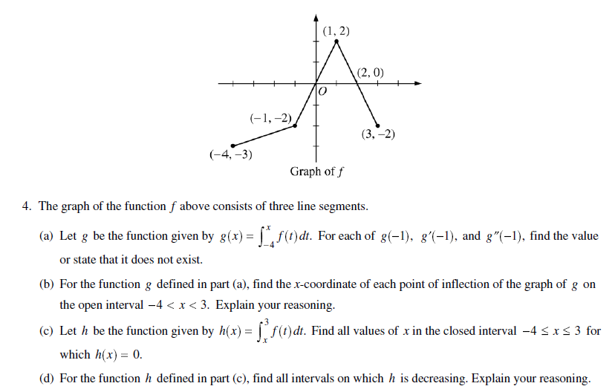

**AB Q304 LESSON 2**

**APPROXIMATING THE DEFINITE INTEGRAL**

**WITH A RIEMANN SUM**

**Approximating a Definite Integral with a Riemann Sum**

RECTANGLE APPROXIMATION

 where is the value of *f* at *x* = *c* on the *k*th interval.

TRAPEZOIDAL APPROXIMATION

 where  and is constant.

1. Consider the area under the curve (bounded by the *x*-axis) of  from  to .

Use 4 equal rectangles whose heights are the left endpoint of each rectangle to approximate the area. (LRAM)

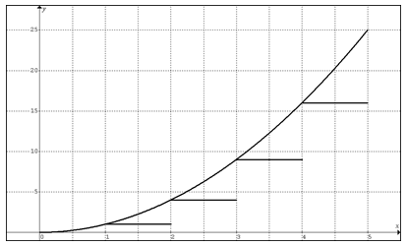

Use 4 equal rectangles whose heights are the right endpoint of each rectangle to approximate the area. (RRAM)

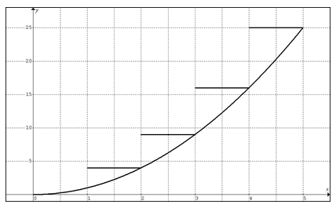

Use 4 equal rectangles whose heights are the midpoint of each rectangle to approximate the area. (MRAM)

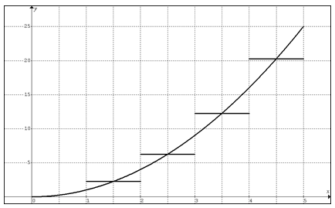

Use 4 trapezoids of equal width to approximate the area. (TRAM)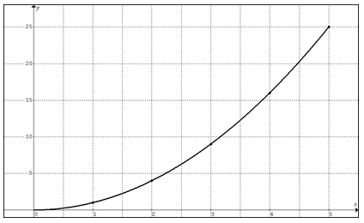2. Use LRAM, MRAM, and TRAM with *n* = 3 equal rectangles to estimate the where values of the function are as given in the table below.

|  |  |  |  |  |  |  |  |
| --- | --- | --- | --- | --- | --- | --- | --- |
| *x* | 2.0 | 2.25 | 2.5 | 2.75 | 3 | 3.25 | 3.5 |
| *y* | 3.2 | 2.7 | 4.1 | 3.8 | 3.5 | 4.6 | 5.2 |

3. Use a Trapezoidal approximation with *n* = 3 trapezoids to estimate the where values of the function are as given in the table below.

|  |  |  |  |  |
| --- | --- | --- | --- | --- |
| *x* | 2.0 | 3 | 5 | 5.5 |
| *y* | 3.2 | 2.7 | 4.1 | 3.8 |

4.

|  |  |
| --- | --- |
| *t* (hours) | *R*(*t*) (gallons per hours) |
| 0 | 9.6 |
| 3 | 10.4 |
| 6 | 10.8 |
| 9 | 11.2 |
| 12 | 11.4 |
| 15 | 11.3 |
| 18 | 10.7 |
| 21 | 10.2 |
| 24 | 9.6 |

The rate at which water flows out of a pipe, in gallons per hour, is given by a differentiable function *R* of time *t*. The table above measured every 3 hours for a 24-hour period.

A. Using correct units, explain the meaning of the integral in terms of water flow.

B. Use a trapezoidal approximation with 4 subdivisions of equal length to approximate .

C. Use a midpoint Riemann sum with 4 subdivisions of equal length to approximate the average of *R*(*t*).

D. The rate of water flow *R*(*t*) can be approximated by . Use *Q*(*t*) to approximate the average rate of water flow during the first 24-hour time period. Indicate the units of measure.

HW1: 1998 #3

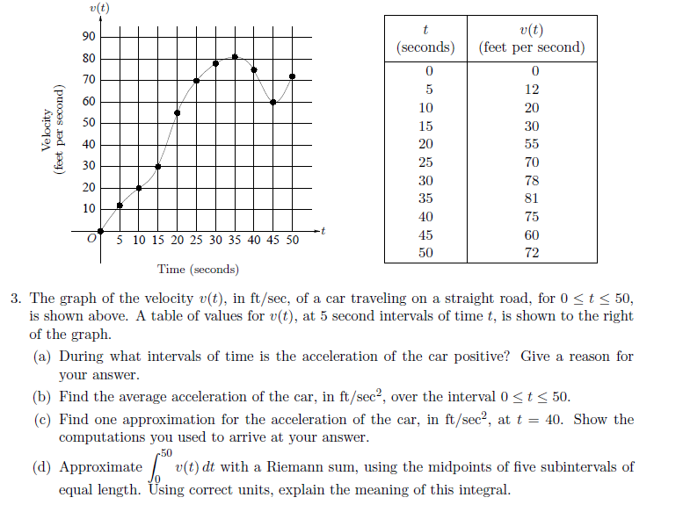

HW2: 2004FB #3

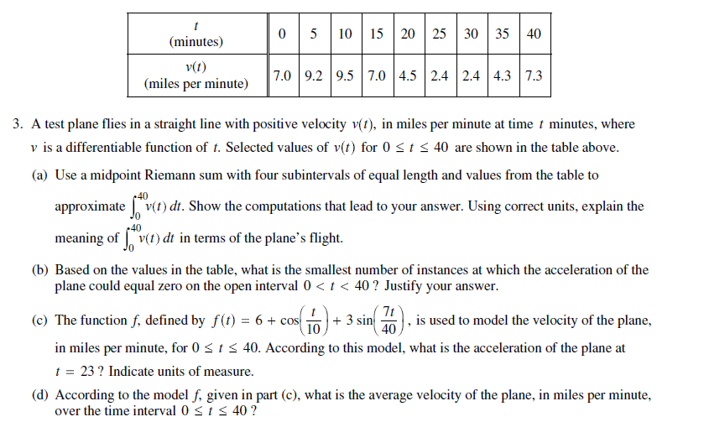HW3: 2008 #2

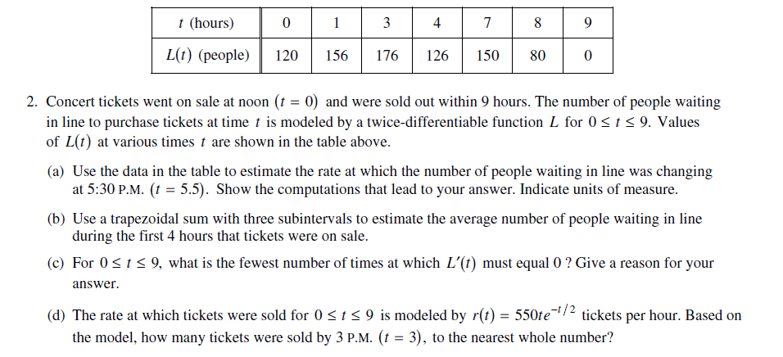

**AB Q304 LESSON 3**

**FUNDAMENTAL THEOREM OF CALCULUS PART 1**

**(CHAIN RULE APPLIED)**

**ILLUSTRATIONS**

Find for each equation below.

1. 

2. 

3. 

4. 

AB: Q304 LESSON 3 CUMULATIVE PRACTICE EXERCISE

|  |  |  |  |  |  |  |
| --- | --- | --- | --- | --- | --- | --- |
|  | -2 | 0 | 1 | 5 | 7 | 8 |
|  | 14 | 5 | 2 | -3 | -10 | 9 |

Let  where is a differentiable function with specific values as shown above.

1. Estimate using a trapezoidal approximation with four trapezoids.

2. Find 

3. Estimate 

4. If , estimate  using a left Riemann sum with three rectangles.

5. If , find .

6. If , find .

AB. Q304 LESSON 3 (MVT PRACTICE)

Let  on .

1. Find the average rate of change in *f* on [-1, 4.5].

2. Find the value(s) of *x* that satisfy the conclusion to the Mean Value Theorem for derivatives.

3. Find the average value of *f* on [-1, 4.5].

4. Find the value(s) of *x* that satisfy the conclusion to the Mean Value Theorem for integrals.

AB: Q304 CH5B PRACTICE EXAMINATION **– CALCULATOR** SECTION

(For integral approximations, show the integral for which you are approximating)

|  |  |  |  |  |  |  |  |
| --- | --- | --- | --- | --- | --- | --- | --- |
| *t* | 0 | 2 | 4 | 6 | 8 | 10 | 12 |
| *P*(*t*) | 0 | 46 | 53 | 57 | 60 | 62 | 63 |

1. An above ground swimming pool contains 1000 cubic feet of water at time *t* = 0. During the time interval hours, water is pumped into the pool at the rate *P*(*t*) cubic feet per hour. The above table gives values of *P*(*t*) for selected values of *t*. During the same time interval, water is leaking from the pool at the rate *R*(*t*) cubic feet per hour, where



1. Use a midpoint Riemann sum with three subintervals of equal length to approximate, to the nearest cubic foot, the total amount of water that was pumped into the pool during the time interval hours. Show the computations that lead to your answer.
2. Calculate, to the nearest cubic foot, the total amount of water that leaked out of the pool during the time interval  hours. Include the set up when expressing your answer.
3. Use the results from parts (a) and (b) to approximate the volume of the water in the pool at time *t* = 12 hours. Round your answer to the nearest cubic foot.
4. Write an equation, using an integral expression, for *A*(*t*), the amount of water in the pool at time *t*.
5. Find and interpret , for *A*(*t*) defined in part (d).

2.

|  |  |
| --- | --- |
| *t*  (days) | *W(t)*  (°C) |
| 0 | 20 |
| 3 | 31 |
| 6 | 28 |
| 9 | 24 |
| 12 | 22 |
| 15 | 21 |

The temperature, in degrees Celsius (°C), of the water in a pond is a differentiable function *W* of time *t*. The table above shows the water temperature as recorded every 3 days over a 15-day period.

1. Approximate the average temperature, in degrees Celsius, of the water over the time interval  days by using a trapezoidal approximation with subintervals of length days. Use correct units when expressing your answer.
2. Using the correct units, explain the meaning of .
3. Approximate .

3. Suppose  and . Estimate to four decimal places. Show your reasoning.

AB: Q304 CH5B PRACTICE EXAMINATION – **NON CALCULATOR** SECTION

1

2

5

(3,-1)

4. The graph of a function *f* consists of a semicircle and two line segments as shown above. Let *g* be the function given by 

1. Find 
2. Find all values of *x* on the open interval (-2, 5) at which *g* has a relative maximum. Justify your answer.
3. Write an equation for the line tangent to the graph of *g* at
4. Find the *x*-coordinate of each point of inflection of the graph of *g* on the open interval (-2, 5). Justify your answer
5. Find the absolute maximum value of *g* on [-2, 5].
6. Let . Find all values of *x* on the open interval (-2, 5) at which *B* has a relative minimum. Justify your answer.

5. A particle starts at position *x* = 5 at time *t* =1 and travels along a horizontal with velocity *.*

A] What is the total distance traveled by the particle from time *t* = 1 to time *t* = 4? Show work.

B] Where is the particle located at time *t* = 4? Include an integral(s) set up and show work when expressing your answer.

6. Find .

7. Using the substitution $=x^{2}-3$, $\int_{-1}^{4}{x}{{(x}^{2}-3)}^{5}dx$ is equal to which of the following?

(A)

(B)

(C)

(D)

(E)

8. Evaluate . Simplify your answer.

9. If on [-1,2], then find the value of *x* that satisfies the conclusion to the mean value theorem for integrals.