**MEAN VALUE THEOREM**

**MEAN VALUE THEOREM FOR DERIVATIVES**

If a function *f* is continuous on an interval [a, b] and differentiable on an interval (a, b),

Then there exists at least one *x*-value on (a, b) such that the instantaneous rate of change at this/these *x*-values is equal to the average rate of change of *f* over [a, b]

*Stated Mathematically:*

If a function *f* is continuous on an interval [a, b] and differentiable on an interval (a, b),

Then there exists at least one on (a, b) such that.

**MEAN VALUE THEOREM FOR INTEGRALS**

If a function *f* is continuous on an interval [a, b],

Then there exists at least one *x*-value on (a, b) such that the function’s value at this/these *x*-values is equal to the average value of *f* over [a, b]

*Stated Mathematically:*

If a function *f* is continuous on an interval [a, b],

Then there exists at least one on (a, b) such that.

1. Consider the function on the interval [0, 2] ***Calculators Permitted***

A. Find the average rate of change of *f* on [0, 2]

B. Find the value of *x* that satisfies the conclusion to the mean value theorem for derivatives.

*Make a sketch supporting your findings.*

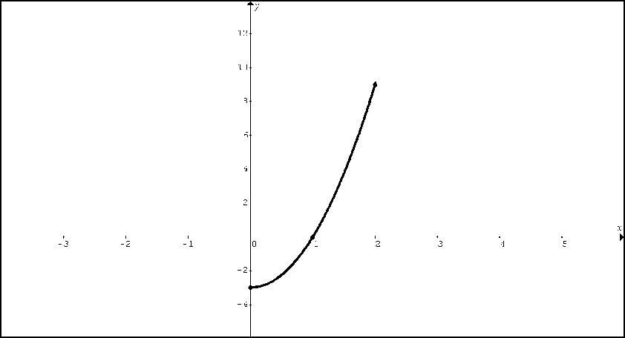

C. Find the average value of *f* on [0, 2].

D. Find the value of *x* that satisfies the conclusion to the mean value theorem for integrals.

*Make a sketch supporting your findings.*



2. Consider the function on the interval [-4, 1] ***Calculators Permitted***

A. Find the average rate of change of *f* on [-4, 1]

B. Find the value of *x* that satisfies the conclusion to the mean value theorem for derivatives.

*Make a sketch supporting your findings.*

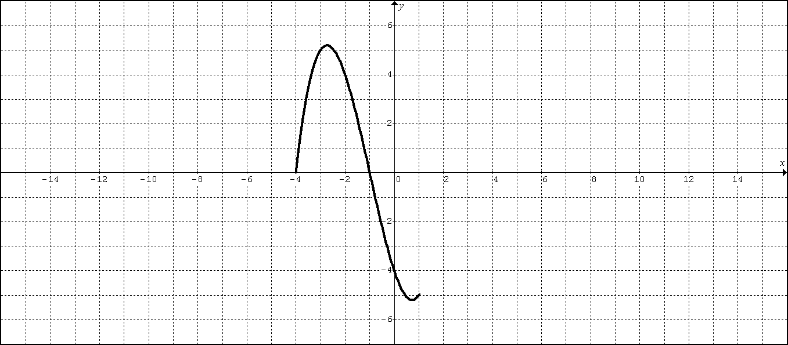

C. Find the average value of *f* on [-4, 1].

D. Find the value of *x* that satisfies the conclusion to the mean value theorem for integrals.

*Make a sketch supporting your findings.*



3. Consider the function on the interval [-1, 2]. ***Calculators Permitted***

A. Find the average rate of change of *y* on [-1, 2]

B. Find the value of *x* that satisfies the conclusion to the mean value theorem for derivatives.

*Make a sketch supporting your findings.*

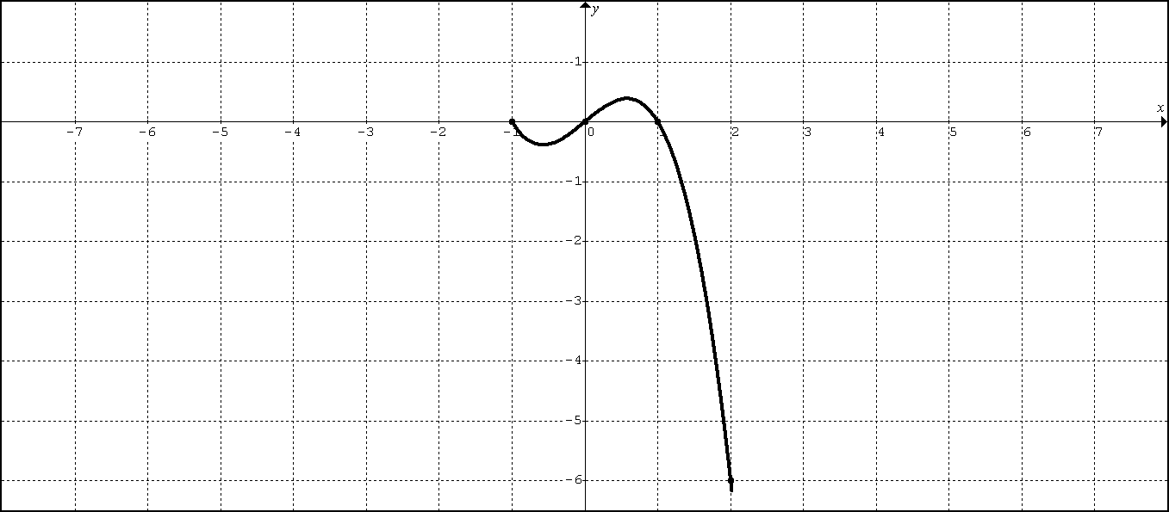

C. Find the average value of *y* on [-1, 2].

D. Find the value of *x* that satisfies the conclusion to the mean value theorem for integrals.

*Make a sketch supporting your findings.*



4. Consider the function on the interval [-3, 3]. ***Calculators Permitted***

A. Find the average rate of change of *y* on [-3, 3]

B. Find the value of *x* that satisfies the conclusion to the mean value theorem for derivatives.

*Make a sketch supporting your findings.*

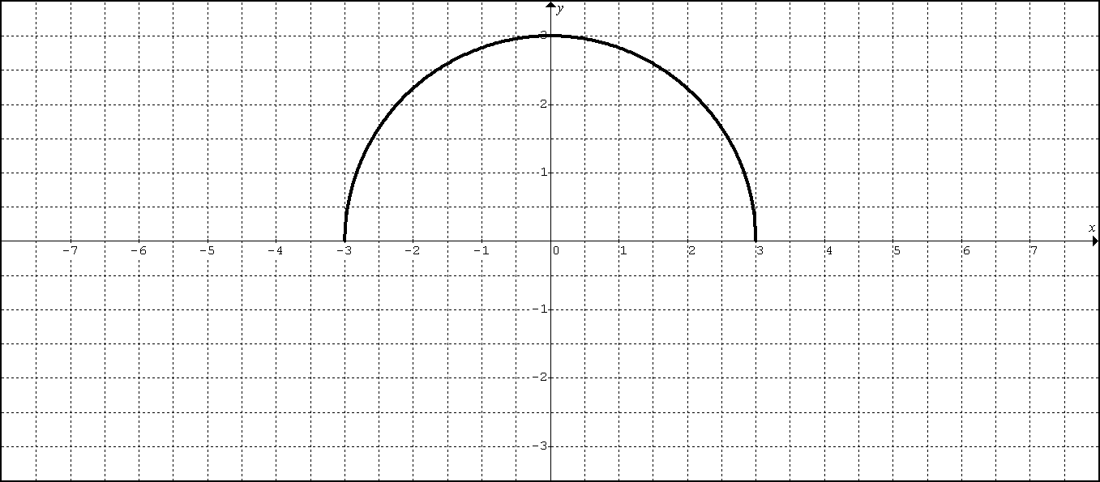

C. Find the average value of *y* on [-3, 3].

D. Find the value of *x* that satisfies the conclusion to the mean value theorem for integrals.

*Make a sketch supporting your findings.*

