CALCULUS AP AB – Q303CH5A: (Lesson 1-A) AREA and INTEGRAL
Area – Integral Connection and Riemann Sums

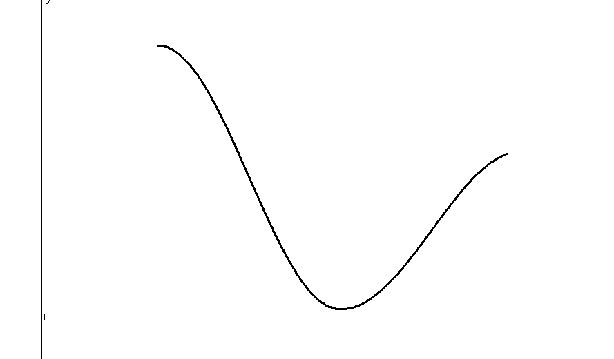

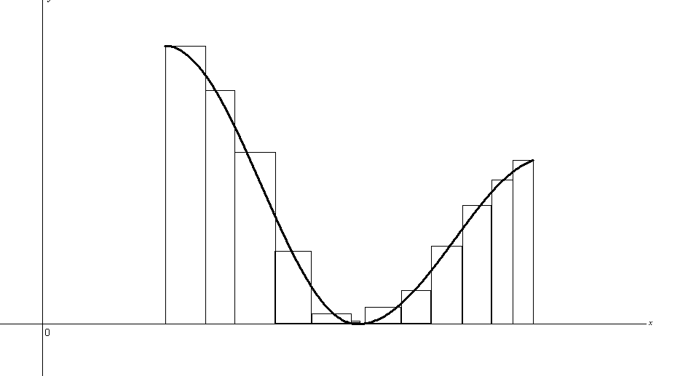

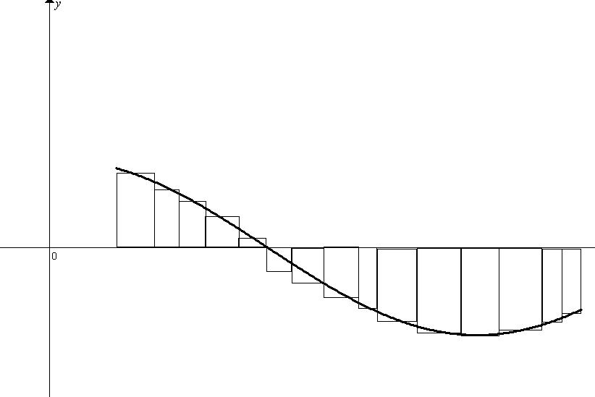
I. INTEGRAL AND AREA – BY HAND (APPEAL TO GEOMETRY)

NOTES: Below are graphs that each represent a different f(x) from x = -3 to x = 4.

A] Find the Area bounded by the graph of f and the x-axis.
B] Evaluate the integral. Express the integral as it relates to a collection of areas.
C] Express the Area as it relates to an (or set of) integral(s).

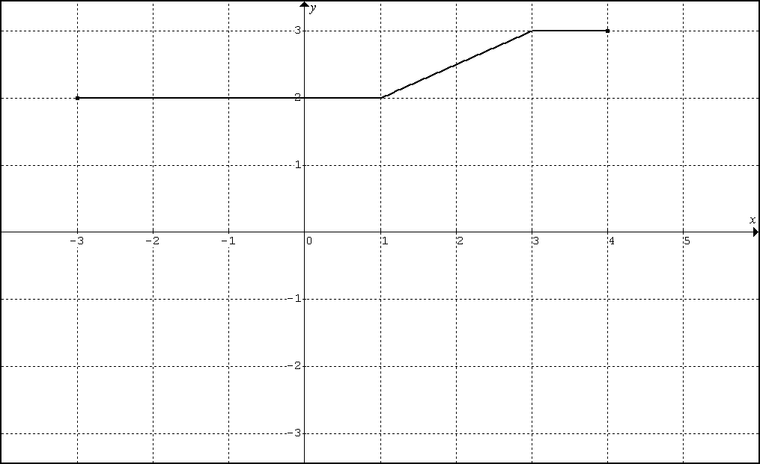  Graph 1 | 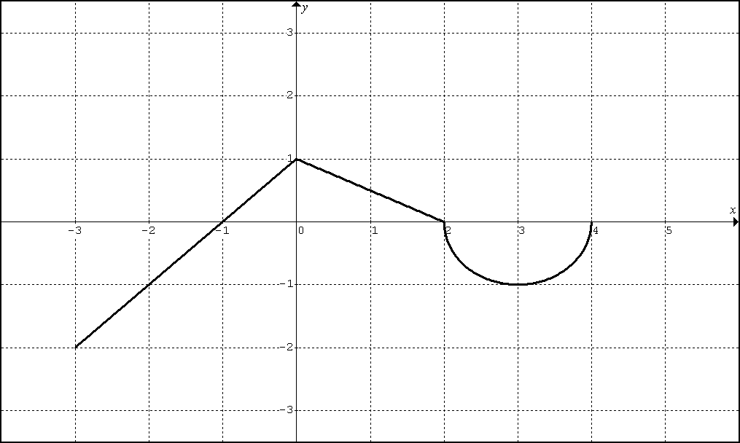  Graph 2

PRACTICE

1. The graph of $f(x)$is made up of line segments and semi-circles as shown in the graph below.
Evaluate A – E.
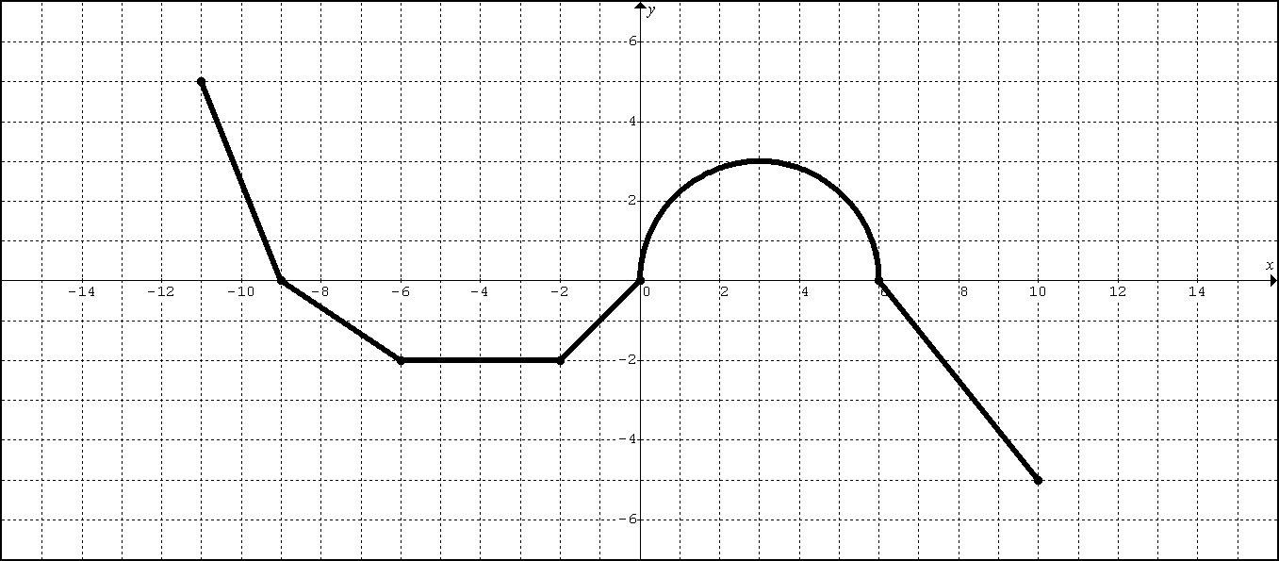

A. Find the total area bounded by the graph of $f(x)$and the x-axis.

B. $\int_{−\text{11}}^{\text{10}}{f(x)\text{dx}}$

C. $\int_{0}^{\text{10}}{f(x)\text{dx}}$

D. $\int_{−9}^{−2}{f(x)\text{dx}}$

E. $\int_{0}^{−9}{f(x)\text{dx}}$
2. The graph of $f(x)$is made up of line segments and semi-circles as shown in the graph below.
Evaluate A – E.

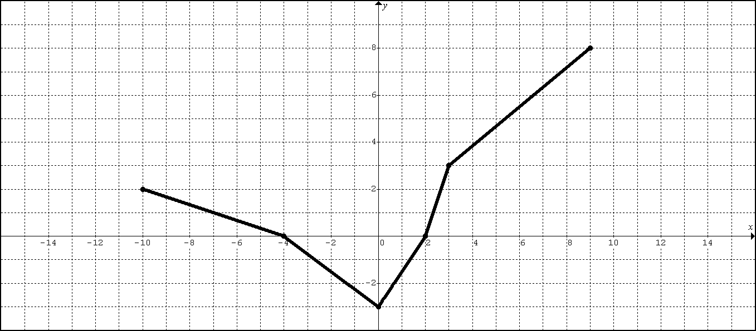

A. Find the total area bounded by the graph of $f(x)$and the x-axis.

B. $\int_{−\text{10}}^{9}{f(x)\text{dx}}$

C. $\int_{−4}^{2}{f(x)\text{dx}}$

D. $\int_{−4}^{−\text{10}}{f(x)\text{dx}}$

E. $\int_{2}^{2}{f(x)\text{dx}}$
3. Evaluate each integral by appealing to geometry.

A. $\int_{−2}^{4}{(1−x)\text{dx}}$ B. $\int_{−2}^{4}{2\text{dx}}$
II. CH5 – (INTEGRAL PROPERTIES):

Suppose that f and h are continuous functions and that
$\int_{1}^{9}{f(x)\text{dx}}=−1$, $\int_{7}^{9}{f(x)\text{dx}}=5$, and $\int_{7}^{9}{h(x)\text{dx}}=4$.
Find each integral below:

$$\int_{1}^{9}{−2f(x)\text{dx}}$$

$$\int_{7}^{9}{\left[f(x)+h(x)\right]\text{dx}}$$

$$\int_{7}^{9}{\left[2f(x)−3h(x)\right]\text{dx}}$$

$$\int_{9}^{1}{f(x)\text{dx}}$$

$$\int_{1}^{7}{f(x)\text{dx}}$$

$$\int_{9}^{7}{\left[h(x)−f(x)\right]\text{dx}}$$
BC: Q301 CH5A – LESSON (1A) HOMEWORK
1.

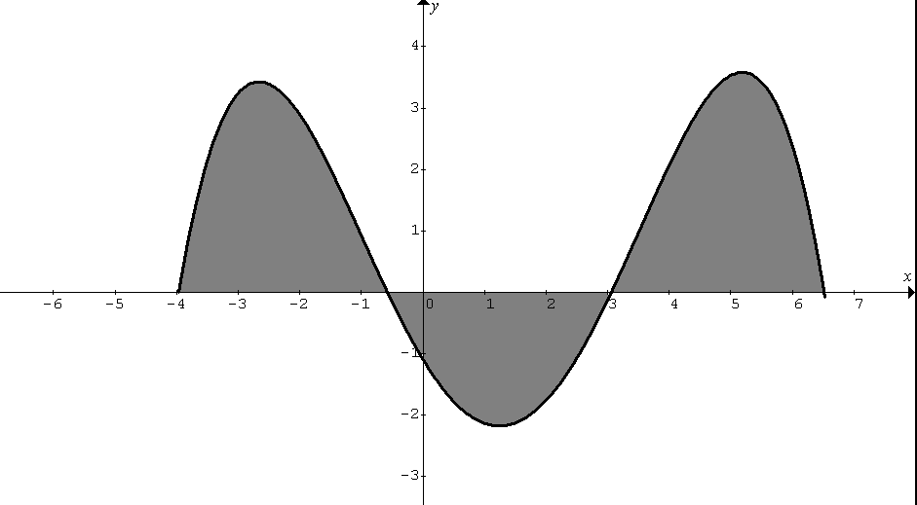
A1
A2
A3
In the diagram above, the values of the areas A1, A2, and A3 bounded by the graph of $f(x)$and the x-axis, are 7, 5, and 8 square units respectively. $f(x)$has zeros at -4, -0.6, 3, and 6.5.

Calculate the following definite integrals:

A. $\int_{−0\text{.}6}^{3}{f(x)\text{dx}}$

B. $\int_{−4}^{6\text{.}5}{f(x)\text{dx}}$

C. $\int_{3}^{−4}{f(x)\text{dx}}$

D. $\int_{−4}^{−0\text{.}6}{f(x)\text{dx}}−\int_{−0\text{.}6}^{3}{f(x)\text{dx}}+\int_{3}^{6\text{.}5}{f(x)\text{dx}}$
2. The graph of $f(x)$is made up of line segments and semi-circles as shown in the graph below.
Evaluate A – E.
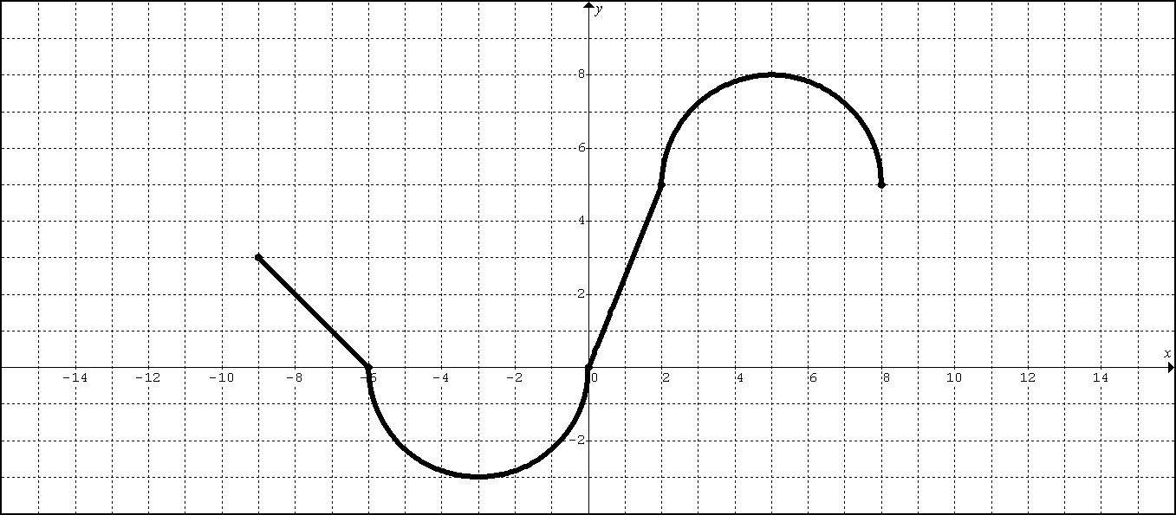

A. Find the total area bounded by the graph of $f(x)$and the x-axis.

B. $\int_{−9}^{8}{f(x)\text{dx}}$

C. $\int_{−3}^{2}{f(x)\text{dx}}$

D. $\int_{0}^{−9}{f(x)\text{dx}}$

E. $7+\int_{−8}^{−6}{f(x)\text{dx}}$
3. The graph of $f(x)$is made up of line segments and semi-circles as shown in the graph below.
Evaluate A – E.
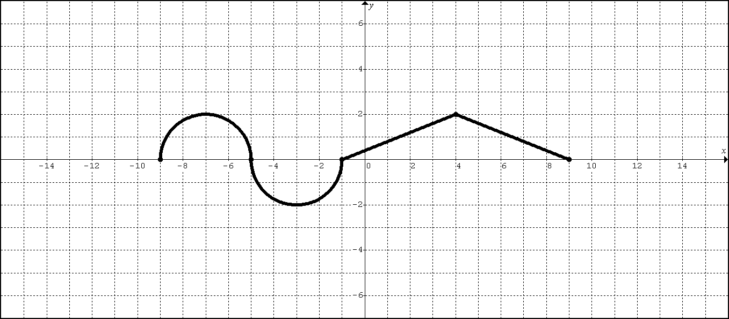

A. Find the total area bounded by the graph of $f(x)$and the x-axis.

B. $\int_{−9}^{9}{f(x)\text{dx}}$

C. $\int_{−9}^{−1}{f(x)\text{dx}}$

D. $\int_{−3}^{4}{f(x)\text{dx}}$

E. $\text{10}−\int_{2}^{2}{f(x)\text{dx}}$

4. Evaluate the following by appealing to geometry.

A. $\int_{−2}^{1}{(x−2)\text{dx}}$ B. $\int_{−2}^{6}{−4\text{dx}}$

5. Suppose that f and g are continuous functions and that …
$\int_{1}^{2}{f(x)\text{dx}=−4}$, $\int_{1}^{5}{f(x)\text{dx}=6}$, and $\int_{1}^{5}{g(x)\text{dx}=8}$

Evaluate each of the following integrals:

A. $\int_{2}^{2}{g(x)\text{dx}}$

B. $\int_{5}^{1}{g(x)\text{dx}}$

C. $\int_{1}^{2}{3f(x)\text{dx}}$

D. $\int_{2}^{5}{f(x)\text{dx}}$

E. $\int_{1}^{5}{\left[f(x)−g(x)\right]\text{dx}}$

F. $\int_{1}^{5}{\left[4f(x)−g(x)\right]\text{dx}}$

CALCULUS AP AB – Q303CH5A: (Lesson 1-B) AREA and INTEGRAL
FTC2: Fundamental Theorem of Calculus (Part II) – Evaluation Method

I. [FTC2-INTEGRAL] Evaluate the following integrals (a) BY HAND and (b) BY TI89

II. [FTC2- AREA]
1. Find the area bounded by and the x-axis on the interval [0, 2]
(a) BY HAND (b) BY TI89

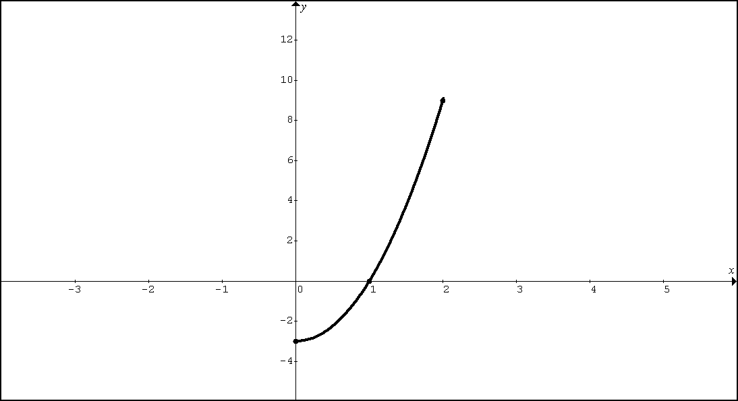

2. Find the area bounded by $y=x−x^{3}$and the x-axis on the interval [-1, 2].
(a) BY HAND (b) BY TI89

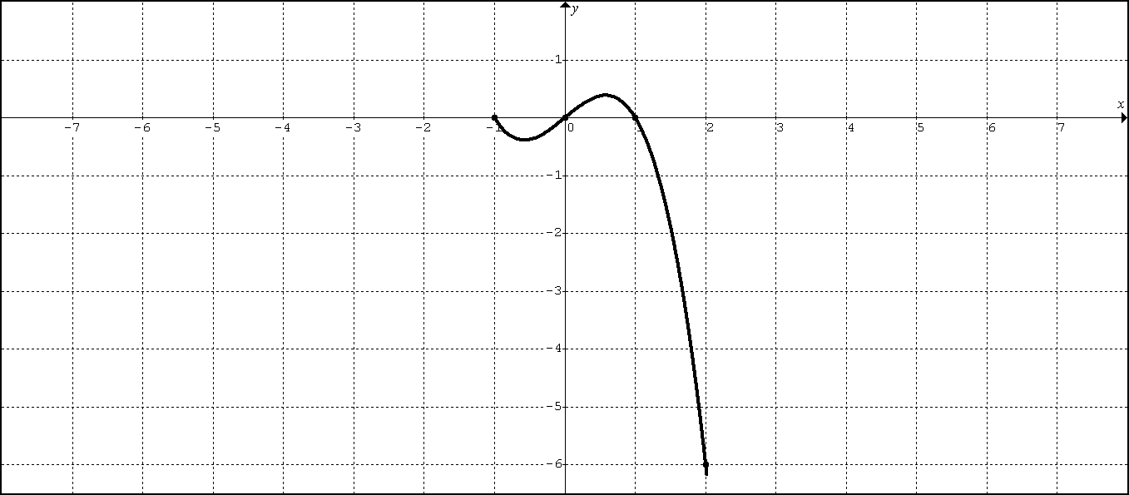
III. [FTC2-AVERAGE VALUE]:

1. (No Calculator) Find the average value of $f(x)=3x^{2}−3$ on [0, 2]

2. (No Calculator) Find the average value of $y=x−x^{3}$ on [-1, 2]

IV. [FTC2-UB]: (No Calculator)
Rewrite and evaluate each integral using the appropriate u-substitution and u-bounds.

1. $\int_{−1}^{2}{\text{45}x^{2}{\left(5x^{3}+1\right)}^{2}\text{dx}}$

2. $\int_{0}^{π}{\text{sin}(5x)\text{dx}}$

V. [FTC2–ID]: (Technology Required) Fundamental Theorem of Calculus “in disguise”

1. Suppose $f^{}(x)=e^{−x^{2}}$and $f(1)=3$. Find $f(2)$.

2. Suppose $f^{}(x)=(e^{x})^{\text{cos}(x)}$and $f(2)=1$. Find $f(0)$.
BC Q301 CH5A LESSON 1-B HW:

FTC2 INTEGRAL– BY HAND:
Section 5.3: 21, 23, 25, 27
Section 5.4: 27, 29, 31, 33, 35, 37

FTC2 INTEGRAL– BY TI89:
Section 5.4: 49, 50

FTC2 AREA– BY TI89:
Section 5.4: 41, 43, 45, 47

(APPEAL TO GEOMETRY) AVERAGE VALUE – BY HAND:
Section 5.3: 15, 16

FTC2 AVERAGE VALUE – BY HAND:
Section 5.3: 32, 34, 35

FTC2 AVERAGE VALUE – BY TI89:
Section 5.3: 11, 13

FTC2-UB
1. Rewrite and evaluate$\int_{\frac{3}{4}π}^{\frac{π}{2}}{\text{cos}(2x) \text{dx}}$ using an appropriate u-substitution and u-bounds.
2. Rewrite and evaluate $\int_{1}^{2}{{\left(2x−1\right)}^{7} \text{dx}}$ using an appropriate u-substitution and u-bounds.

FTC2-ID
1. Suppose $f^{}(x)=(2+\text{sin}x)^{x}$and $f(−1)=5$. Find $f(4)$

2. Suppose $f^{}(x)=(2+\text{ln}x)^{x}$and $f(2)=5$. Find $f(0\text{.}5)$

AB.Q303 – FTC2: Fundamental Theorem of Calculus (Part II)
Lesson 2A: APPLICATIONS
A. Area Connection (Lesson 1-A)

B. Evaluation Method [FTC2] (Lesson 1-B)

C. FTC2 APPLICATIONS

C1: Displacement/Position/Total Distance (Lesson 2A)

C1: Displacement/Position/Total Distance (Lesson 2A)

A particle moves along the x-axis such that its position at time t is given as x(t).
The velocity of the particle at time t is given as .

Review:
- The particle is moving to the right when
- Acceleration is positive when
- The particle is getting faster (speed increasing) when and share the same sign.

New:

LESSON 2A NOTES

1. An object moves along the x-axis with initial position . The velocity of the object at time is given by .
A. What is the total distance traveled by the object over the time period ?
B. What is the position of the object at time t = 4?
C. What is the average velocity over the time period ?
D. What is the average acceleration over the time period ?

LESSON 2A NOTES
2. A particle moves along the x-axis so that its velocity at time t is given as .
At time t = 0, the particle is at position x = 1.
A. What is the total distance traveled by the particle from time t = 0 until time t = 3?
B. What is the position of the particle at time t = 3?
C. What is the average velocity from time t = 0 until time t = 3?
D. What is the average acceleration from time t = 0 until time t = 3?

LESSON 2A NOTES
3. AP:2000#2
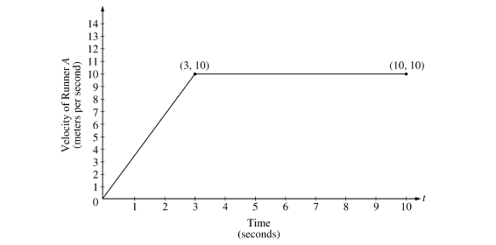
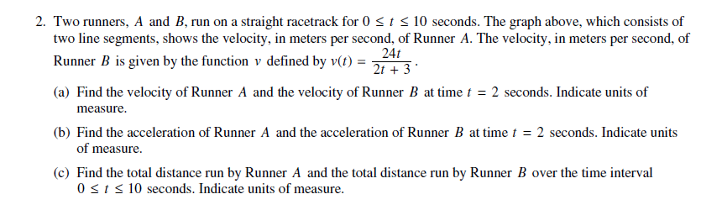
LESSON 2A HW

1. A particle moves along the y-axis so that its velocity v at time is given by . At time t = 0, the particle is at .
A. Find the total distance traveled by the particle between time t = 0 and time t = 2.
B. What is the position of the particle at time t = 2?
C. What is the average velocity over the time period ?
D. What is the average acceleration over the time period ?

LESSON 2A HW
2. AP:2011#1
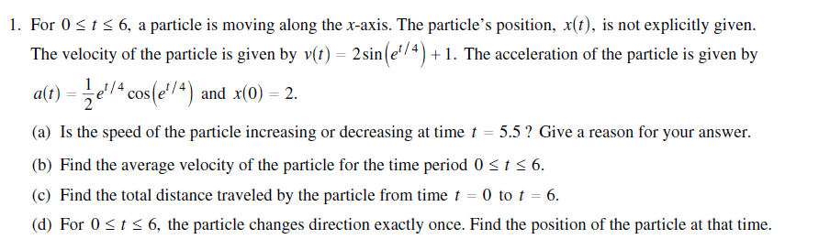

LESSON 2A HW
3. AP:2009#1
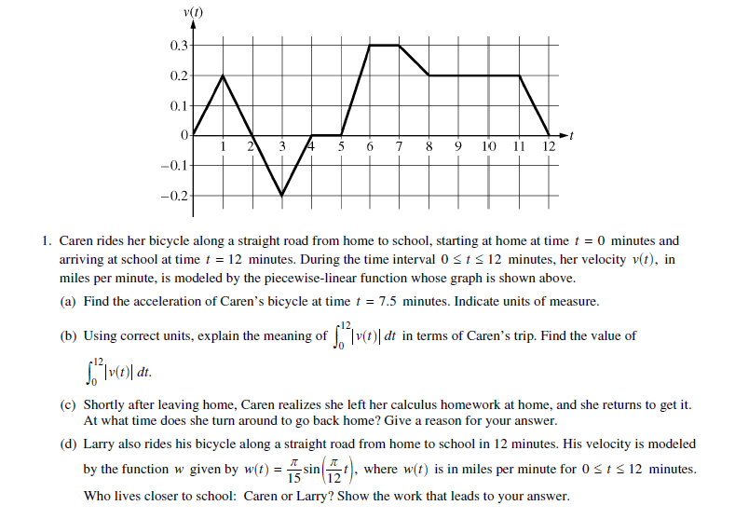

AB.Q303 – FTC2: Fundamental Theorem of Calculus (Part II)
Lesson 2B: APPLICATIONS
A. Area Connection (Lesson 1-A)

B. Evaluation Method [FTC2] (Lesson 1-B)

C. FTC2 APPLICATIONS

C2: Accumulating Quantity/(Rate In – Rate Out) (Lesson 2B)

C2: Accumulating Quantity/(Rate In – Rate Out) (Lesson 2B)
LESSON 2B NOTES
1. The rate at which people enter an amusement park on a given day is modeled by the function E defined by .

The rate at which people leave the same amusement park on the same day is modeled by the function L defined by .

Both E(t) and L(t) are measured in people per hour and time t is measured in hours after midnight. These functions are valid for , the hours in which the park is open.
At time t = 9, there are no people in the park.

A. How many people have entered the park by 5:00 pm (t = 17)? Round to the nearest whole number.
B. The price of admissions to the park is $15 until 5:00 pm. After 5:00 pm the price of admissions to the park is $11. How many dollars are collected in admissions to the park on the given day? Round to the nearest whole number.
C. Let H(t) be the number of people in the park at time t. Find H(17).
D. Write a function, involving an integral expression, for H(t), the number of people in the park at time t.

LESSON 2B NOTES
2. Traffic flow is defined as the rate at which cars pass through an intersection, measured in cars per minute. The traffic flow at a particular intersection is modeled by the function F defined by for , where F(t) is measured in cars per minute and t is measured in minutes.
A. To the nearest whole number, how many cars pass through the intersection over the 30-minutes period?
B. What is the average traffic flow over the time interval ? Indicate units of measure.
C. What is the average rate of change of the traffic flow over the time interval ? Indicate units of measure.

LESSON 2B NOTES
3. AP:2010#3
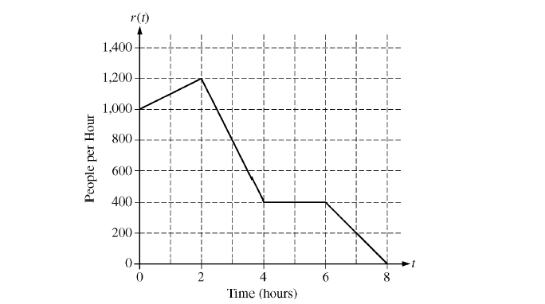
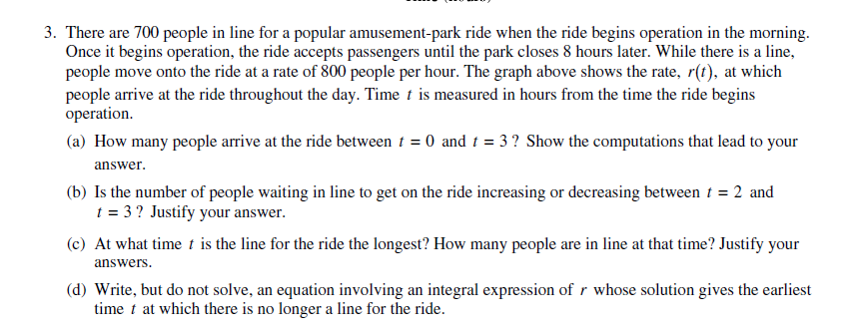
LESSON 2B HW

1. The tide removes sand from Sandy Point Beach at a rate modeled by the function R, given by .
A pumping station adds sand to the beach at a rate modeled by the function S, given by .

Both R(t) and S(t) have units of cubic yards per hour and t is measures in hours for . At time t = 0, the beach contains 2500 cubic yards of sand.

A. How much of the sand will the tide remove from the beach during this 6-hour period? Indicate units of measure.
B. Write a function, involving an expression, for Y(t), the total number of cubic yards of sand on the beach at time t.
C. Find the rate at which the total amount of sand on the beach is changing at time t = 4.
D. Find the total number of cubic yards of sand on the bank at time t = 4.

LESSON 2B HW
2. AP:2003FB#2
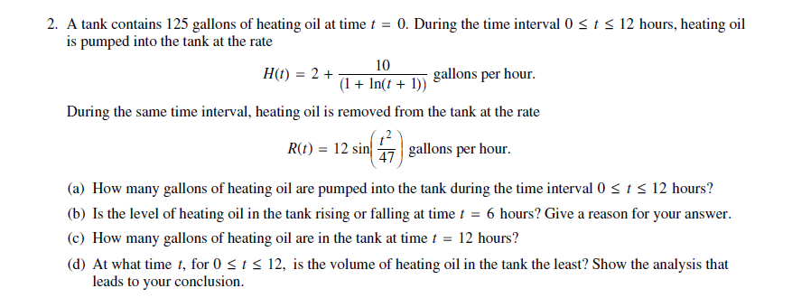

LESSON 2B HW
3. AP:2002FB#2
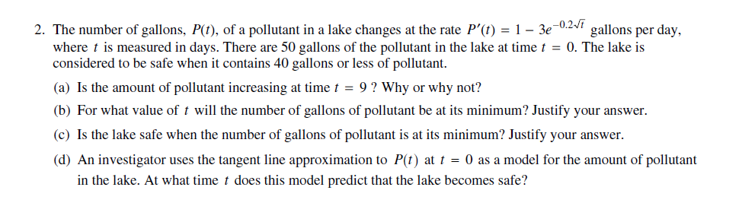

LESSON 2B HW
4. AP:2010#1
