AB.Q103.NOTES: Chapter 2.4, 3.1, 3.2 LESSON 1
DEFINITION DEVELOPMENT

Average rate of change of f on [a,b]
Slope of the secant line though curve f on [a, b]

Standard:

Alternate:

Instantaneous rate of change of f at $x=a$
Slope of the line tangent to the curve of f at $x=a$
Derivative of f at $x=a$

Standard:

Alternate:

1. Consider the function $y=f(x)$where$f(x)=3x^{2}−2$
a. Find the average rate of change in f on the interval [-1, 2]

b. Using the standard definition of a derivative at $x=a$ …
Find the instantaneous rate of change in f at $x=1\text{.}$ (Precede your answer with Lagrange notation).

c. Write an equation of the tangent line to the graph of $f(x)$at $x=1\text{.}$

2. Consider the function $y=f(x)$where$f(x)=\sqrt{x+1}$
a. Find the average rate of change in f on the interval [0, 8]

b. Using the alternate definition of a derivative at $x=a$ …
Find the instantaneous rate of change in f at $x=3\text{.}$ (Precede your answer with Lagrange notation).

c. Write an equation of the tangent line to the graph of $f(x)$at $x=3$.

3. Consider the function $y=f(x)$where$f(x)=\begin{aligned}\left\{5−2x; x≥1 | \right.\end{aligned}$
a. Find the average rate of change in f on the interval [0, 2]

b. Using the standard definition of a derivative at $x=a$ …
Find the instantaneous rate of change in f at $x=1\text{.}$ (Precede your answer with Lagrange notation).

c. Write an equation of the tangent line to the graph of $f(x)$at $x=1$.

4. Consider the function $y=g(x)$where$g(x)=\begin{aligned}\left\{5−x; x≥0 | \right.\end{aligned}$
a. Find the average rate of change in g on the interval [-2, 5]

b. Using the standard definition of a derivative at $x=a$ …
Find the instantaneous rate of change in g at $x=0\text{.}$ (Precede your answer with Lagrange notation).

c. Write an equation of the tangent line to the graph of $g(x)$at $x=1$.

Details and Summary

What is the derivative of f at x = a?

DEF (Sandard): The derivative of the function $f$at the point $x=a$is $f^{}(a)={\text{lim}}_{h→0}\frac{f(a+h)−f(a)}{h}$, provided it exists.

DEF (Alternate): The derivative of the function $f$at the point $x=a$is $f^{}(a)={\text{lim}}_{x→a}\frac{f(x)−f(a)}{x−a}$, provided it exists.

Is the function differentiable at x = a?

DEF (Std): A function f is differentiable at x = a if ${\text{lim}}_{h→0}\frac{f(a+h)−f(a)}{h}$exists.
If the limit does not exists then we say that the function is not differentiable at x = a.

DEF (alt): A function f is differentiable at x = a if ${\text{lim}}_{x→a}\frac{f(x)−f(a)}{x−a}$exists.
If the limit does not exists then we say that the function is not differentiable at x = a.
AB.Q103.LESSON 1 – HW:

1. If $f(2)=3$and $f^{}(2)=5$, find an equation of (a) the tangent line, and (b) the normal line to the graph of $y=f(x)$at the point where $x=2$.

2. Consider the function $y=f(x)$where$f(x)=x^{2}−4x$
a. Find the average rate of change in f on the interval [-2, 4]
b. Find the instantaneous rate of change in $f(x)$ at $x=1$.
Classify $f(x)$as either smooth, a corner, a cusp, a vertical line tangent, or discontinuous at $x=1$.
c. Write an equation of the tangent line to the graph of $f(x)$at $x=1\text{.}$

3. Consider the function $y=f(x)$where$f(x)=\begin{aligned}\left\{−x; x<0 | \right.\end{aligned}$
a. Find the average rate of change in f on the interval [-2, 4]
b. Find the instantaneous rate of change in $f(x)$ at $x=0$.
Classify $f(x)$as either smooth, a corner, a cusp, a vertical line tangent, or discontinuous at .
c. Write an equation of the tangent line to the graph of $f(x)$at $x=0\text{.}$

4. Consider the function $y=f(x)$where
a. Find the average rate of change in f on the interval [-4, 0]
b. Find the instantaneous rate of change in $f(x)$ at $x=−2$.
Classify $f(x)$as either smooth, a corner, a cusp, a vertical line tangent, or discontinuous at .
c. Write an equation of the tangent line to the graph of $f(x)$at $x=−2\text{.}$

5. Consider the function $g(x)=\frac{1}{x}$.
a. Find $g^{}(2)$using the standard definition of the derivative at x = a.
b. Find $g^{}(2)$using the alternate definition of the derivative at x = a.

6. Let $p(x)=\begin{aligned}\left\{\frac{x^{2}−1}{x+1}; x≠−1 | \right.\end{aligned}$. Prove that p is or is not continuous at $x=−1$.
AB.Q103.NOTES: Chapter 2.4, 3.1, 3.2 LESSON 2

1. Let . Prove that p is or is not continuous at .

2. Let . Prove that f is or is not continuous at .

3. THEOREM:

4. OVERVIEW

5.
A. Prove that f is or is not continuous at .
B. Prove that f is or is not differentiable at .

6.
A. Prove that f is or is not continuous at .
B. Prove that f is or is not differentiable at .

7.
A. Prove that p is or is not continuous at .
B. Prove that p is or is not differentiable at .

AB.Q103.LESSON 2 – HW:
1. Consider the function $y=f(x)$where$f(x)=\begin{aligned}\left\{x+1; x>1 | \right.\end{aligned}$
a. Find the average rate of change in f on the interval [-1, 2]

b. Using the standard definition of a derivative at $x=a$ …
Find the instantaneous rate of change in f at $x=1\text{.}$ (Precede your answer with Lagrange notation).

c. Write an equation of the tangent line to the graph of $f(x)$at $x=1\text{.}$

2. Consider the function $b(x)=\begin{aligned}\left\{x; x>1 | \right.\end{aligned}$
a. Prove that b is or is not continuous at $x=1\text{.}$

b. Using the standard definition of a derivative at $x=a$, prove that b is not differentiable $x=1\text{.}$

c. Explain how you could have used part (a) to prove that b is not differentiable $x=1\text{.}$

3. Use the table below to estimate a) $f^{}(1\text{.}\text{57})$ and b) $f^{}(3)$
t | 0.00 | 0.56 | 0.92 | 1.19 | 1.30 | 1.39 | 1.57 | 1.74 | 1.98 | 2.18 | 2.41 | 2.64 | 3.24
f(t) | 1577 | 1512 | 1448 | 1384 | 1319 | 1255 | 1191 | 1126 | 1062 | 998 | 933 | 869 | 805

4. Using the definition for a derivative at $x=a$,
prove that $f(x)=\begin{aligned}\left\{x; x≤1 | \right.\end{aligned}$is or is not differentiable at $x=1$.
Classify $f(x)$as either smooth, a corner, a cusp, a vertical line tangent, or discontinuous at $x=1$.

5. Prove that $g(x)=\begin{aligned}\left\{2+\sqrt{x}; x>0 | \right.\end{aligned}$ is or is not continuous at $x=0$.
AB.Q103.NOTES: Chapter 2.4, 3.1, 3.2 LESSON 3
Definition: The derivative of the function $f$with respect to the variable $x$is the function $f^{}(x)$whose value at $x$ is $f^{}(x)={\text{lim}}_{h→0}\frac{f(x+h)−f(x)}{h}$, provided it exists.
NO ALTERNATE DEFINITION FOR $f^{}(x)$

1. Consider the function$f(x)=3x^{2}−2$.
A. Find $f^{}(x)$.

B. Write an equation of the tangent line to the graph of f(x) at $x=−1$ and $x=5$.

C. Write an equation of the normal to the graph of f(x) at $x=−1$ and $x=5$.

D. Find the points on the graph of f where the slope of the tangent line is parallel to $y=4x+5$.
2. Graph $f^{}(x)$from $f(x)$

The graph of $y=g(x)$shown here is made of line segments joined end to end. Graph the function’s derivative.
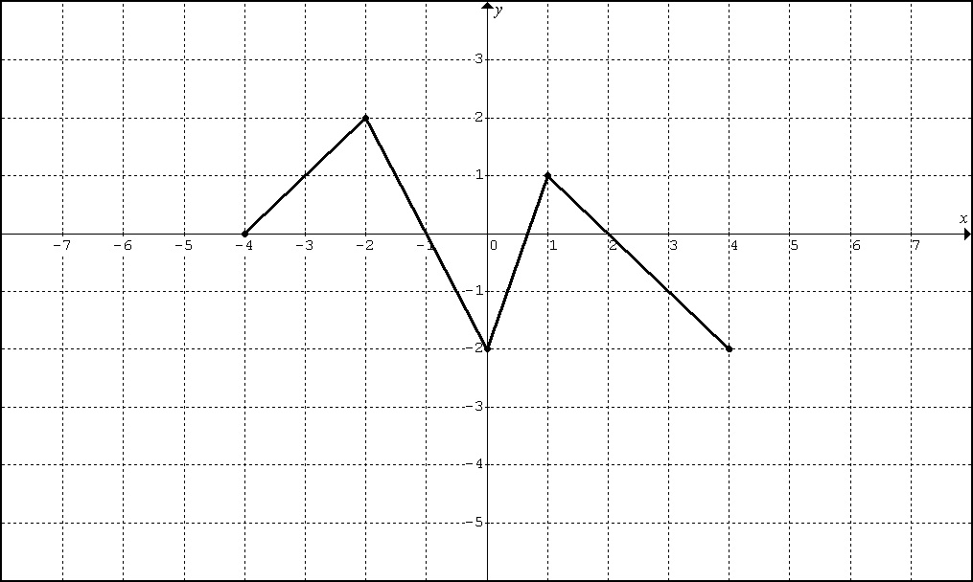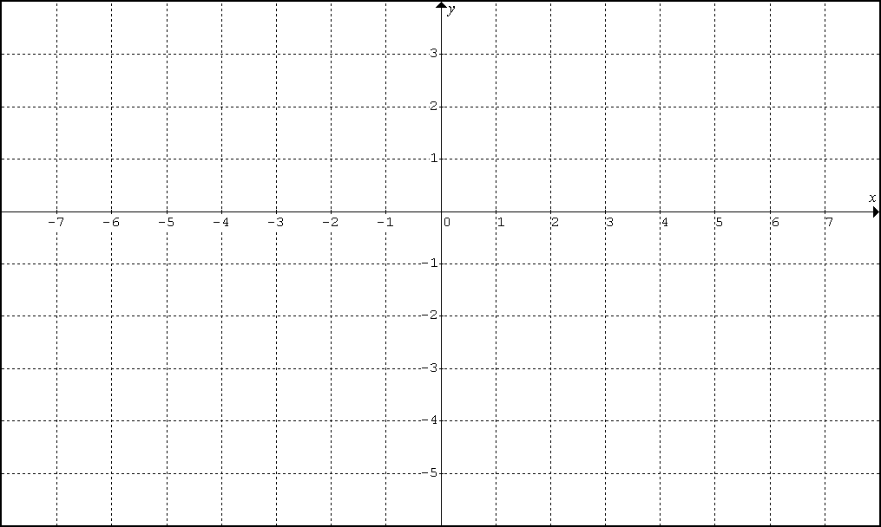

3. Graph $f(x)$ from $f^{}(x)$

Sketch a possible graph of a continuous function f that has domain [-3, 3], where $f(−1)=−2$and the equation of $y=f^{}(x)$is shown below.
$$f^{}(x)=\begin{aligned}\left\{−1; x<−1 | \right.\left\{0; −1<x<2 | \right.\end{aligned}$$

AB.Q103.LESSON 3 – HW:

1. The graph of the function $y=f(x)$shown here is made of line segments joined end to end.
Graph $y=f^{}(x)$and state its domain.
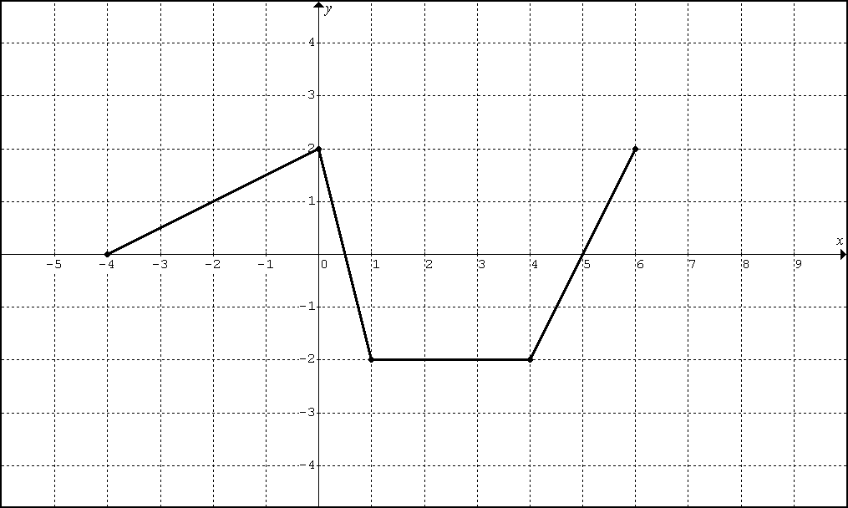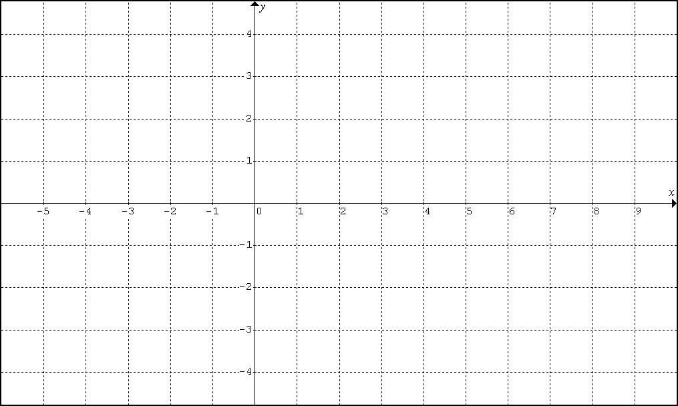

2. Sketch the graph of a continuous function with domain [-2,2],$f(0)=−1$, and $f^{}(x)=\begin{aligned}\left\{1; x<−1 | \right.\end{aligned}$.

3. Using the information from problem 2, write an equation of the line tangent to f at $x=0\text{.}$

4. Find $f^{}(x)$ for $f(x)=5x^{2}−2x+1$ using the appropriate definition.

5. Find the value of x for which the tangent to $f(x)=5x^{2}−2x+1$ is horizontal.

6. Find $f^{}(x)$ for $f(x)=\frac{1}{x+1}$ using the appropriate definition.

7. Find $f^{}(x)$ for $f(x)=\sqrt{2x+1}$ using the appropriate definition.

8. Consider the function $y=f(x)$where$f(x)=\begin{aligned}\left\{x+1; x>1 | \right.\end{aligned}$.
Find $f^{}(x)$.

9. Using the definition for a derivative at $x=a$,
prove that is or is not differentiable at $x=1$.
Classify as either smooth, a corner, a cusp, a vertical line tangent, or discontinuous at $x=1$.

