**AB CALCULUS**

**Q102**

**LIMITS and CONTINUITY FOR CALCULUS**

**NO CALCULATORS**

**AB CALCULUS Q102: Limits – Lesson 1**

1. 

2. 

3. 

4. Let  Find 

5. Let  Find 

6. Let  Find 

7. Let and 

Show Properties

a. 

b. 

c. 

d. 

8. 

9. Let . Find 

10. . Find 

Summary of Analytic techniques to find the limit of a function as *x* approaches a real number:

1.

2.

3.

4.

5.

6.

Definition of Vertical Asymptote of a function *f*:

TWO-ONE SIDED LIMIT THEOREM:

**AB.Q102.LESSON 1 – HW**:

Textbook Section 2.1:

11, 18, 19, 22, 49, 35, 51, 62, 37, 43

Textbook Section 2.2:

13, 14, 27, 53

*These have been typed out on the next page.*

Section 2.1 . Find the limit or state the limit does not exist.

11.  18. 

19.  22. 

49. Assume  and .

(a)  (b)  (c)  (d) 

51.  where  .

62. 

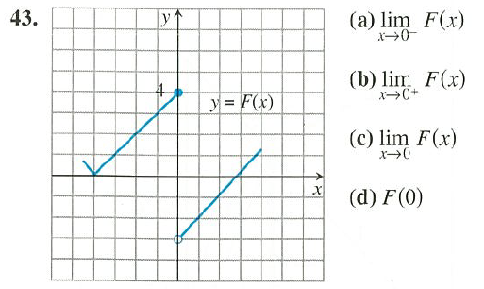

37. True or False

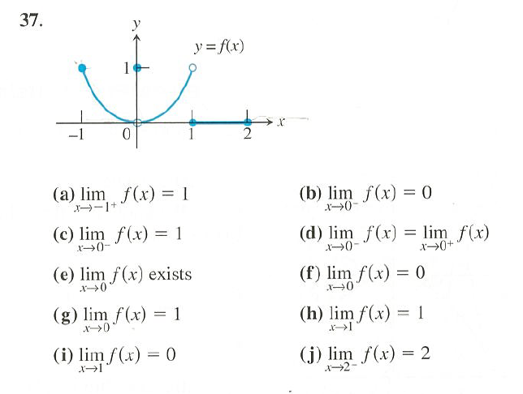

Section 2.2. Find the limit or state the limit does not exist.

13.  14. 

53. For 

(a)  (b)  (c)  (d) 

27. For  ,

Write limit statements for any vertical asymptotes of the graph of.

Write limit statements for any horizontal asymptotes of the graph of.

**AB CALCULUS Q102: Limits Continued – Lesson 2 (Part 1)**

1. Find 

2. Find 

3. Find 

4. Find 

Definition of a Horizontal Asymptote:

**AB CALCULUS Q102: CONTINUITY – Lesson 2 (Part 2)**

Definition of a function *f* continuous at :

EXAMPLE:

EXAMPLE:

EXAMPLE:

**AB CALCULUS Q102: IVT – Lesson 2 (Part 3)**

**Intermediate Value Theorem** (the no-duh theorm)

If *f* is continuous on a closed interval [a, b], then *f* takes on all values between *f*(*a*) to *f*(*b*).

Example: Let  be continuous on [-4, 2] with corresponding values as shown in the table below:

|  |  |  |  |  |  |  |  |
| --- | --- | --- | --- | --- | --- | --- | --- |
| *x* | -4 | -3 | -2 | -1 | 0 | 1 | 2 |
| *f*(*x*) | -139 | 72 | 41 | 2 | -3 | -4 | 17 |

A. How many times will obtain the value of -120? Justify using the intermediate value theorem.

B. How many zeros will obtain on the interval [-4, 2]? Justify using the intermediate value theorem.

**AB.Q102.LESSON 2 – HW**:

**CONTINUITY at *x* = *a* : Read Section 2.3**

1. Prove that is or is not continuous at .

2. Prove that  is or is not continuous at .

3. Prove that is or is not continuous at .

4. Prove that  is or is not continuous at .

5. A. Prove that is not continuous at .

B. Extend *g*(*x*), making it a piecewise function that is continuous at.

6. A. Prove that is not continuous at .

B. Extend *d*(*x*), making it a piecewise function that is continuous at.

7. Prove that  is or is not continuous **at** 

Hint: See the Sandwich Theorem of Limits.

LESSON 2 HW CONTINUED …

Section 2.3 #23, 41 – 44, 47

23. Find all domain values of *x* such that is not continuous. (proof not required). Classify the discontinuity as a jump, removable, or infinite discontinuity.

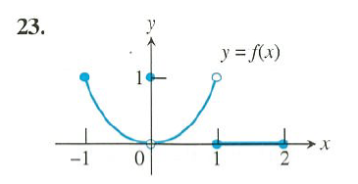

**41-44: Sketch a possible graph for a function *f* that has the given properties.**

41. exists, but does not exist.

42. exists, , but does not exist .

43. exists,  exists, but f is not continuous at .

44. is continuous for all *x* except . *f* has a removable discontinuity at .

**47.** Find a value of the constant “a” such that  is continuous at .

**Section 2.2 #6, 9, 22**

6. For 

Find and and use this to describe the end behavior of the graph of *f*

9. Find  using the sandwich theorem.

22. 

Find and and use this to describe the end behavior of the graph of *f*