AB CALCULUS

Q101

ALGEBRAIC and TRIGONOMETRIC ESSENTIALS FOR CALCULUS

NO CALCULATORS

AB. Q101. LESSON 1. NOTES
Definition of Absolute Value and Writing Piecewise Functions
Define $\sqrt{x^{2}}$: Define $\left|x\right|$:

1. Write the function $f(x)=\left|3x−2\right|$without using the absolute-value symbol.

2. Write the function $g(x)=5−\left|x+1\right|$without using the absolute-value symbol.

3. Write the function $y=\frac{\left|x+2\right|}{x+2}$without using the absolute-value symbol. GRAPH IT.

4. Write the function $h(x)=4−\sqrt{x^{2}}+x\left|x\right|$without using the absolute-value symbol.

5. Write the function $f(x)=\left|2−x\right|+1$ without using the absolute-value symbol. GRAPH IT.

6. Write the function $f(x)=3−2\left|x−1\right|$ without using the absolute-value symbol.

DOMAIN / SET AND INTERVAL NOTATION

STATE THE DOMAIN FOR EACH FUNCTION (USING BOTH INTERVAL AND SET NOTATIONS)

1.
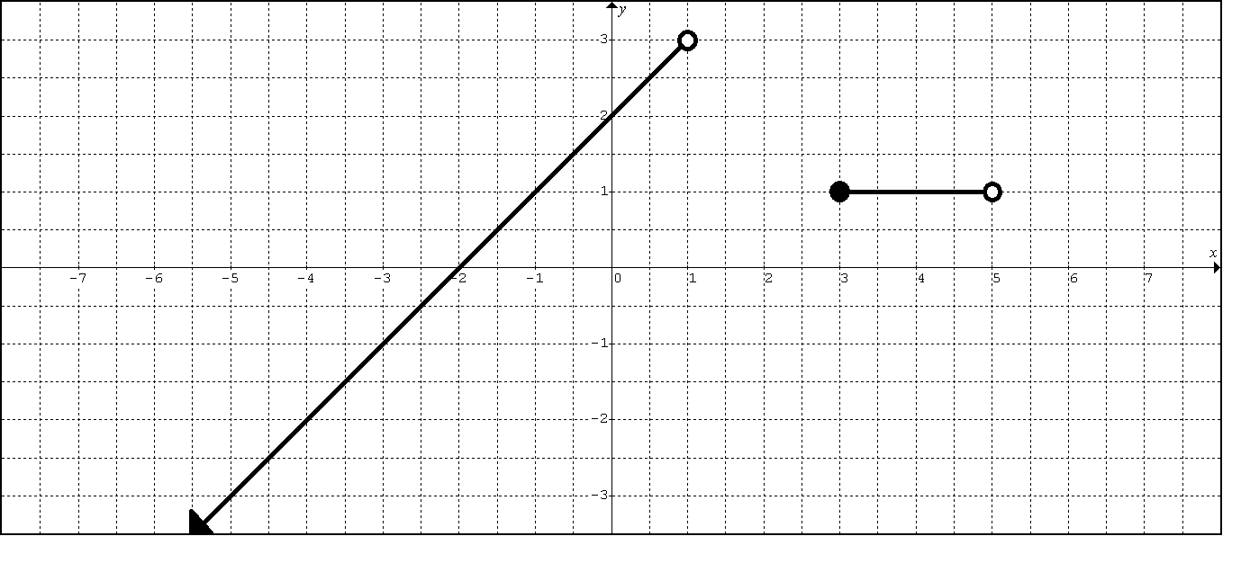

2.
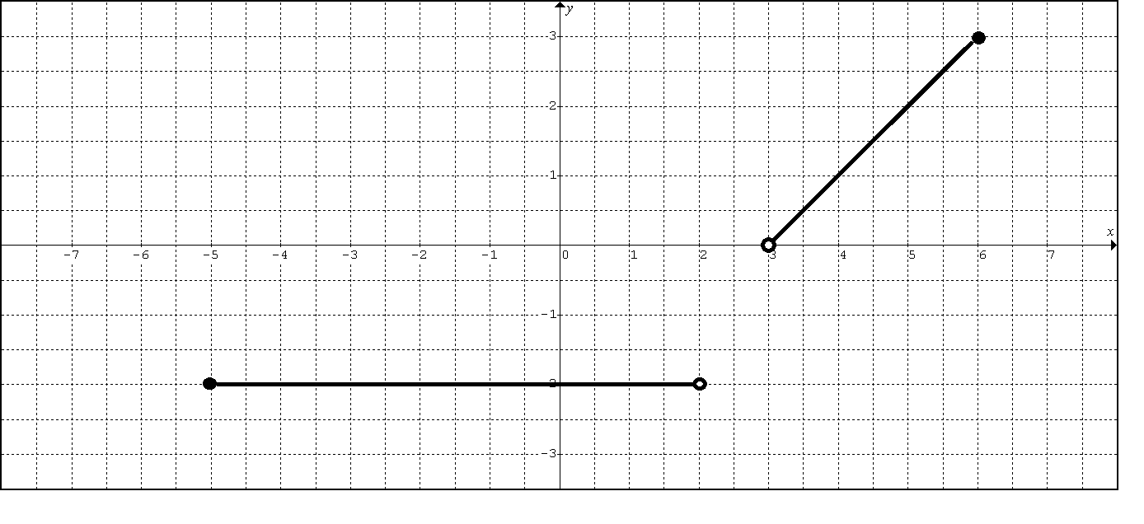

3.
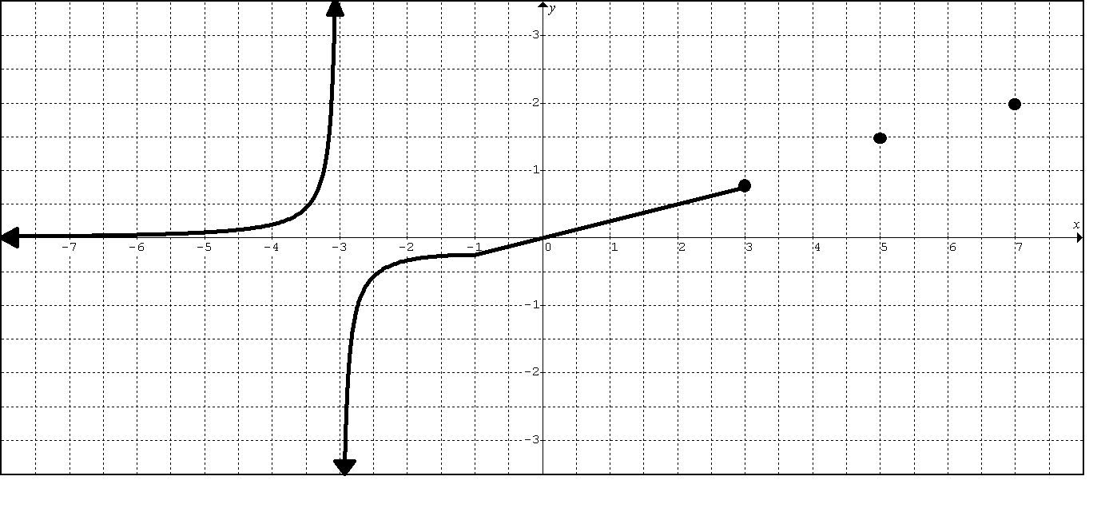

4.
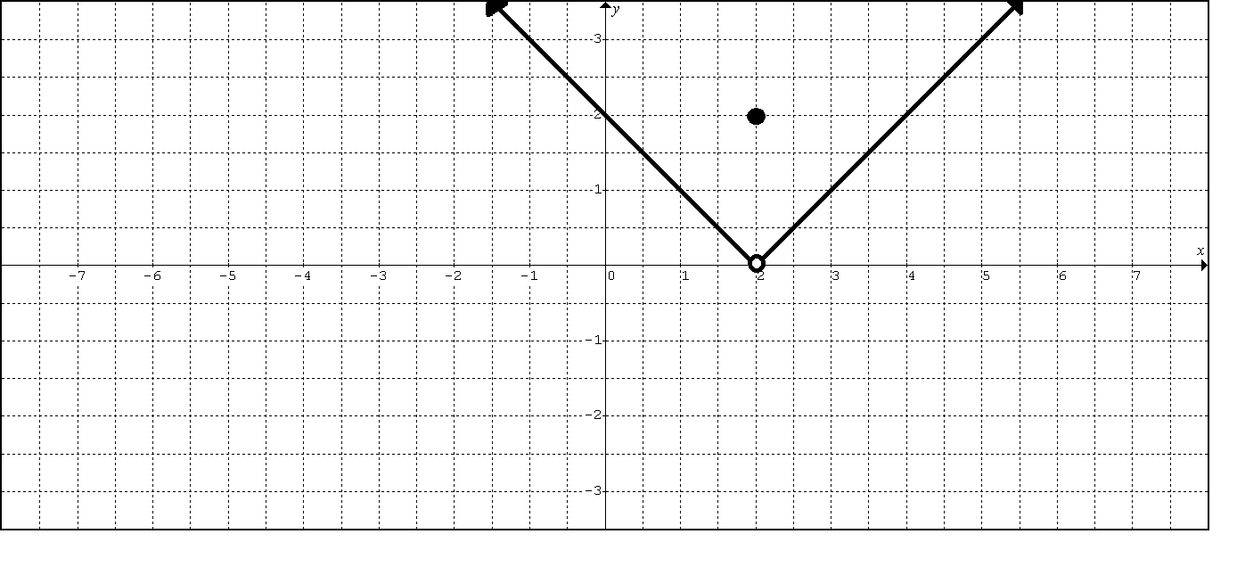

5.
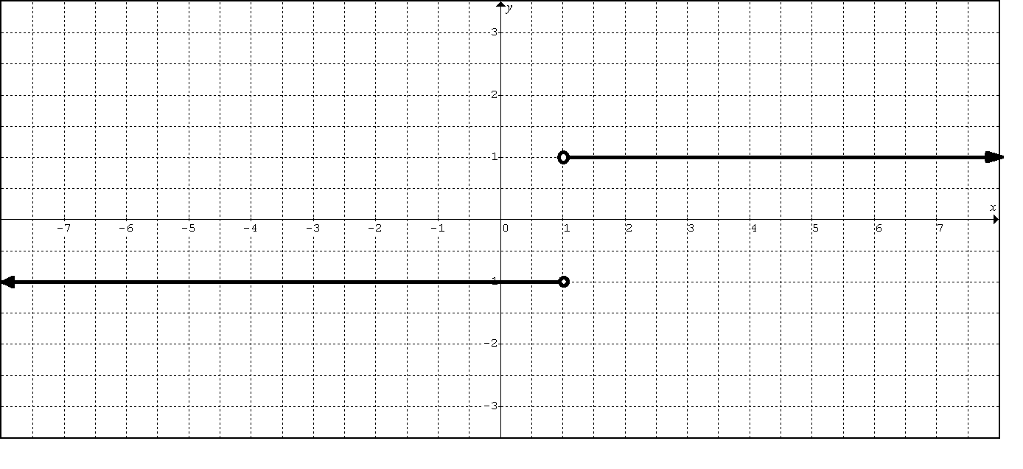

6.
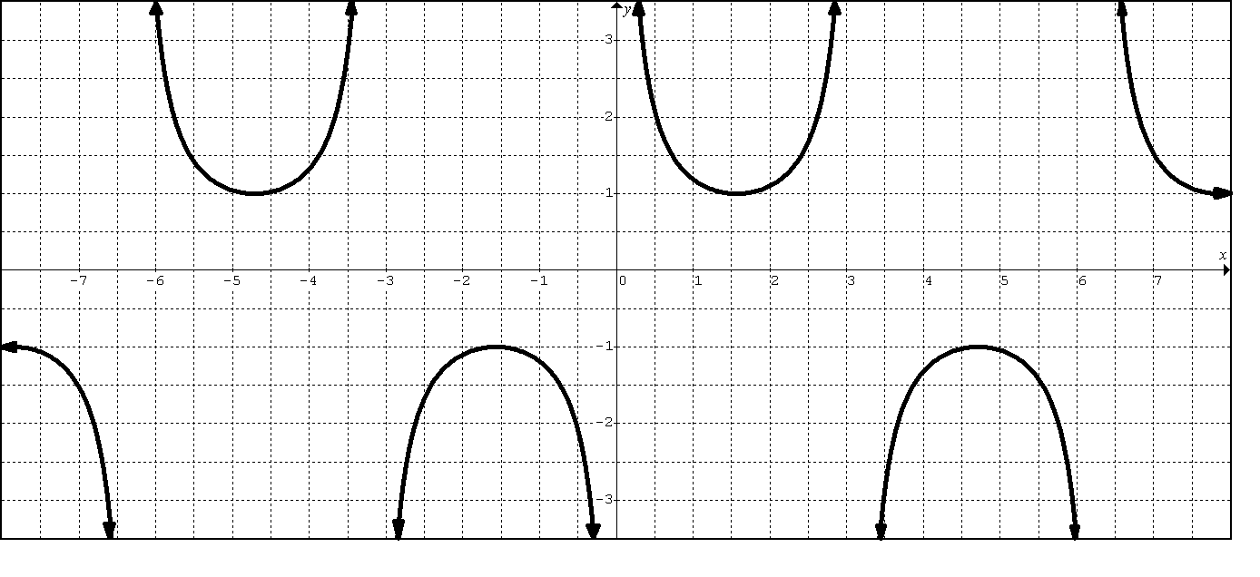

STATE THE DOMAIN FOR EACH FUNCTION (USING SET NOTATION)

1. $y=\sqrt{x−2}$

2. $y=\frac{3}{\sqrt{x}}$

3. $y=\frac{\left|x+5\right|}{x+5}$

4. $y=\sqrt{5−x}$

5. $y=\sqrt{x^{2}−4}$

6. $y=\frac{2x}{\left(x−3\right)\left(3x+5\right)}$

7. $y=\frac{\text{10}}{\text{16}−{\left(x+2\right)}^{2}}$

8. $y=\frac{\sqrt{4+x}}{1−x}$

9. $y=\text{ln}(x)$

10. $y=5\text{ln}(x−2)$

11. $y=\text{sin}(x)$

12. $y=\text{tan}(x)$

13. $y=e^{x}$
AB. Q101. LESSON 1 HOMEWORK
Write each function without the absolute value symbol using a piecewise representation.
1. $f(x)=2+\left|5−2x\right|$

2. $g(x)=5+\sqrt{{\left(7+x\right)}^{2}}$

Report the domain using SET and INTERVAL notations.

3. $y=\frac{x+1}{\left(x−3\right)\left(x+2\right)}$

4. $y=\frac{\sqrt{7−x}}{\sqrt{x+1}}$

5. $y=\begin{aligned}\left\{5; x<0 | \right.\end{aligned}$

6. $y=\begin{aligned}\left\{\text{ln}(x+4); x<0 | \right.\end{aligned}$

7. $y=\text{sec}x$

Mixed Review (Algebraic Essentials)

8. Solve the inequality: $−5≤\frac{\text{14}−3x}{2}<1$

9. Solve the inequality: $x^{2}−\text{10}>3x$

10. Solve the inequality: $\left|x−3\right|<\frac{1}{2}$

11. Solve the inequality: $\left|2x−7\right|>3$

12. Write an equation of a line (in point-slope form) that passes through the points (1,7) and (-3, 2).

13. Simplify the expression $\frac{f(2+h)−f(2)}{h}$for the function $f(x)=x^{2}+6x−4$.

14. Graph the function $f(x)=\begin{aligned}\left\{2x+3; x<0 | \right.\left\{x^{2}; 0≤x<2 | \right.\end{aligned}$.

15. Graph the function $g(x)=\begin{aligned}\left\{\frac{|x−2|}{x−2}; x≠2 | \right.\end{aligned}$

16. Graph the function $r(x)=\begin{aligned}\left\{x+2; x≠−1 | \right.\end{aligned}$

17. Graph the function $h(x)=\begin{aligned}\left\{x^{2}; x≤0 | \right.\end{aligned}$

18. Graph the function $f(x)=x+\sqrt{x^{2}}+2$

19. Graph $y=f\left(g(x)\right)$ AND for the functions $f(x)=\text{16}−x^{2}$and $g(x)=\sqrt{x}$.
Also state the domain of each.

14. 15. 16.
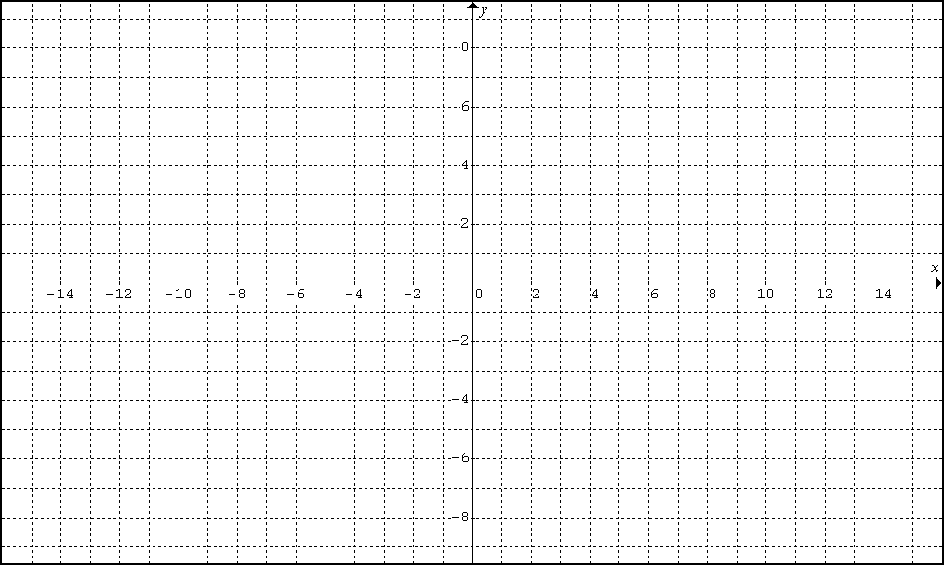
17. | 18.
19. | 19.

AB. Q101. LESSON 2. NOTES: Powerful Graphing

Consider a rational function in factored form.

Graphing :

- Find the holes and write the coordinates of each.
- Find the vertical asymptotes and write the equation of each
  - (determine how the graph approaches the asymptote, i.e. from the same or opposite direction)
- Find the zeros of the function and write the coordinates for each
  - (determine how the graph touches the x-axis, i.e. bounce, plateau, cut through)
- Find the y-intercept and write the coordinates.
- Determine the horizontal asymptotes and write the equation for each

Guidelines Details

- Holes (or removable) discontinuities occur for x values that make a canceled factor go to zero.

- Vertical Asymptote discontinuities occur for x values that make a simplified rational function undefined.
After simplifying, set the denominator equal to zero to find these vertical asymptotes.
- If the asymptote repeats an even number of times, then the graph will approach the vertical asymptote from the same direction.
- If the asymptote repeats an odd number of times (or does not repeat), then the graph will approach the vertical asymptote from opposite directions.

DEF: A line $x=a$is called a vertical asymptote of the graph of a function f if $f(x)→+∞$or $f(x)→−∞$as x approaches a from the left or right.

- A function’s Zeros occur for the x values that make a simplified rational function equal zero.
After simplifying, set the numerator equal to zero to find these zeros.
- If the zero repeats an even number of times, then the graph will bounce off the x-axis.
- If the zero repeats an odd number of times, then the graph will plateau on the x-axis.
- If the zero does not repeat, then the graph will simply cut through the x-axis.

- A function’s Y-intercept occurs when the x-value equals zero.
Plug zero in for x and solve for y to find the value of the y-intercept.

- Horizontal Asymptote:

Choose the highest power term in both the numerator and denominator.

- If the power in the numerator is higher than the power in the denominator, then there will not be a horizontal asymptote.

- If the power in the numerator is less than the power in the denominator, then there will be a horizontal asymptote at y = 0. (end behavior not necessarily local)

- If the power in the numerator is equal to the power in the denominator, then there will be a horizontal asymptote at where a is the leading coefficient of the numerator and b the leading coefficient of the denominator.

DEF: A line $y=L$is called a horizontal asymptote of the graph of a function f if $\underset{x→+∞}{\text{lim}}f(x)=L$or $\underset{x→−∞}{\text{lim}}f(x)=L$
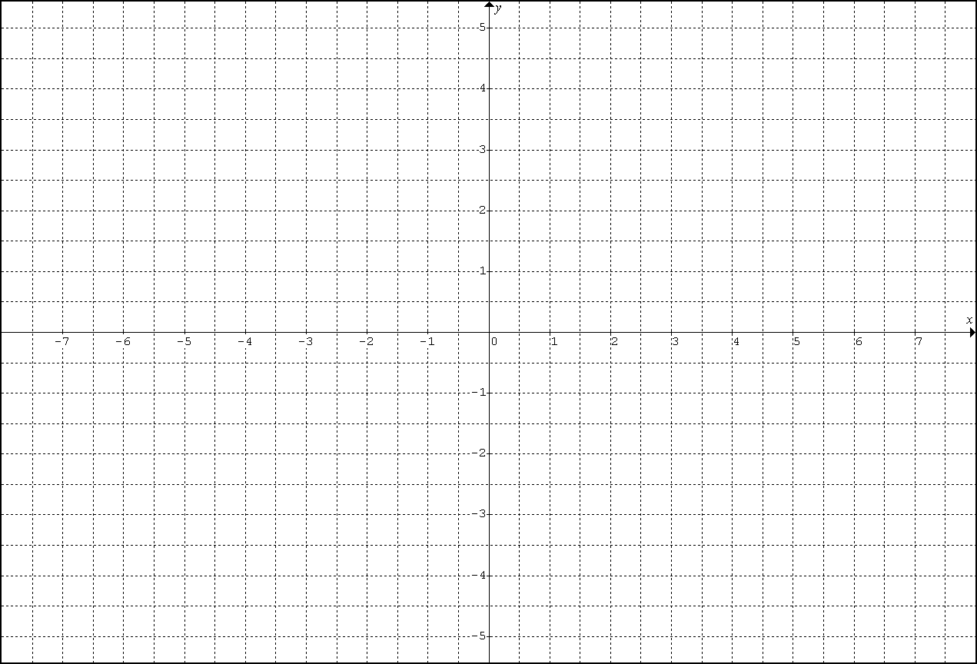
EXAMPLE 1
EXAMPLE 2

EXAMPLE 3
1.

Q101 Lesson 2 HW
Carefully graph the function. Show work.
Show the appropriate limit notation leading to the horizontal asymptote
Show the appropriate limit notation leading to the vertical asymptote(s).
Carefully highlight and indicate the coordinates of any key points.
Carefully label any asymptotes and axes.

2.

3.

4.

5.

6. $f(x)=\frac{\text{14}(x^{2}−\text{81})}{9{\left(x+3\right)}^{2}\left(x−4\right)\left(x−7\right)}$

7.

8.

1.
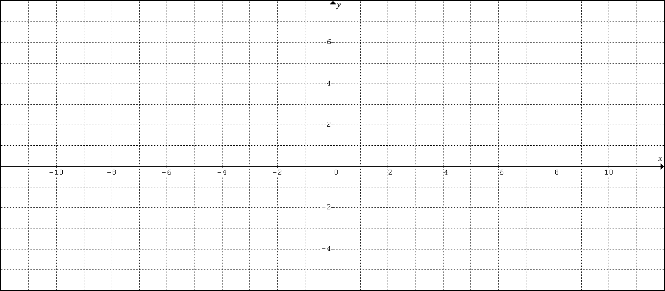

2.
3.

4.
5.
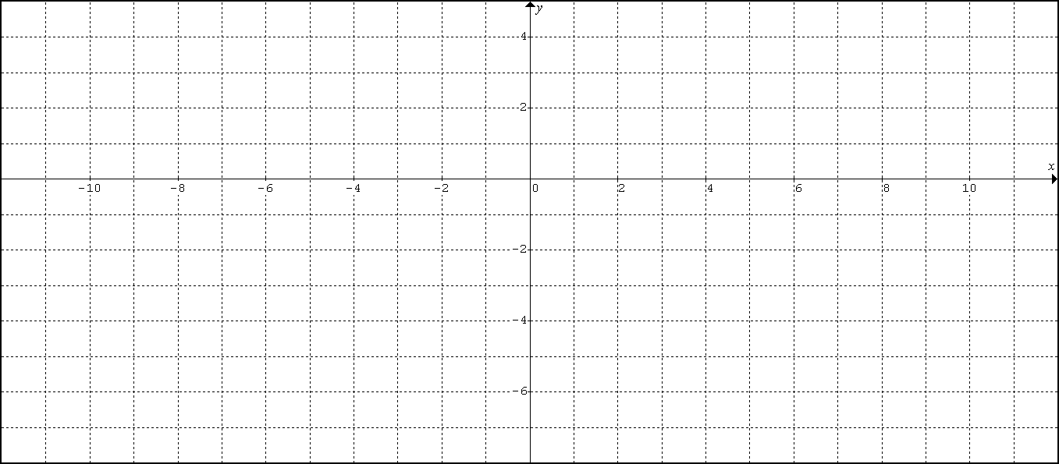

6.
7.

8.

Mixed Review (Trigonometric Essentials)

Evaluate the following:

1. $\text{sin}\left(\frac{5π}{6}\right)$

2. $\text{cos}\left(\frac{\text{11}π}{6}\right)$

3. $\text{tan}\left(\frac{4π}{3}\right)$

4. $\text{sec}\left(\frac{2π}{3}\right)$

5. $\text{csc}\left(\frac{7π}{6}\right)$

Solve each equation on the domain $\left[0, 2π\right]$ (answer in radians):

6. $\text{sin}\left(x\right)=\frac{1}{2}$

7. $\text{tan}\left(x\right)=−\frac{1}{\sqrt{3}}$

8. $\text{sin}\left(x\right)+\text{cos}(x)=0$

9. ${\text{cos}}^{2}\left(x\right)+\text{cos}(x)=0$

10. $\text{sin}\left(x\right)−2\text{cos}(x)\text{sin}(x)=0$

